Table of contents

**FRONT-END** 3

1. Login 3

2. Upload your CV 3

3. Job list 5

3.1. Apply to a job 6

3.2. Job ad sharing 7

4. Candidate login 8

4.1. Personal area and job ads 8

4.2. Job Agent (*ADDITIONAL MODULE) 10

4.3. Documents 10

4.4. Video resume (*ADDITIONAL MODULE) 10

4.5. Job test 11

4.6. Image upload 12

4.7. Account management 12

5. Mobile version 13

**LOGIN EMPLOYER** 15

1. Account management 15

1.1. Personal 15

1.2. Users 15

1.3. Candidates 19

1.4. Management setup 22

1.5. File storage (*ADDITIONAL MODULE) 22

1.6. Job ads logo (*Additional module*) 23

2. MODULE AGENDA 24

3. MODULE CANDIDATES 27

3.1. Dashboard 27

3.2. Post ad 30

3.3. My ads 31

3.4. Recruitment step 34

3.5. Interview step 45

3.6. Selection step 50

3.7. Candidates (Database searches) 51

3.8. Shared with me 53

3.9. Exports 53

3.10. Candidate profile 54

3.11. More tools 68

4. MODULE REPORTING (*ADDITIONAL MODULE) 69

4.1. Selection and Conversion 69

4.2 Data-log 90

4.3. Active employees (*ADDITIONAL MODULE) 92

4.4. Exports 93

# **FRONT-END**

The software front-end is made up of 3 pages: the login, the job list and the application form. Once linked to the company website, these sections are accessible to all the different users.

## Login

The login page is a page from where users can log into the system. This page can be accessed by all the system users (candidates and employers).

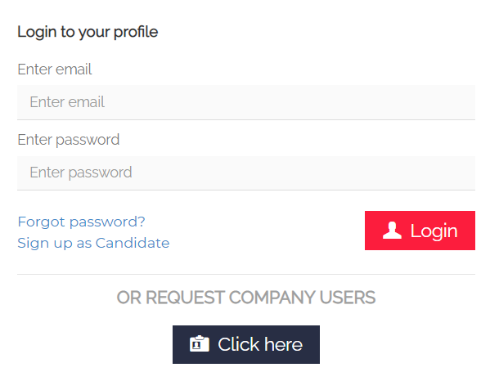

If you have forgotten your password, you can easily click on "Forgot password?" and you will be redirected to the password recovery page. By clicking on "Recover", you will receive an automated e-mail to set a new password. If the e-mail entered has not been registered in the database yet, you will see the following message:



**N.B.:** It is necessary to access the "recover password" from the link in the last email received.

## Upload your CV

Here you can access the candidate's application form. Compulsory fields are marked with the symbol * (if you don’t fill in these fields, the application cannot be completed).

The email address is the unique identifier that allows to recognize each candidate profile. If an email address has already been registered into the database, an error message is reported.

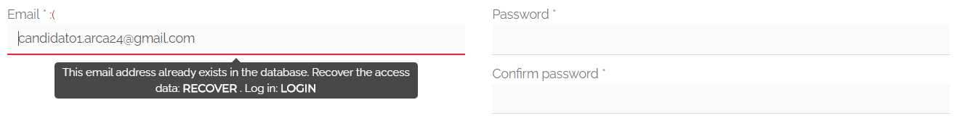

**Upload CV:** In the section “Personal details”, you have to upload your CV.

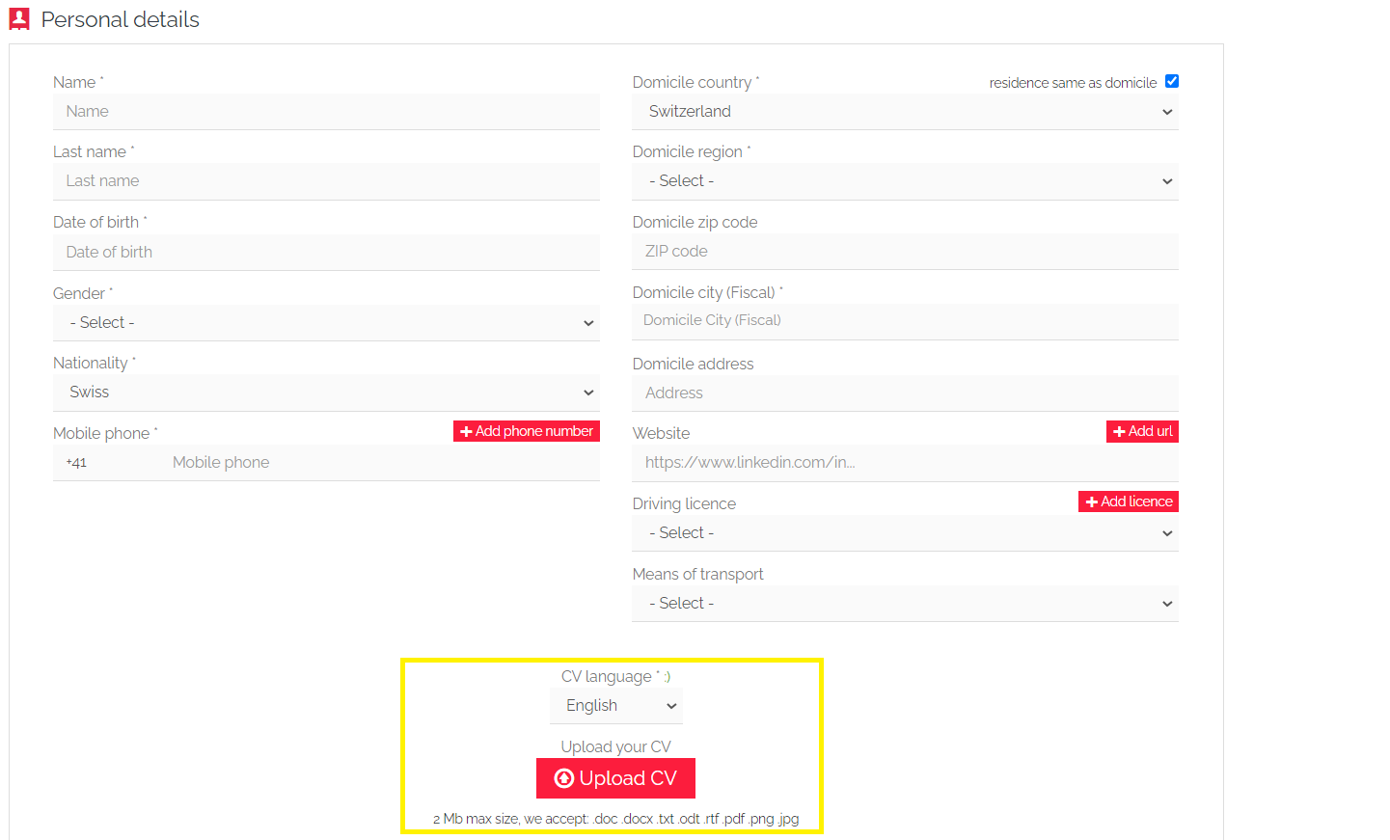

It is necessary to choose the language in which your CV was written (English, German, French, Italian, Portuguese, Spanish and (if provided) Polish). The semantic reading will be carried out according to the language used in the CV. The language of all automated e-mails sent from the system depends on that of the CV. In the event that the installation is monolingual, all emails and SMS will be sent in the installation language, regardless of the language of the CV.

For what concerns the file upload, the system informs you that:

* only the following formats are accepted.doc .docx .txt .odt .rtf .pdf .png .jpg
* the maximum size accepted is 2MB

**Privacy**: The standard flags in this section are the following:

1. “I accept Privacy, Terms & Conditions” – this is compulsory to proceed with the application

2. “I consent to receive electronic communications” – this flag creates a filter into candidates’ searches, helpful for activities related to multimailing

3. “Send me e-mails about new job offers aligned with my profile” – this flag is included only in the systems with the mod **“job agent”** activated, and it allows to automatically activate job alerts according to the candidate’s profile.

Once you have filled in the application form and you have clicked on the button “Save”, you will be shown a second page where you can:

* Upload a new certificate (*ADDITIONAL MODULE*);
* Add experience. This section allows the candidate to add professional experiences, especially those not mentioned in the CV;
* See and improve the CV extraction as well as the professional tags identified by the semantic engine. The candidate can change the text extracted from the CV and adjust the related tags.

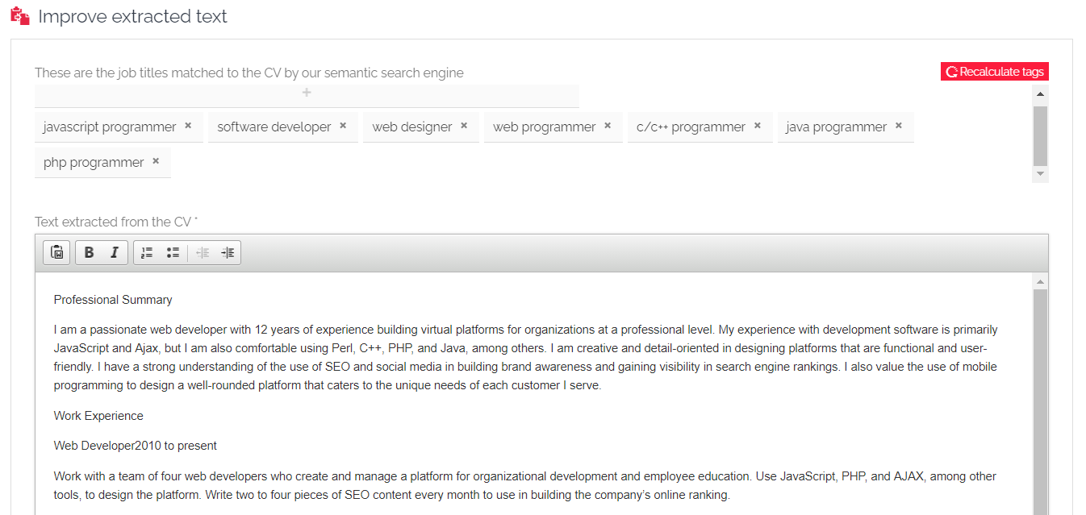

If there are any problems with the CV extraction, the following message will be displayed:

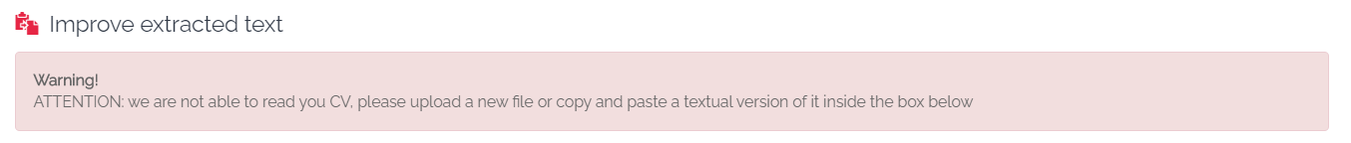

## Job list

The job list includes the full list of online ads.

Each job ad string shows workplace, sector and role, as well as a preview of the ad description (along with the last publication date).

Thanks to the widget on the right, you can use the filters to find job ads aligned with your search. Next to some filters, the link "list all" lists all the current sectors, roles and regions in reference to the active offers.  
Once the filters have been set, use the button “**Start the search**” at the bottom of the filters to select the jobs to be displayed:

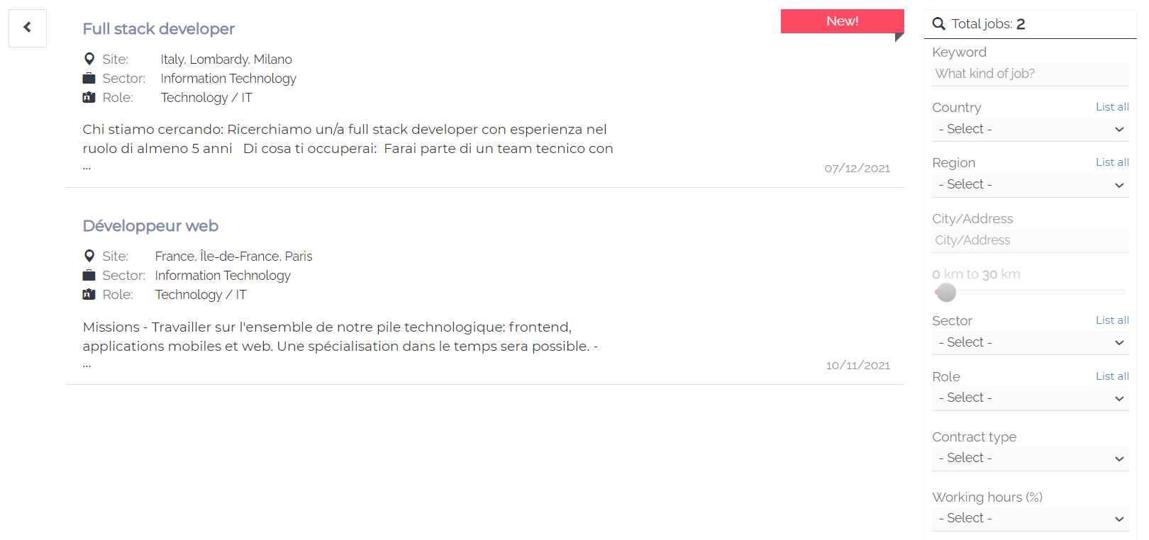

By clicking on each job title, it is possible to see all the details about the job inserted by a recruiter.

### 3.1. Apply to a job

By clicking on “Apply”, you can submit your application for the selected vacancy.

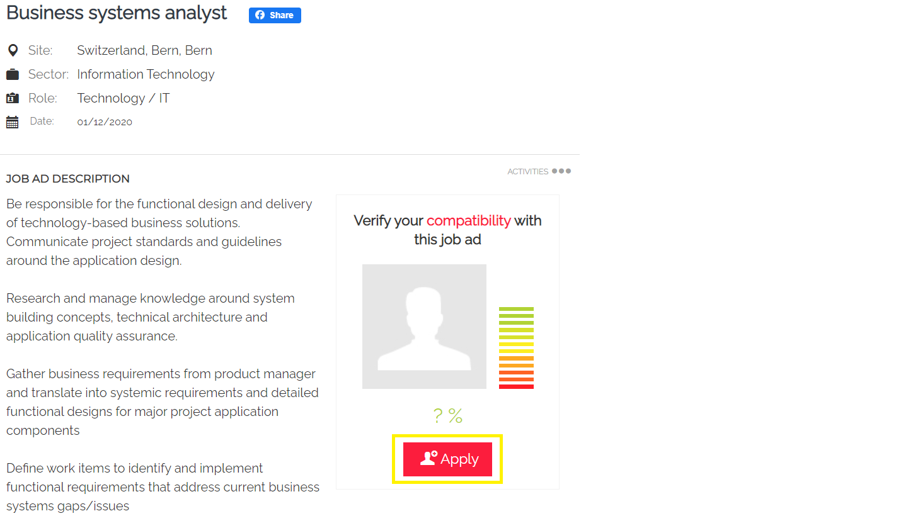

A pop up will be displayed and you can choose between different options:

* “Sign up”. The candidate has not registered yet. He/she will be redirected to the page “Upload your CV” and then directly to his/her personal area -> Tab “Ads” (where it will be displayed the online job ad for which he/she has applied);
* “Login”. The candidate is already registered. He/she will only need to add his/her credentials. By clicking on “Login”, the application is automatically submitted;
* “Login with Google”. The candidate has previously logged into his/her account with Google and applies directly to the job with the linked profile.

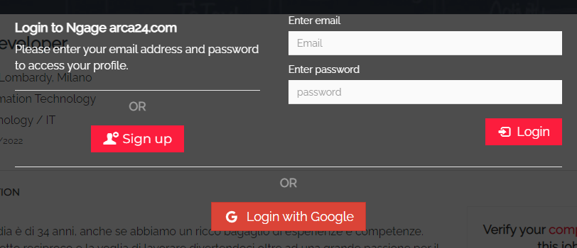

On the right, similar job ads are reported:

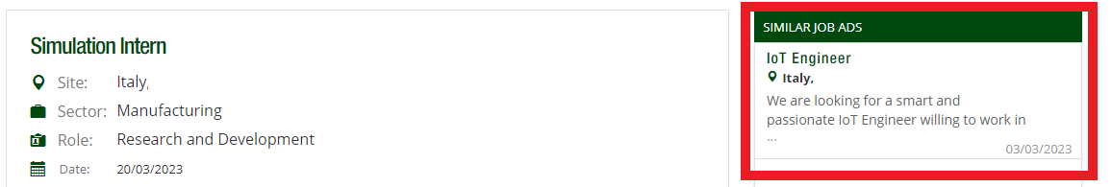

### Job ad sharing

Job ads can be shared on Facebook, Xing, Twitter, LinkedIn, as shown here below:

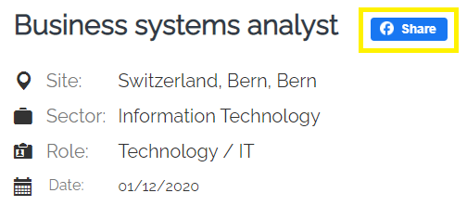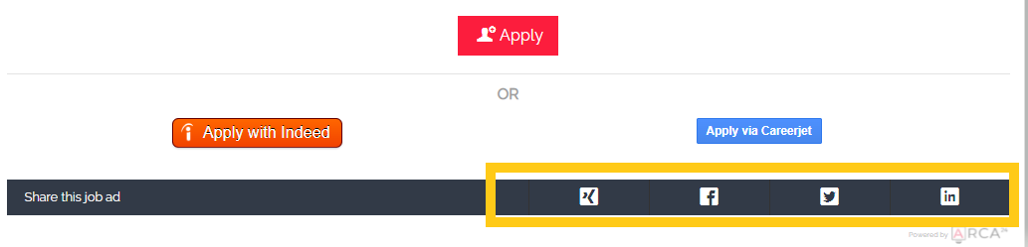

By clicking on “Activities”, it is possible to:

* **If logged in as a candidate**, save a job ad (which will be displayed in the personal area in the tab "Ads");
* Share the job ad via email through the option “Tell a friend”;
* Print the job ad, by clicking on “Print”.

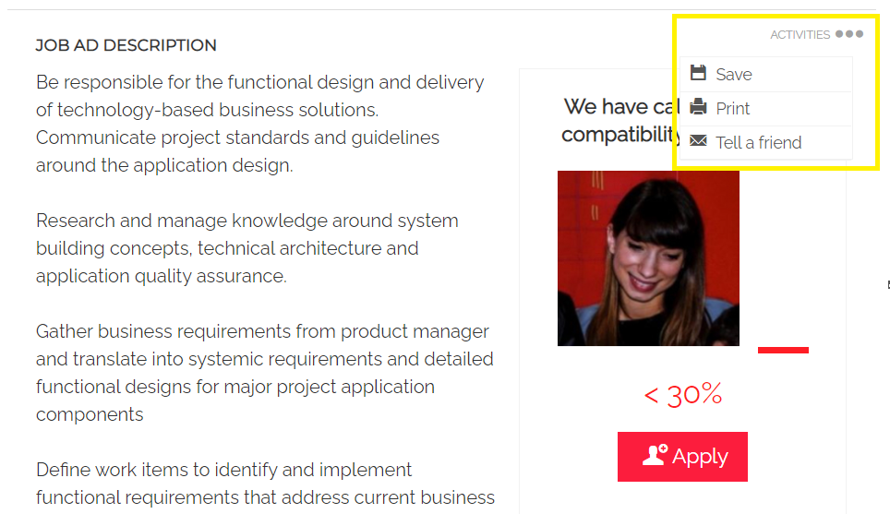

## Candidate login

The candidate's personal area, which will be accessed via the login page, is divided into several tabs, depending on the functionalities activated.

### 4.1. Personal area and job ads

The candidate's dashboard consists of a notifications box, in which the candidate can view and access all the requests sent to him/her by employers, and a message box, where he/she will see a welcome message.

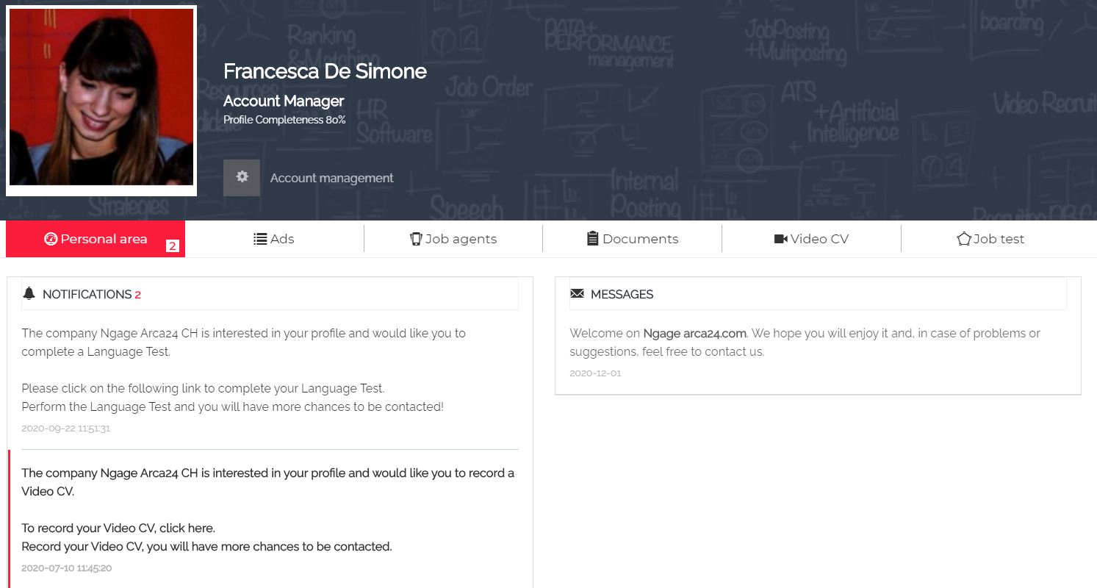

In the tab “My Ads”, two labels differentiate ads to which the candidate has applied ("Applied", green icon) from ads that have only been saved ("Saved", blue icon):

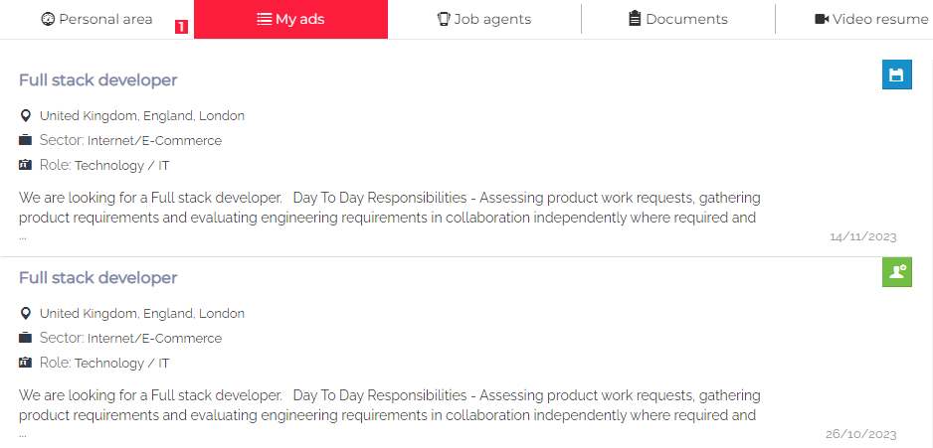

A candidate can delete a submitted application any time: he/she just needs to open the job ad (either from the tab “Ads” or the Job list) and to click on “Cancel application”.

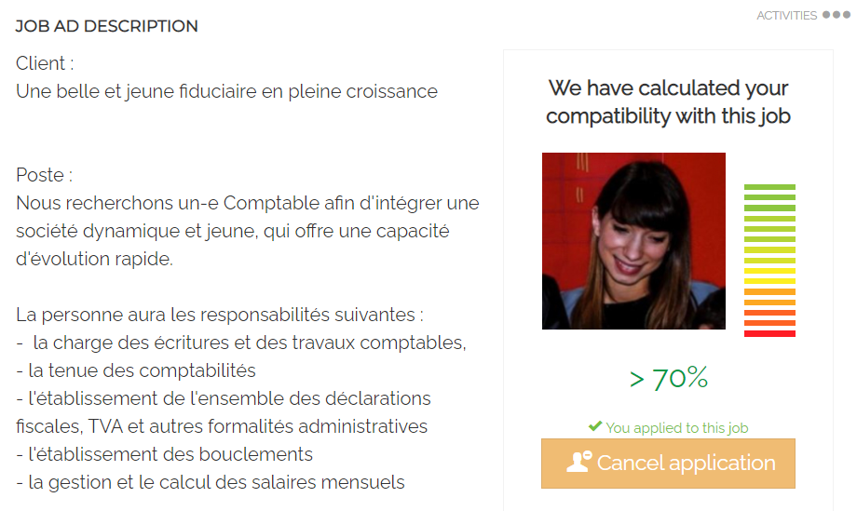

### 4.2. Job Agent (*ADDITIONAL MODULE)

Job Agent is a functionality that allows the candidate to create automatic alerts connected to open job vacancies matching his/her profile or other searches. The candidate will receive a weekly email with links to the new job vacancies according to the job agents created.

A job agent is automatically created upon registration, and it is based on the candidate’s profile:

• The keyword set for the first alert corresponds to the "main profession", entered by the candidate in the application form (when modifying the main profession in the form, the job agent will be modified as well).

• This job agent can be activated/deactivated but cannot be deleted.

By clicking on "Create a new job agent", candidates can easily add new alerts. New job agents can be activated or deactivated at any time, they can also be modified and deleted.

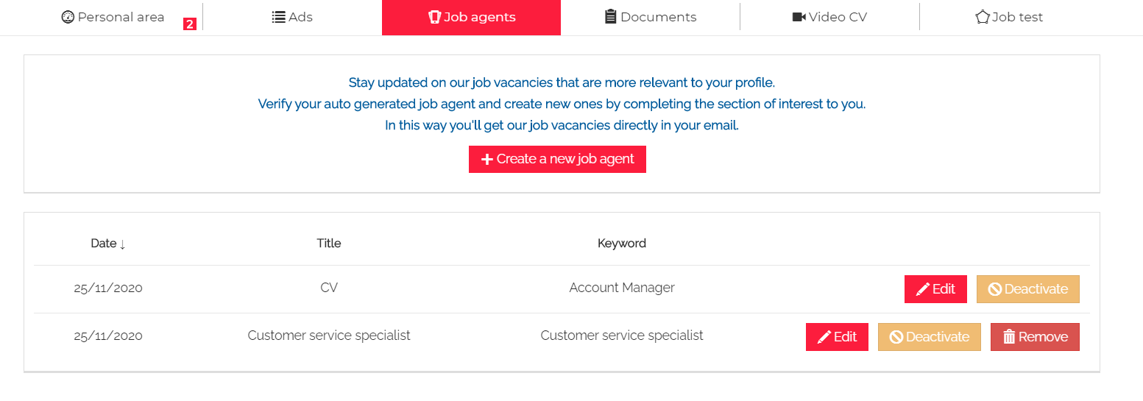

### 4.3. Documents

The candidate can upload files, which can be seen and downloaded from an employer directly into the candidate’s profile. The allowed formats are: pdf, doc, docx, txt, odt, rtf, jpg, jpeg, png, xls, xlsx, csv, ppt, pages, pps, pptx. The maximum size is 2Mb.

If the candidate wants to upload a new document, he/she just needs to click on “Documents” first and then on “Upload documents”.

For each document uploaded, it is possible to:

* Rename the file and add comments (which can be seen from the employer);
* Save changes, by clicking on “Update”;
* Download or delete the file, by clicking on “Download” or “Delete”;
* Filter the file by:
  + tag (the dropdown can be freely set by the admin of the system and can be added on a file only from employers – not from candidates themselves)
  + start/end date, where the timeframe is related to the upload date.

To apply the selected filters, you must click on the funnel button 

### 4.4. Video resume (*ADDITIONAL MODULE)

If the mod “Video” is included in the contract, and if there are enough credits, candidates can record a video resume by clicking on "Record". They can do that in complete autonomy or upon employer’s request.

Before recording, an instruction page is displayed to allow the candidate to test both audio and video on the computer.

After clicking on "Record your Video resume", the candidate must turn on the access permission for both the microphone and the webcam.

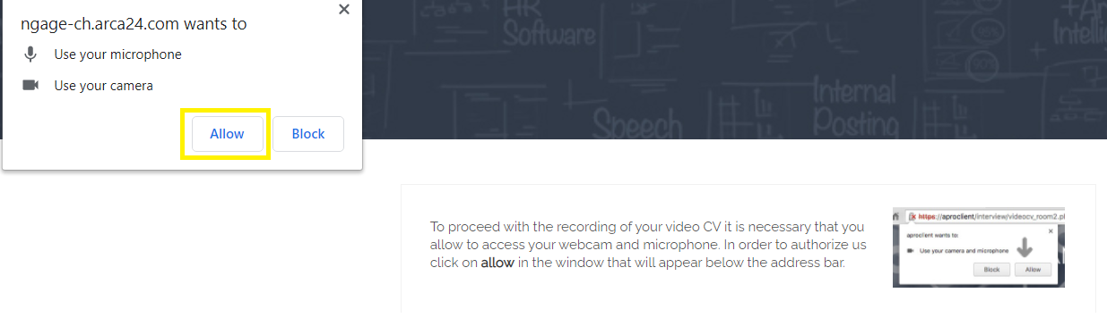The candidate will then see the questions and the time available to answer on his/her device screen. If the candidate answers a question in less time, he/she can click on the button “Stop” to move on to the next question. At the end of the last question, the candidate receives confirmation that the CV video has been completed.

By clicking on "Profile page", the candidate is redirected to the tab “Video resume”, where the following message is shown: “Average processing time: 1 hour”.

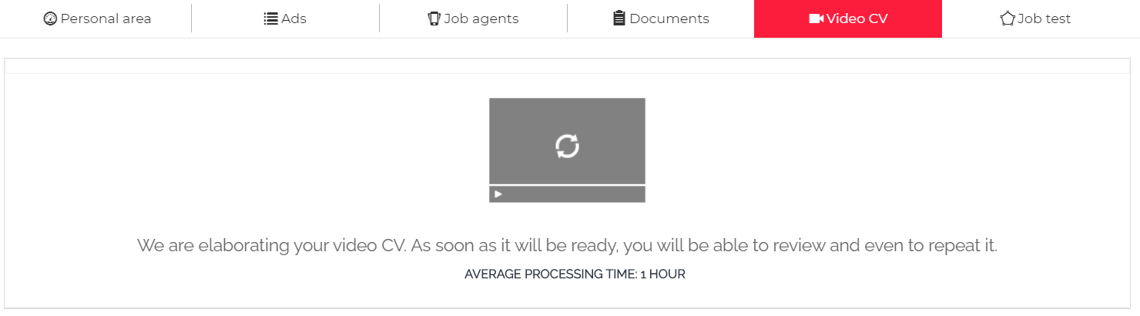

After the video processing, the candidate can decide to record a new video. By clicking on "Record a new Video resume", the previous video is automatically deleted and a new one can be recorded.

### 4.5. Job test

The candidate can take a Job Test in complete autonomy in his/her personal area – or upon employer’s request – by clicking on “Start your Job Test”. At the end of the test, the result is displayed into the tab. The candidate can see the description of each assessed dimension by clicking on the red button "Psychological styles".

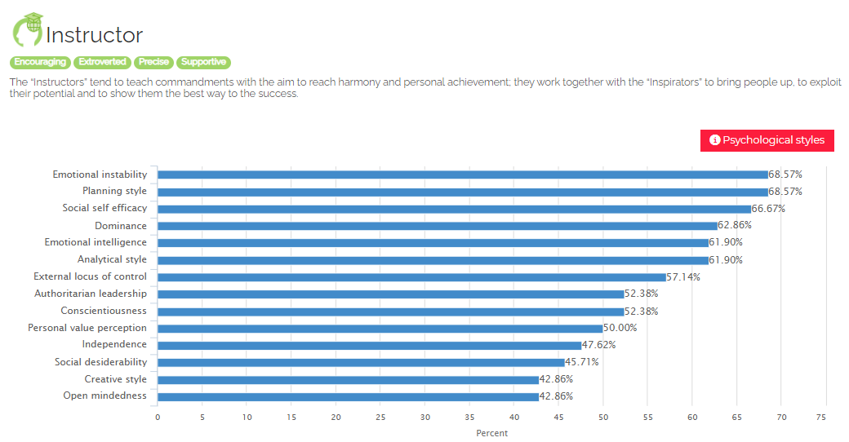

Three months after the test, the button "Repeat the Job Test will be displayed to give the candidate the chance to repeat the test.

### 4.6. Image upload

Candidates can manage their profile image by hovering the cursor over the image frame and clicking on "Edit". They can upload an image, cut/resize and even rotate it. After every modification, candidates always have to click on “Save”.

### 4.7. Account management

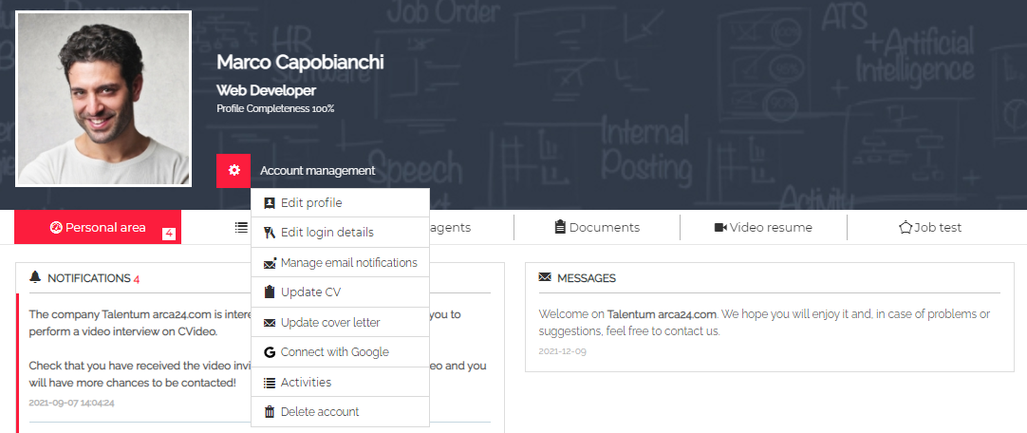

**Edit profile:**It allows to modify the details entered in the application form. (If the profile is incomplete – less than 75%, the candidate will receive recurring emails requesting to complete the profile details).

**Edit login details:**It allows to modify the email address and/or password.

**Manage email notifications:**The standard flags to manage email notifications are listed here below:

* “About the status of my CV”, it allows the candidate to choose whether to receive a few automatic e-mails from the system or not (thumbs down, move to STEP 2 or 3, completion request, reminder e-mails for pending requests).
* “Send me e-mails about new job offers that are suitable to my profile”, whether to receive Job Agent emails or not.
* “I consent to receive electronic communications”, related to the filter "subscribed to the newsletter" that recruiters can use for searches in the database.

**Update CV:** It is possible to edit the CV (language, download/upload files), the experiences (add or delete them) and the result of the CV extraction (text extraction and related professional tags).

If a new CV is uploaded, a candidate can recalculate the tags by clicking on "Recalculate tags". 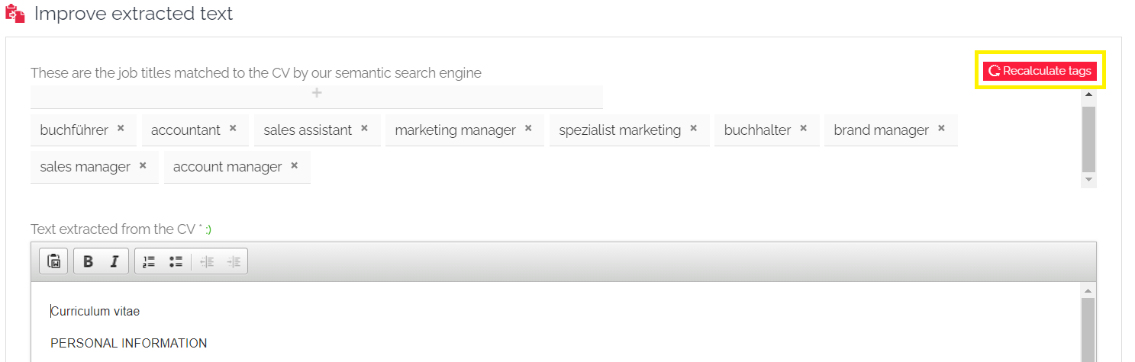

**Update cover letter:** It is possible to add a cover letter through a dedicated textbox. The cover letter will be shown to the recruiter into the Candidate’s profile > Profile > CV.

**Connect with Google:**By entering their login details for Google, candidates can easily log in with these credentials by clicking on the Google button on the login page.

**Activities:**Activity logs carried out by/on the candidate are listed in this section. The candidate can also download the xml file containing his/her data, in compliance with the right of data portability.

**Delete account:** Tab to delete the profile with all the related data and information.

## Mobile version

The candidate's front-end and personal area are mobile friendly.

Compared to the desktop version, in the mobile version you can also share the job ad on WhatsApp and Telegram.

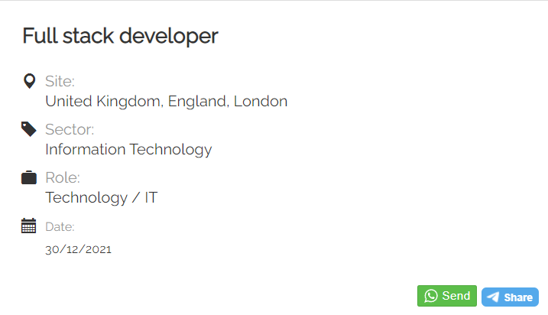

If you send the application from a mobile device, you will see a screen that allows you to enter an email address to receive an email with the link to the job ad, so that you can send the application later.

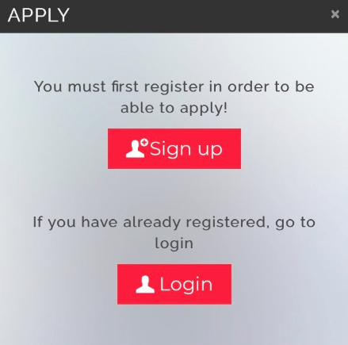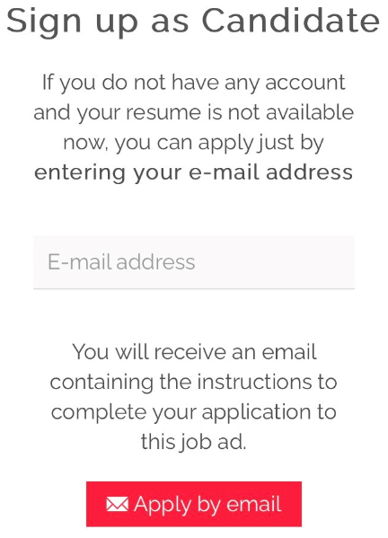

# **LOGIN EMPLOYER**

**N.B.:** When using the software, we recommend not working on several browser tabs at the same time to ensure that all activities are tracked correctly.

## Account management

In this section, you can access your account configuration and other settings. Some functions are visible only when using the admin account or are subject to the activation of specific permissions.

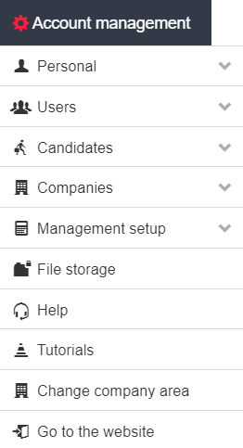

### 1.1. Personal

You can manage and update your profile (overall information and login credentials).

In the section "Edit profile", you can manage your data; "Name in Emails" and "Signature in Emails" allow you to add the name and signature that will be displayed to recipients.

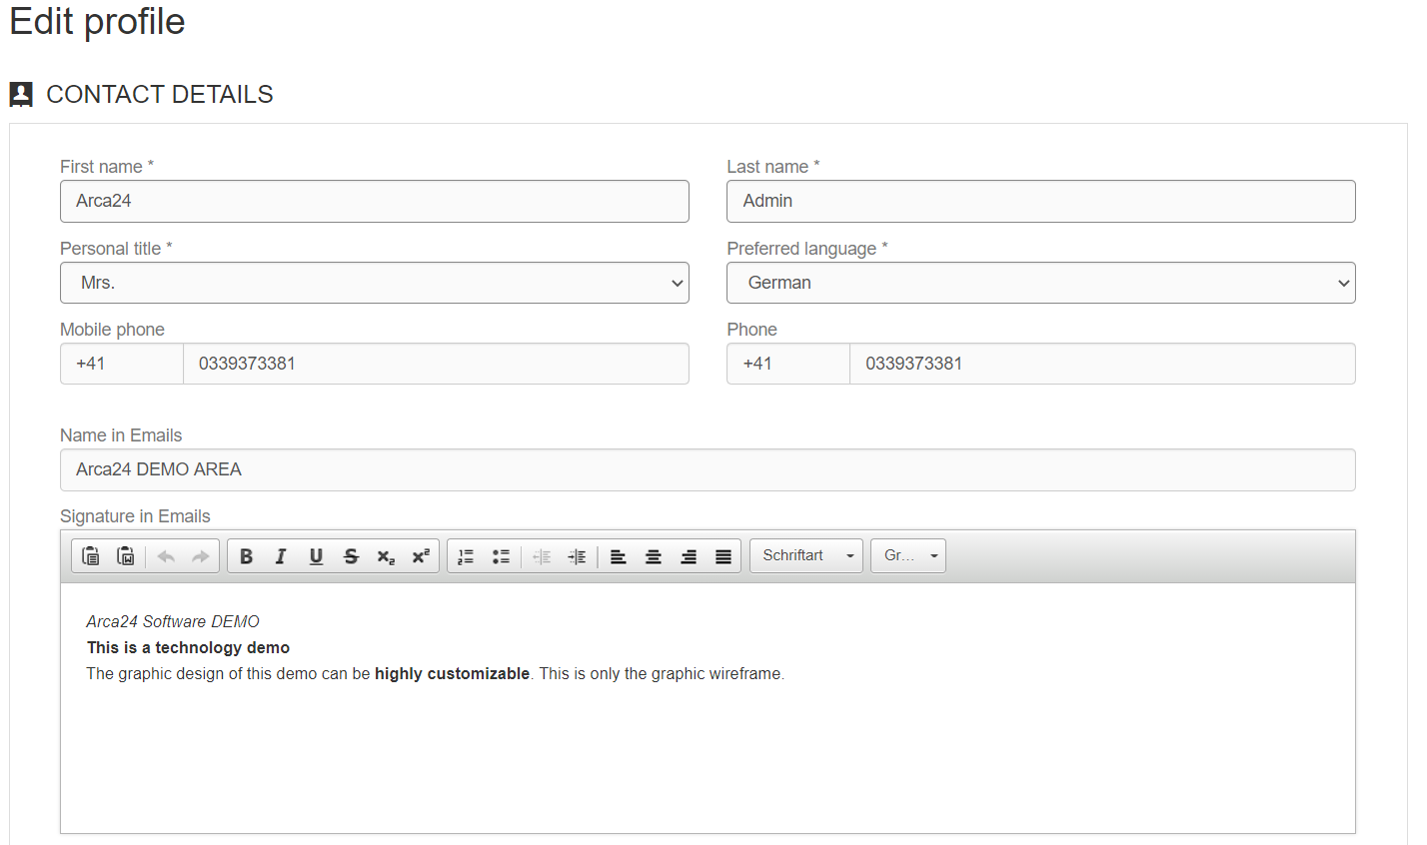

### 1.2. Users

**N.B.:** This section can only be viewed and managed by the admin.

#### 1.2.1. User management

In this section it is possible to add and set a new company user (always pay attention to permissions, sites/users groups and credit distribution).

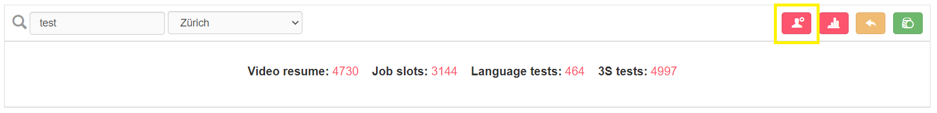

For each user, there are several options available (*Operations)* at the right of their string.

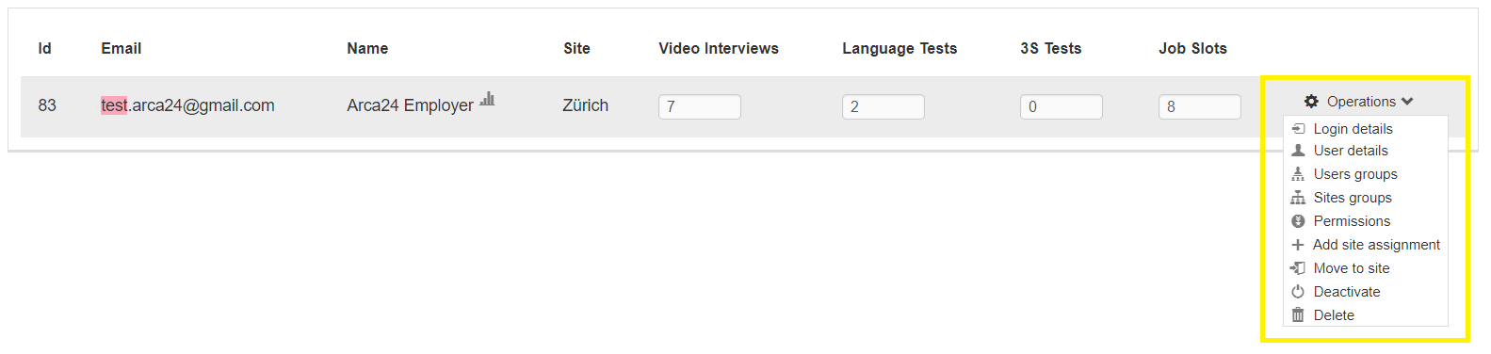

**Login details:**It allows to change the login details (e-mail and password).

**User details:**It allows to view/edit data such as name, surname, preferred language, signature in emails and assignment.

**User groups:**It allows to set the visibility between users (i.e., whether a user can see and manage job ads, researches, agenda and statistics of colleagues). 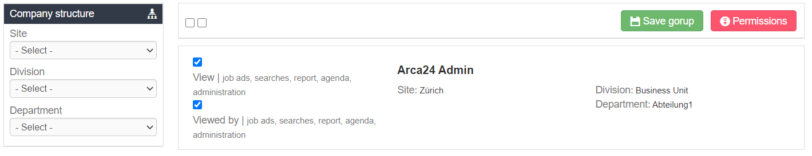

**Sites groups:**It allows to determine whether the user can see and manage job ads, researches, agenda and statistics related to other company sites. (Sites groups preset the visibility on users, which can then be modified to detail the visibility on individual users).

**Permissions:**It allows to determine which functions the user can access or not.

**Add site management:**It allows to assign a user to other company sites (while also **keeping** the previously sites set).

**Move to site:**If a user is moved to another site using the "Move to site" function, the permissions are maintained and the site hierarchy is adjusted to the new one (e.g., A user moved from the Zürich site to the Bern site will automatically have the sites hierarchy set to “Bern”).

**Deactivate or delete?**

By deactivating a profile, with the aim to reactivate the account at a later date, the employer will not be able to access the system with his/her own credentials. Data remain a property of the deactivated user.

Deletion is an irreversible operation. When an employer is deleted, the admin must necessarily assign the data to another employer, selecting the site and the colleague to whom assign the data (activities, job ads, updates, etc.).

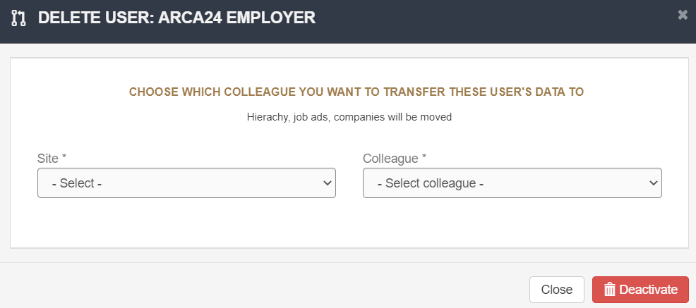

**User statistics**

For each user, it is possible to view statistics about the use of the ATS:

Total ads: number of ads assigned to the user.

Online ads: number of online ads that have the user colleague assigned and percentage on total ads.

Searches: number of free searches carried out in the database.

Searches saved: number of saved searches and percentage on the total number of searches performed.

Last login.

Viewed candidates: number of candidate profiles opened (the same profile is counted only once, regardless of the number of times it has been opened).

Step 2: number of candidates present in step 2 in the ads assigned to the user.

Step 3: number of candidates present in step 3 in the ads assigned to the user.

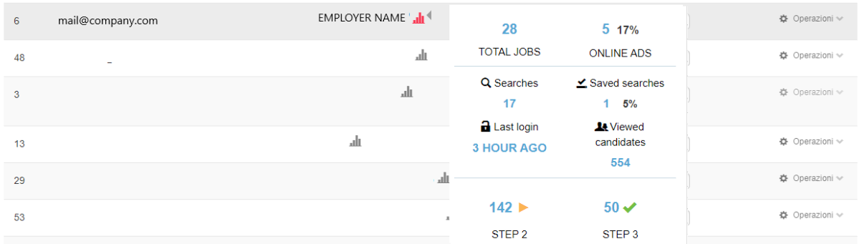

#### 1.2.2. Credits management

For each user, it is possible to distribute video credits, job slots, test credits and SMS credits. Video credits

purchased by package/license can be used for both video resumes and video interviews. To save changes to your credit distribution, you need to click on the green button at the right of the page.

Credits not yet allocated will be visible at the top of the page, and are therefore linked to the admin user.

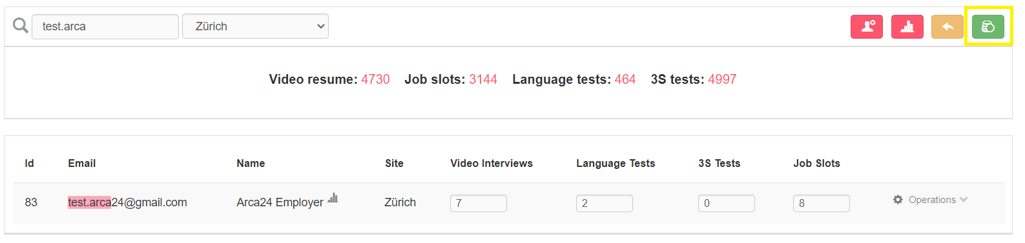

**N.B:** The information about compatibility with the video software is available at the following links: <https://caniuse.com/?search=mediarecorder> <https://caniuse.com/stream>

**Differences between Video resume/Video interview**: The video resume is a video presentation that the candidate can record independently or upon request from an employer. It consists of four questions which are already set, but editable by Admin user in Account management > Candidates > Video resume questions.

Video interviews are linked to a specific selection process; they are set by the employer in the "interview" step. Employers can create the questions directly during the selection process or select a preset template from a drop-down field (See “Video interviews templates” in the section “Candidates”).

**Video credits**:

**Video resume**: Credits are deducted from the total amount of credits shown at the top of the page (whether the candidate makes the video in autonomy from his/her personal area or upon request from an employer. If the candidate decides to repeat the video CV, only one credit is deducted). Therefore, we strongly suggest **NOT** to distribute all the credits, but always to leave some to the admin for CV resumes. An employer with **at least one credit** can view the "Request video resume" symbol in candidates' profile and can therefore send a request to candidates.

**Video interview:** Credits are deducted from those distributed to the employer. Therefore, if you assign 10 video credits to an employer, these can be used to request 10 video interviews. Video interview requests from the admin are deducted directly from the total amount of available credits.

If video credits are not distributed, they remain allocated to the **admin** and can therefore be used for spontaneous video resumes by candidates and/or for admin’s requests, both for sending video resumes and video interviews.

**Deduction of credits for VIDEO INTERVIEWS:** One credit is deducted for each candidate, whether the profile has already been moved to the interview step before or after the opening of the interview session.

If a video interview session is **reopened**:

* All candidates who have not taken the test (even if moved to the selection step) will be able to take the video.
* New candidates moved to the interview step will receive an invitation e-mail.

In both cases, one credit will be deducted for each candidate.

**Refund of credits for VIDEO INTERVIEWS:**

* If **at the end of a session** (automatic or manual) some candidates have not taken the test, the corresponding credits are refunded. The refund is made **immediately** when the session is closed.
* If the candidate refuses to take the test by clicking on "Refuse" on the test access page, the corresponding credit is **immediately** returned to the employer.

#### 1.2.3. Permissions management

In this section, the admin can manage the permissions of all users (helped by the filters on the left). For each user the admin selects the functions he/she can use. It is not possible to set permissions for the admin account: all permissions will always be active.

#### 1.2.4. External portal management

In this section it is possible to enter specific details, which are necessary for the connection between the application and the accounts used to access fee-charging external portals.

#### 1.2.5. Sites, divisions and departments management

**Sites**: It allows you to add company sites and their details – such as name, country, region, city and address. Location configuration should be done during the initial setup or each time a new location/branch is added.

**Divisions**: It allows you to manage the permissions related to each division. When entering a new user, who is assigned to a specific division, the new user is going to have the permissions associated with that division. The admin can edit the permissions of each individual user at any time. After modifying the permissions for a single division, if you want the users in that division to have their permissions updated, you’ll need to click on “Set permissions to the users assigned”. In this way, the permissions are updated for all the users assigned to that division.

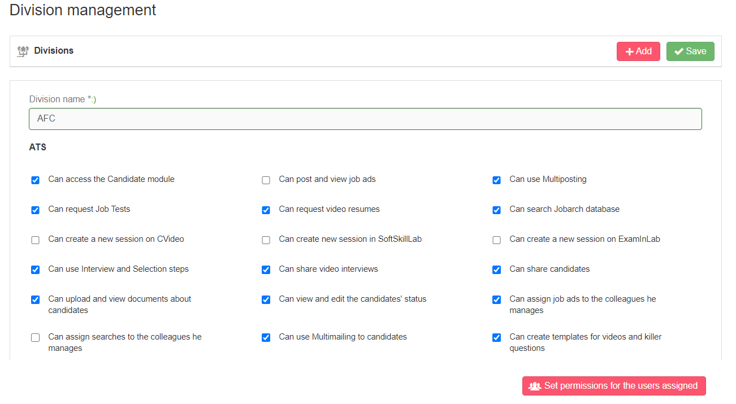

**Departments**: You only need to add a department and associate it with a division.

### 1.3. Candidates

In this section you can manage some settings, which can be useful in the selection process. In particular:

**Candidate evaluation form**: This section allows you to manage the evaluation parameters (title and field type) expressed in the evaluation form in the candidate profile.

**Video resume questions**: This section allows you to edit the preset questions of the video resume.

**Killer questions and video interviews templates:** this section allows you to create video interview templates or questionnaire templates to select in the “Interview” step:

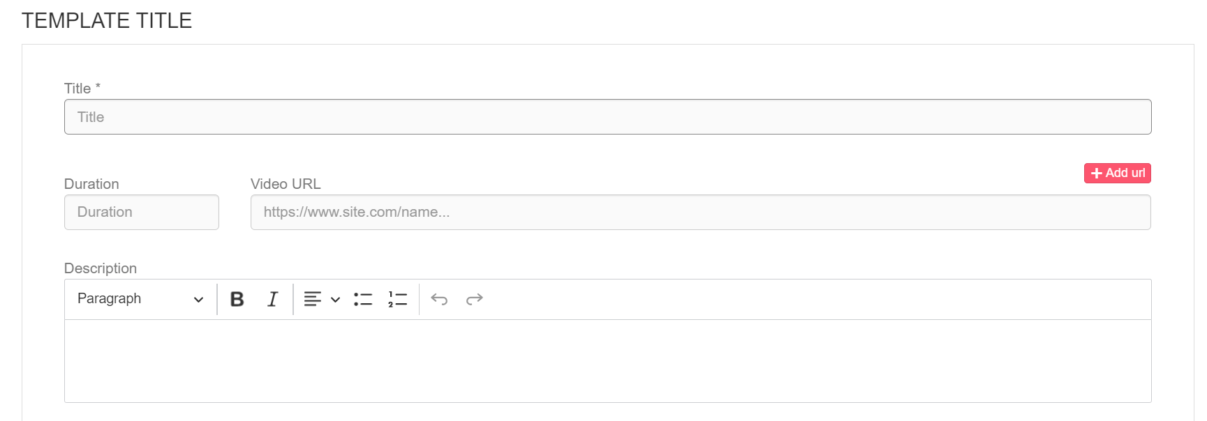

NB: ‘Duration’ field (*optional*): for installations that include it, it is possible to specify the months of validity (1, 2, 3 etc.) of a candidate's score.

If the recruiter decides to send the same questionnaire or video interview template for several advertisements, he/she can specify here the validity period of the score obtained by a candidate who applies to all these advertisements. It will thus be sufficient for the candidate to answer the questionnaire or video interview only once, and the score will also be reported in step 2 of the other advertisements.

**Soft skills templates**: This section is visible only to the admin account. In this section, you will find some pre-defined personality types, developed in collaboration with the Catholic University of Milan. These personality types have been defined on a sample of 100,000 candidates, and are meant to support the recruiter in choosing the right person for the role.

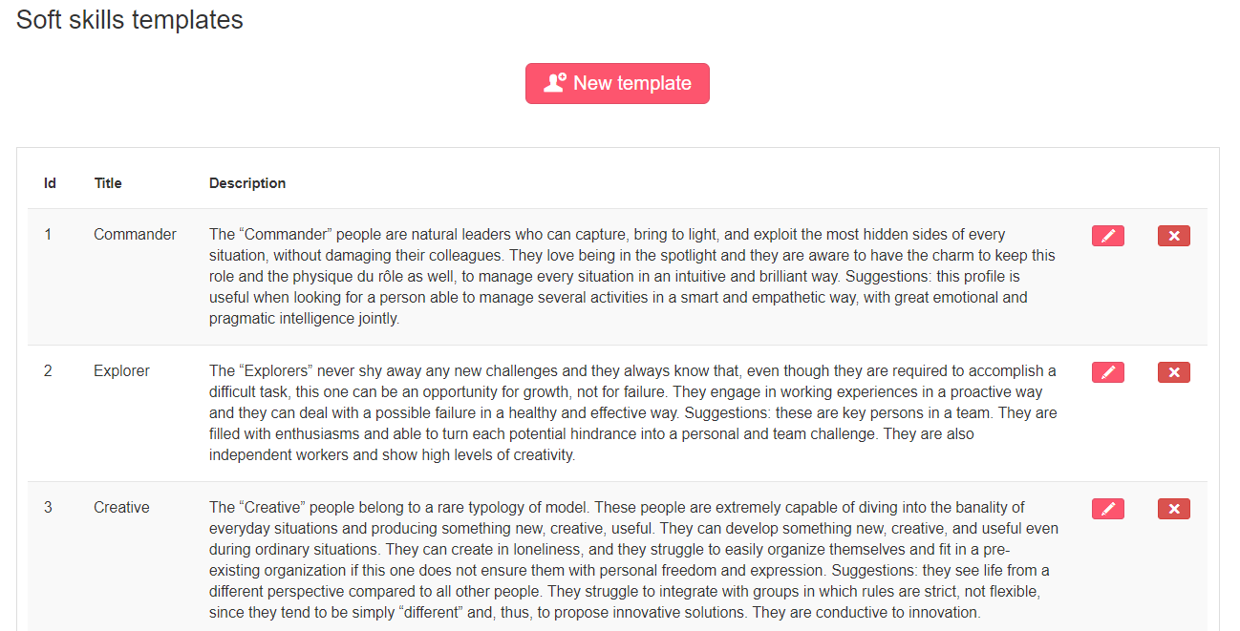

To add a new personality type, simply click on “New template” at the top of the list of pre-defined templates: it is necessary to fill in the title and description and set the parameters of the soft skills attributes by adding the minimum and maximum limits. The new template is taken into consideration only after flagging the option "Active":

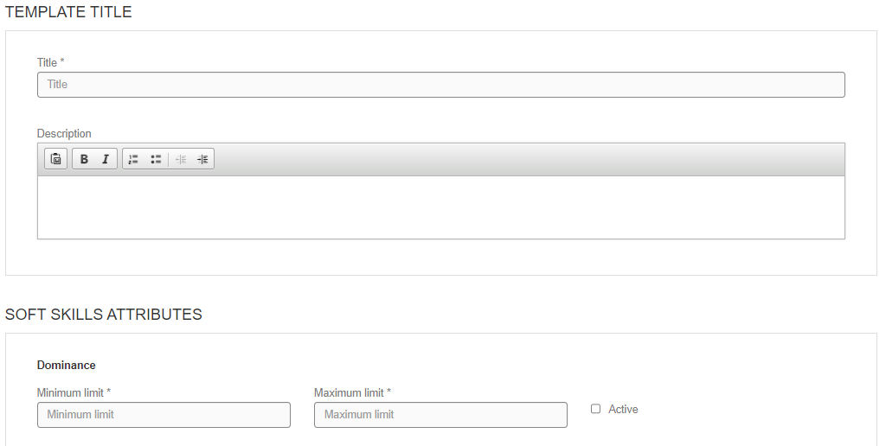

We strongly suggest to use only pre-filled templates, as it takes the expertise of a psychologist to correctly set the parameters of a new template.

**Merge candidates**: This section allows you to merge two different profiles, which refer to the same candidate.

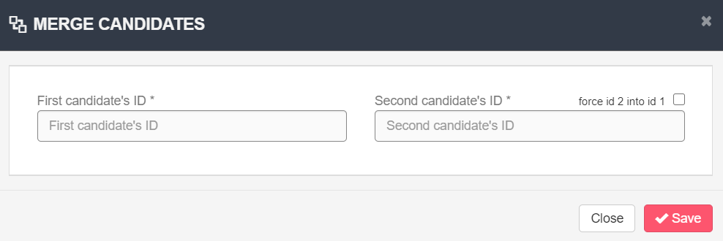

By entering the IDs of the candidates’ profiles, the system compares the last update dates of both profiles, and keeps only the most recent profile. Whenever possible, the information concerning the oldest profile is kept, as in the case of activities, documents and applications to job ads.

If some data are entered in only one profile, the data are saved even if they refer to the oldest profile. For example, if the result of a job test is available in only one profile, this information is kept regardless of whether the profile is the oldest one.

The flag "force id 2 into id 1" results in the merging of the second candidate’s ID into the first one, regardless of the last update. This means that the data concerning the first candidate’s ID are kept, (but all documents and activities still remain).

**Link for anonymous job ad:** A link is generated; it can be copied and pasted in job ads published on external portals (e.g., Indeed, Infojobs, etc.). This link will redirect candidates to the application form without displaying the company name, so that they can register directly to your database.

### 1.4. Management setup

It allows you to set some dropdowns menus according to your needs:

**File tag:** It defines the type of files that can be uploaded on the candidate profile. The file tag can be entered and modified by the employer, while for the candidate it is a read-only information (the candidate sees the tag entered by the employer, but he/she cannot modify it).

**City (*additional module*)**: This functionality is necessary for systems that communicate with a third-party software. From here you can add new cities that are not added in the system by default.

### 1.5. File storage (*ADDITIONAL MODULE)

It allows you to upload files that can be shared with both employers and candidates.

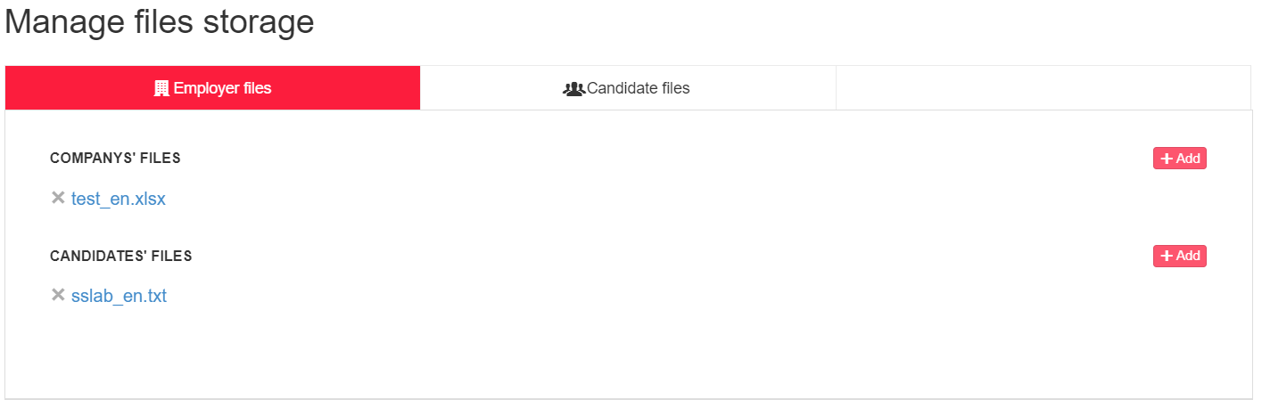

* From this section, employers can download uploaded documents.
* Candidates can do the same from their personal area (Account management > File storage)

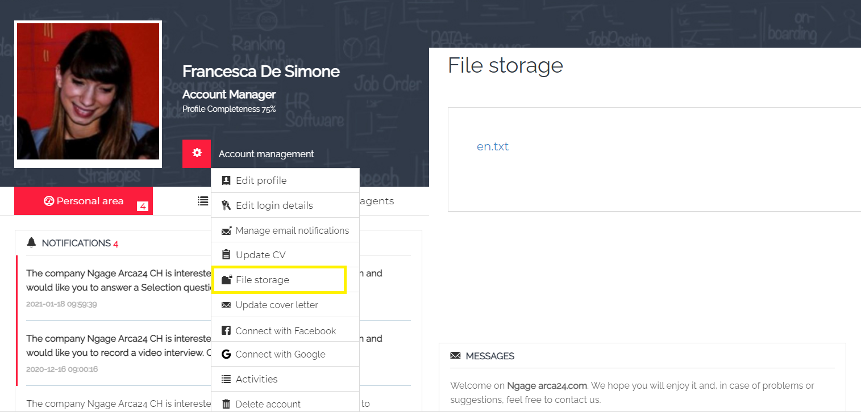

### 

### 1.6. Job ads logo (*Additional module*)

**N.B**.: If the modules “Job ads logo” and “File storage” are both active, “Job ads logo” will be included within the section for archived files.

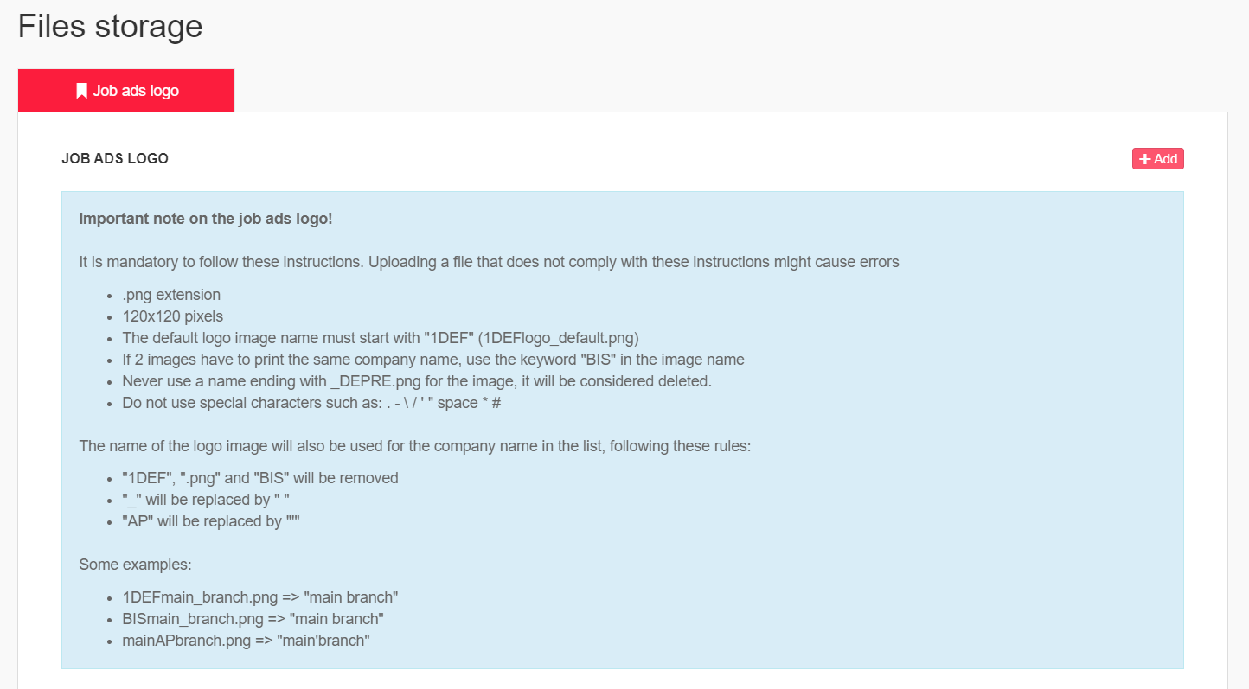

“Job ads logo” is a section that allows you to manage, add and delete in complete autonomy the images that you want to upload in the job ad creation form. The chosen images will be displayed at front-end in the job ads page, next to the job description.

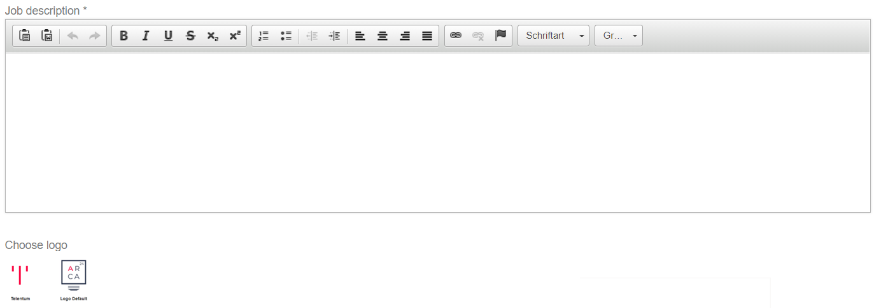

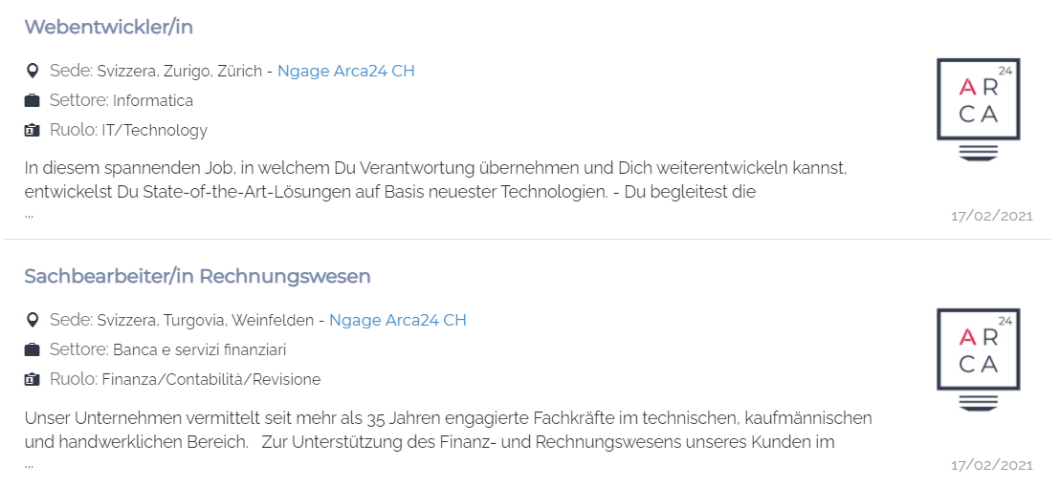

## MODULE AGENDA

It is possible to view the activities entered by you and/or by your colleagues – if you have visibility on them, (use the filters “Site” and “Colleague”).

By clicking on a date in the calendar, you can enter an activity directly from it. It is possible to add two different types of activities: Personal or candidate activities.

Links can be inserted within the activity by clicking on the appropriate button in the bar with the various functionalities. Links should be written preceded by: https://

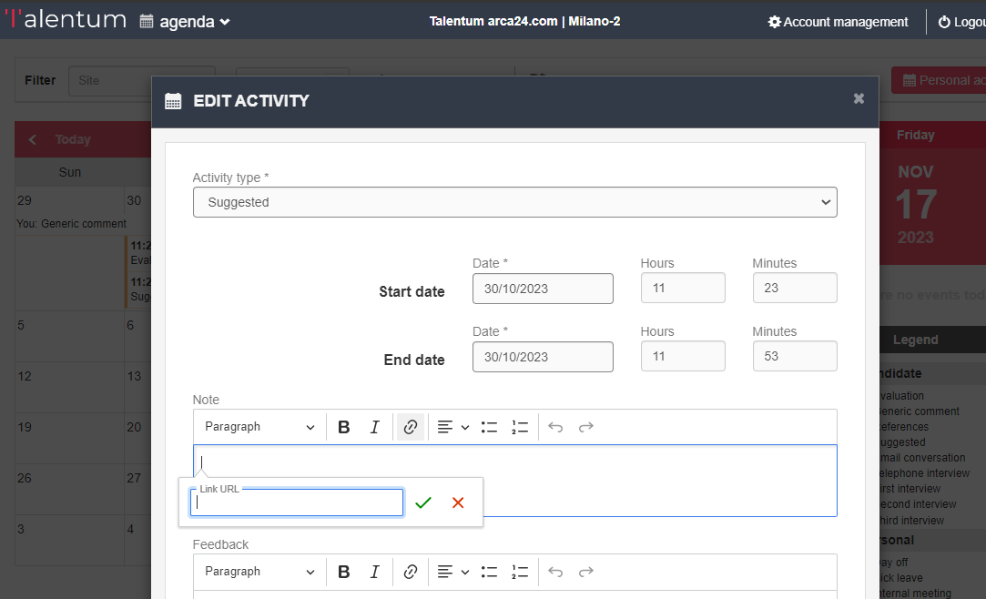

 Once you have entered the activity type, date, time and any comment, you can configure the activity thanks to 3 flags.

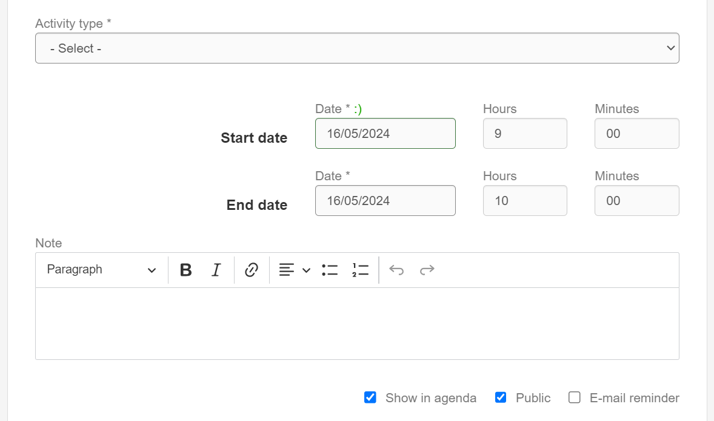

**Show in agenda (with flag) – Public (without flag).** The activity is visible for you in your agenda, but not for the colleagues of your hierarchy in their agendas. The activity is always visible in the candidates’ profile.

**Show in agenda (without flag) – Public (with flag).** The activity is not visible for you and for the colleagues of your hierarchy in the agenda. The activity is always visible in the candidates’ profile. *The activity cannot be visible to colleagues if there is no “show in agenda” flag. This is because the activity must be visible to you in order to be visible to your colleagues too. *

**Show in agenda (without flag) – Public (without flag).** The activity is not visible for you and for the colleagues of your hierarchy in the agenda. The activity is always visible in the candidates’ profile.

**Show in agenda (with flag) – Public (with flag).** The activity is visible for you and for the colleagues of your hierarchy in the agenda. The activity is always visible in the candidates’ profile.

|  |  |  |
| --- | --- | --- |
| **Flag** | **Not marked** | **Marked** |
| E-mail reminder | No reminders sent. | Notification mail sent on the day of the meeting starting from 7 am. The reminder is sent to all involved people **(comments are not visible)** |

**N.B.:** The notification e-mail will be sent according to the following rules (except for custom changes):

1. The employer who entered the activity, and any colleague the activity was shared with, receive the reminder containing all the activities of the day, regardless of the type of activity (i.e., also personal activities);

2. The candidate for whom the activity is entered receives the notification only for activities categorized as “Interview”.

As far as personal activities are concerned, the "show in agenda" flag is not present, because these activities must always be visible to the user.

**Shared activity:** An activity can be shared with colleagues by selecting them from the dropdown and clicking on “add colleague”. A shared activity is also visible to the person it is shared with.

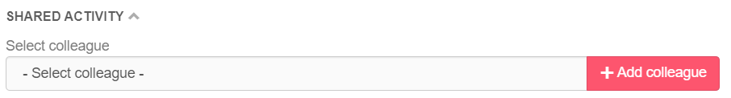

At the top of the page, you can use some **filters** (Site/Colleague), access the ATS (“Search candidates”), add personal activities or even export data within a specific timeframe in **CSV-format**.

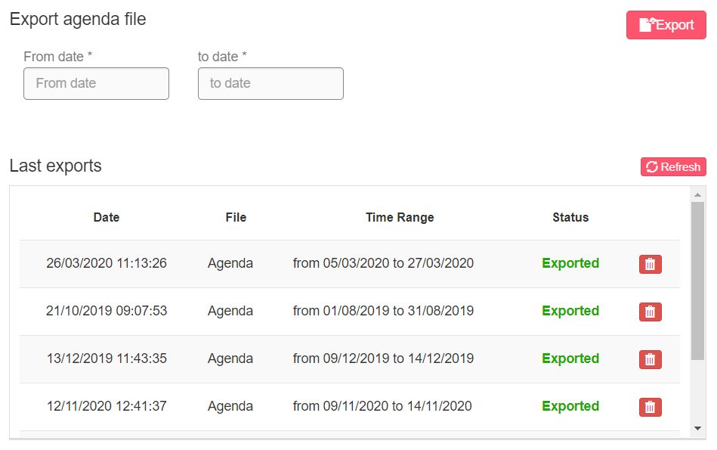

Filter on tasks in the legend: allows tasks to be displayed on the agenda according to type.

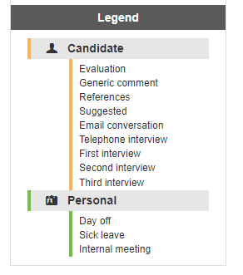

- By clicking on the entry corresponding to an individual task, all appointments corresponding to this type of task will be hidden in the agenda screen.

- By clicking on the title of the two types of activities, all activities belonging to the selected group will be hidden.

- If you wish to display only one type of task, you can hide them all by clicking on the group title and select only one by clicking on it.

Exporting tasks in CSV format takes into account the filters used; the file will only include the tasks visible in the calendar at that time.

Set filters cannot be saved.

## MODULE CANDIDATES

### Dashboard

In this section you have an overview of your candidates’ database, as well as updates about pending requests, and a set of counters (job slots and video credits).

**Quick search bar:** It allows you to search for a job title in the database based on the selected location and km radius. You just need to click on the button “Find” to start the search.



**Evaluation results:** if you got candidates replies to tests or new feedbacks on shared profiles, the box shows the links to their profiles. Next to the title “Evaluation results”, you can see the number of responses that have not been opened yet. Each candidate string not yet opened is highlighted in red. If you click on the profile, from any process, the notification will be set as read.

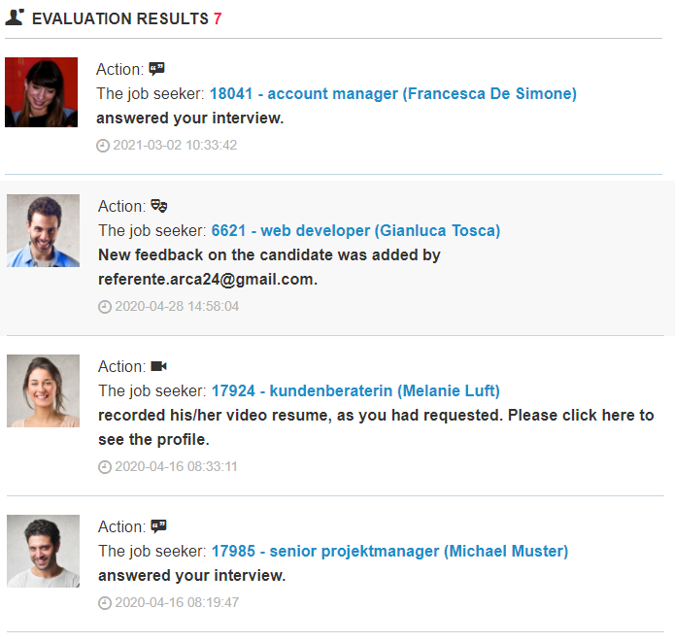

**Box “Candidates”:** It allows you to display your candidates’ database (the data is saved in a temporary memory and updated on the software every 5 hours).

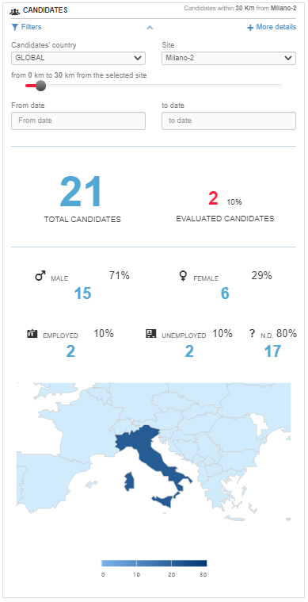

By clicking on "Filters", you can view and set the geographical filter according to which the candidate details will be displayed. The filter "Country of candidates" determines which country is taken into consideration (based on the "Country" field entered by the candidate in the form); the filter "location" is used to determine the center of the kilometer radius. In order to have the data referring to the whole system, you need to select "Global" as candidates' country and "All" as site. "From date" filter "to date" in the Dashboard enables to show candidates in the selected time range based on the registration date.

By clicking on "More details", you can view a chart referring to: traffic sources, age, education level, job seekers per role, job seekers per job sector. In each of these cases, it is possible to extract the charts in different formats (PNG, JPEG, PDF, SVG, CSV, XLS). In the last two charts, you can also exclude some columns by clicking on them.

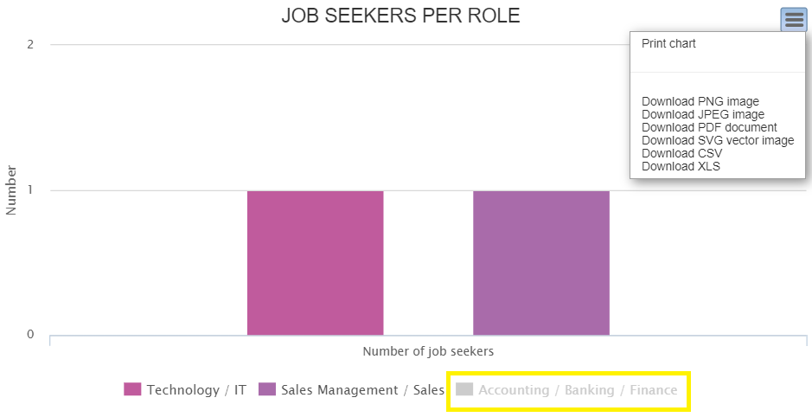

**Box “Counters”:** It allows you to check the different counters related to:

* Your **job ads.** If you click on “More details”, you can see where your job ads are geolocated;
* Your **video credits** (remaining and used);
* (*If a maximum number of CVs is included in the contract*), the remaining **CVs** and those currently available in the database. The number of remaining CVs in the database will turn red when 90% of the total number provided for in the contract is exceeded.
* Total **emails** sent today.

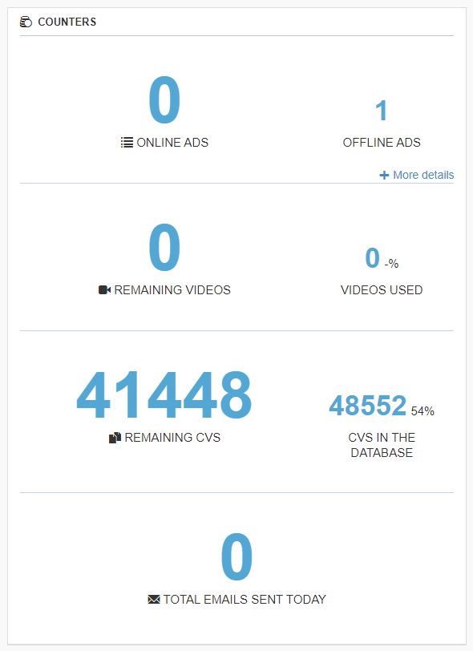

### Post ad

In this section you can easily post a new job ad.

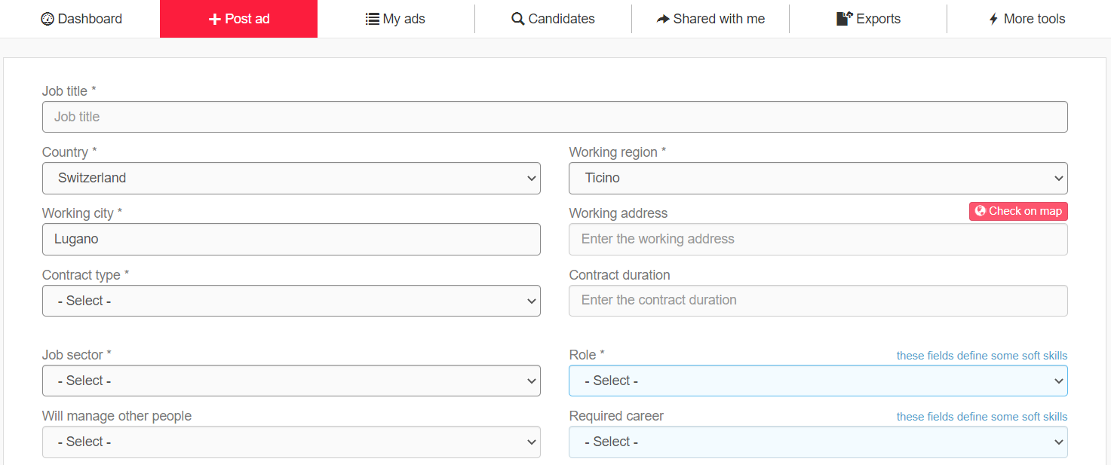

The fields “Job title”, “Job description” and “Required skills” are used to **extract the professional tags**, which are then read by the semantic search engine. The job title and job description of the ad are analyzed according to the preferred language of the employer (Account management > Personal > Edit profile > Field “Preferred language”). In the field “Job title”, only the **job title** must be entered in order for the semantic engine to obtain a more precise result. Any other information (which can be entered in the other fields) could alter the professional tags extracted. In the field “Job description”, it is important to list the tasks related to the job ad.

The fields related to the **glocalization** (“Country”, “Working region”, “Working city” and “Working address”) are filled in by default with the employer's location. These fields are essential as they allow the proper glocalization of the job offer and, therefore, the search for matching candidates. Geolocalization can be checked using the button “Check on map”; it is always suggested to do this check before posting the job ad. If you do not want to enter the work address, you can leave the field empty and the geolocalization will be done starting from the city center.

**“Upload attachment”** to insert downloadable files attached to the job offer. You can attach images in .jpg and .png format. The image must be less than 100 KB, preferably short and wide. In this way, it will be inserted directly in the front-end between the title and the description of the ad.

**\*Optional* "Automated interview"** allows you to invite candidates to the video interview/questionnaire at the time of the application. The applied candidates will then be moved directly to step 2 and will receive the invitation email. After flagging, you must go to step 2 to create the video interview/questionnaire session.

**\*Optional* "Automated Job Test"** allows you to invite candidates to the Job Test as soon as they apply.

**\*Optional* “Automated Video Resume”** allows you to invite candidates to video resume as soon as they apply.

**\*Optional* “Expiration date”**: date on which the ad will be automatically set offline.

The fields “Role” and “Required career” define the job test profiles:

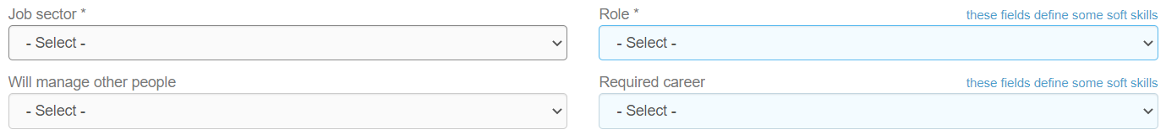

It is necessary to fill in these fields so that the field “Soft skill” will be pre-filled automatically with the related soft skills’ template:

The box **“Candidate’s goal”** includes data that will not be published on the job ad (and it is therefore visible to employers only). This section allows you to pre-select filters that will be set on matching candidates.

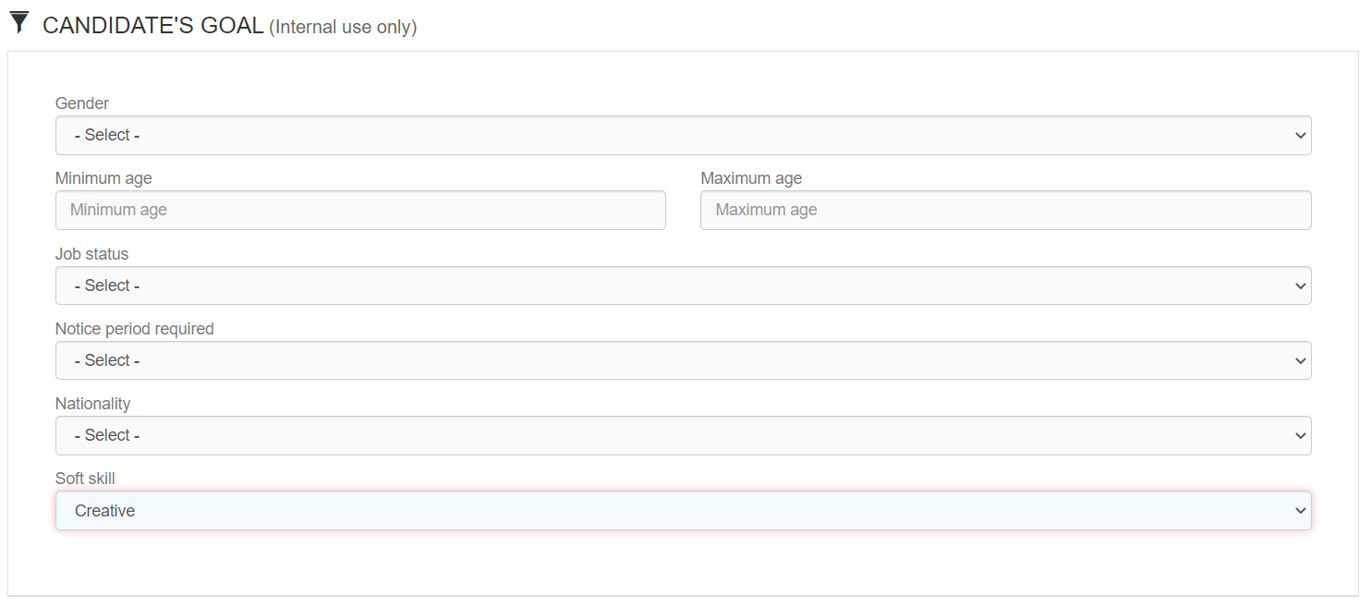

**"Email frequency"** determines how often the employer to whom the job ad is assigned will receive an email containing new matching profiles. If the employer logs into the system every day and selects "daily" on the frequency fields, no mails will be sent to him/her, since notifications are set up in the system showing new matching candidates.

By clicking on “**Preview**”, you can see how the job ad will be displayed to candidates. By clicking on “**Create**”, the job ad will be published on your career site and the multiposting screen opens up automatically. (See “Multiposting” in the section “Online ads”).

### My ads

This section allows you to manage all the published job ads (online and offline).

Online ads are automatically moved to the archive three months after the date of **last modification**. Job ads in the archive are permanently deleted 12 after months of being offline.

#### Online ads

This section displays all currently online job ads:

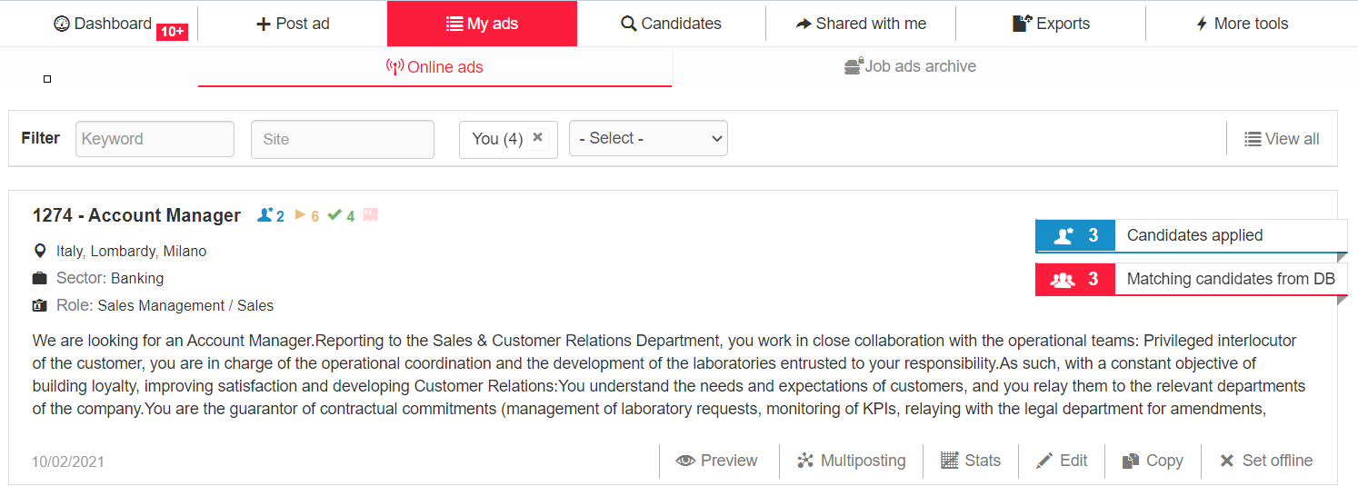

Next to the title of the advertisement are several icons (available on request) expressing certain activities performed on candidates in that selection process (described in section 3.3).

**The following filters are available:**

**Keyword**: This filter allows you to search by exact word in ID and by whole or partial word in job title, working city and job description (it is not possible to search for country, region, sector, role). If you search for “man”, results that have the letters “man” will be shown as well (e.g., Manager). In such cases, it is useful to insert spaces before and/or after the word for more specific searches.

**Site**: Filter by location according to “Site groups”. If a user does not have visibility on a specific location, this user will be able to view job ads associated to that location in read-only mode, without the possibility to manage them (however, this user can always manage his/her own job ads).

**Colleague**: Filter by employer according to “Users groups”. In order to display a colleague in the filter, that user must have published at least one job ad.

**New candidates:** filter allowing you to choose whether to display all job offers or only those with new applications not yet displayed.

The date displayed bottom left refers to the last update date.

**Preview:** you can preview what the job ad will look like to candidates, once published.

**Multiposting:** Multiposting is the tool that allows you to publish job ads on external job boards and aggregators. You can publish your job ads on free job boards (organic feeds), payable job boards or social networks (a post is generated). You just need to select the job boards and/or social networks where you want to publish your job ad. If you set a job ad offline in the system, that job ad will be set offline on external portals as well (deletion time may vary according to each organic feed).

In the Multiposting window, a message is displayed next to each job board flag: Online ads sent to this job board: <number>. The message is also shown for the cumulative flag “All Organic feeds”. The number shown corresponds to the active flags for the employer assigned to that advert and the counts are made only for online job offers.

N.B.: The number is not indicative of actual publications of the offers on the job boards.

The following are visible next to the Multiposting button: *Status on infojobs*: Only in case of subscription with the portal, here you can see the status of the jobs in Infojobs

Number of portals: indicates how many flags are active on the Job boards in the payable job boards section.

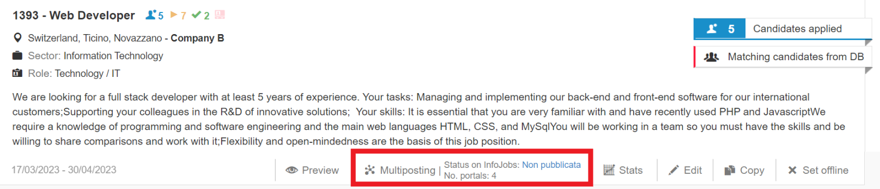

**Stats:** these statistics refer to each single job ad. They are based on **registered candidates** and are related to: gender, job status, country, traffic sources, age, education level, job seekers per role and per sector. Each chart can be exported in different formats. The interface is the same one used for the charts available in the dashboard.

**Edit**: it allows you to edit a job ad.

**Copy**: it allows you to copy a job ad and to add a new one with the same information (without the need to create it starting from scratch).

**Set offline**: it allows you to set a job ad offline and to move it in the archive.

#### Job ads archive

This section displays all offline job ads:

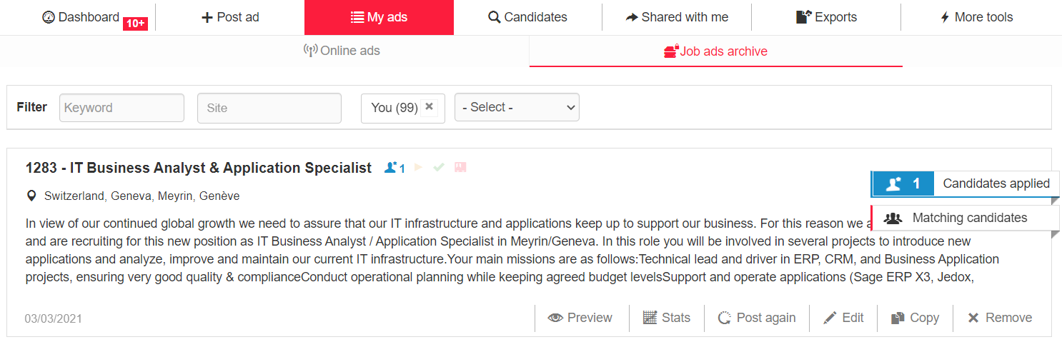

Compared to online jobs, here you have additional options:

**Post again**: it enables you to post a job ad again. In this case, the multiposting settings will be maintained; therefore, if you want to check/change them, you need to use the multiposting option on the job ad only after reposting the ad.

**Edit**: it enables you to modify the job ad.

**Remove**: The job ad will be fully deleted.

**Candidate counters**

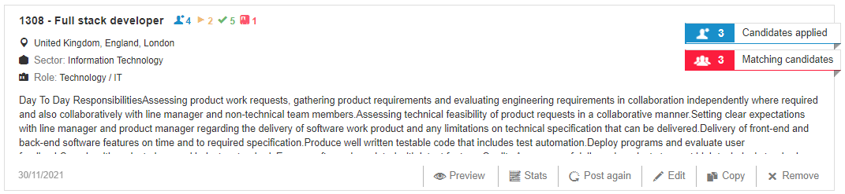

The icons next to the job ad title are the counters referring to candidates who applied for the job, candidates in the interview step, candidates in the selection step and candidates hired. The counters are dynamic and updated in real time, except for the icon showing the number of applicants, next to the job ad title. It can take up to 4 hours for this counter to be updated. For example, the numbers of counters vary if a candidate unsubscribes or if profiles are moved within the three steps.

Number of candidates who applied for the ad

Number of candidates moved to the Interview step

 Number of candidates moved to the Selection step

 Number of candidates hired

### Recruitment step

#### Candidates applied and matching candidates from DB

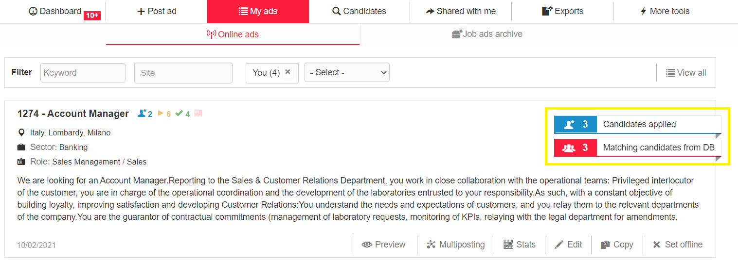

Within the section *“Candidates Applied”*, all candidates who applied directly to the job ad, whether from the career page or possibly from external job boards/aggregators, and candidates who have been added manually to the recruitment process are listed. In the standard version of the software, it is not possible to use filters within this section.

If you have the filter "Order by" in the section “Candidates applied”, the candidates are sorted by **date of registration** in the database.

To see the candidates who have applied for the given job by date of registration (from the most recent to the oldest), you have to use the filter sorting by "**Update date**". Indeed, in this section, the sorting by update date takes into account the **date of application** for that job advert. In searches, instead, it takes into account the update date of the CV or professional profile, which is also printed in the candidate preview.

Within the section “*Matching candidates from DB*”, you will see all the candidates extracted from the system who meet the requirements of your search, including those who have directly sent an application.

The number shown on the flashing label refers respectively to new applications and matching candidates. These labels stop flashing as soon as they are clicked by the user assigned to the advertisement, who then accesses the corresponding sections.

##### **Candidate icons**

Within the candidate string, you can view different labels or icons, which convey relevant data/information about the candidate they are referred to.

* **“New!”(** **):** This icon refers to new candidates in the database or who applied to a specific job ad. This icon will remain visible for three days from the last update of candidate's profile, regardless of when the candidate’s profile was opened.
* **Disadvantage conditions** () [Only for Italian installations]: as established by the Italian [Ministry of Labour](https://www.lavoro.gov.it/notizie/Pagine/DM-Individuazione-dei-lavoratori-svantaggiati-e-molto-svantaggiati.aspx), candidates with at least one of the following characteristics:

- over 50

- between 15 and 24 years old

- those who have not had a regularly paid job for at least 6 months

- those who do not have a high school diploma

- those who have been unemployed for at least 24 months

* **Protected classes** ()[Only for Italian installations]: if the "Protected classes" field is present in the candidate form and the candidate selected
* **Hired:** Hired candidates () or Ex workers (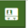).
* **Applied candidates:** Candidate who was manually added to the recruitment process (), Candidate who applied directly to a job vacancy ().
* **Highlighted (****)**: Candidate marked as “highlighted”.
* **Irrelevant (****)**: Candidate marked as “irrelevant”.
* **Job test (****):** Candidate who carried out the job test.
* **Soft skills compatibility (****):** Candidate's soft skills matching those required for the job (> 60%).
* **Updates** **(****):** Candidate who updated his/her profile after having received an update request from the employer.

##### **Candidate string and preview**

##### 

The candidate string displays the candidate’s ID and the job title. Whenever available, you can also see the following information:

* Name and surname
* Mobile phone
* Email (from the icon near the email address, you can directly send an email to the candidate)
* Sector
* Role
* Working status
* Age
* Gender
* Nationality
* Domicile country, region and city
* Newsletter (only if consent to receive communications has been given)
* Last update date
* Source

If you hover the cursor over the job title, you can see an additional section with:

* Distance from the workplace
* Languages
* Compatibility percentages

**Compatibility**. It is the overall compatibility for each candidate, given by a weighted average between hard skills compatibility (with a higher weight) and soft skills compatibility.

**Soft skills compatibility.** It is the compatibility related to the soft skills of each candidate. It is calculated according to the template pre-filled in the job ad or to the one manually selected in the filters as well as the candidates’ job test result.

**Hard skills compatibility.** It is the semantic compatibility for each candidate. The compatibility calculation, although much more complex, can be explained as follows:

* 40% derives from the job title (i.e., comparison of the main profession indicated by the applicant on the application form and the job offer title);
* 20% derives from the keywords in the CV as full text (i.e., comparison of the text extracted from the CV, working experiences entered by the candidate, job description and required competencies entered in the job ad creation);
* 40% derives from the semantics analysis (based on the extract text of the CV, working experiences entered by the candidate, job description and required competencies entered in the job ad creation).
* Experiences (matching tasks, parsed CV, CV extraction).

In the candidate string, hovering over the activity calendar icon opens a pop-up displaying the activities entered on the candidate and a specification on the motivation notes entered on the candidate marked as Irrelevant.

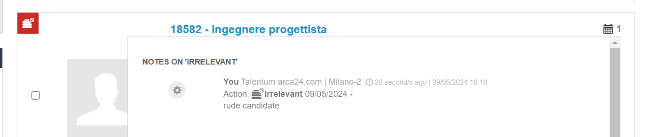

Regardless of the step the candidate is in, by hovering over the calendar icon in the candidate string, you will see a tab containing a preview of the evaluations entered on the candidate, as well as a preview of the activities performed on the same candidate. In other words, if the candidate has at least one saved evaluation within the evaluation forms (evaluation form, technical evaluation form - for customers with the latter), the last saved evaluation entered on that candidate will be visible in the preview, without having to open the candidate's form.

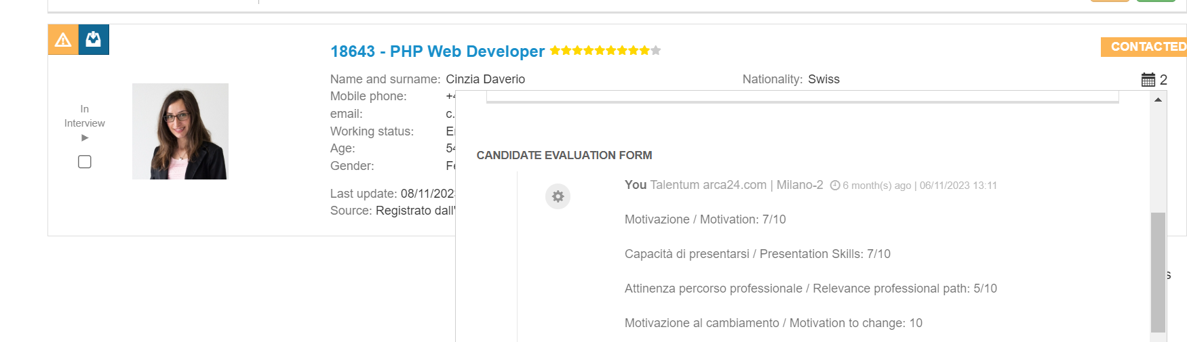

#### Job titles

In the section related to **matching candidates**, it is possible to check and manage the professional tags automatically extracted from the job description through the semantic search engine.

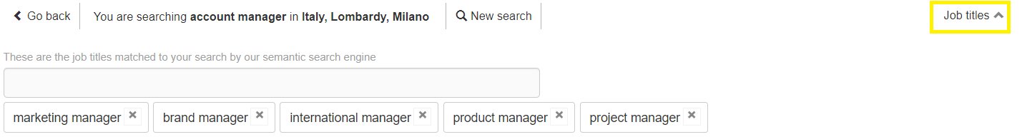

Once you have published a new job ad, it is very important to check this section. The recruiter can delete and add new professional tags considered suitable for the research at any time; just consider into that the more tags are selected, the more difficult it will be to have a candidate who achieves a high score in the compatibility percentage.

In the curriculum preview, you can view the subdivision made by the CV parser; the links allow you to quickly move the display between the following sections: matching tasks, parsed CV and CV extraction.

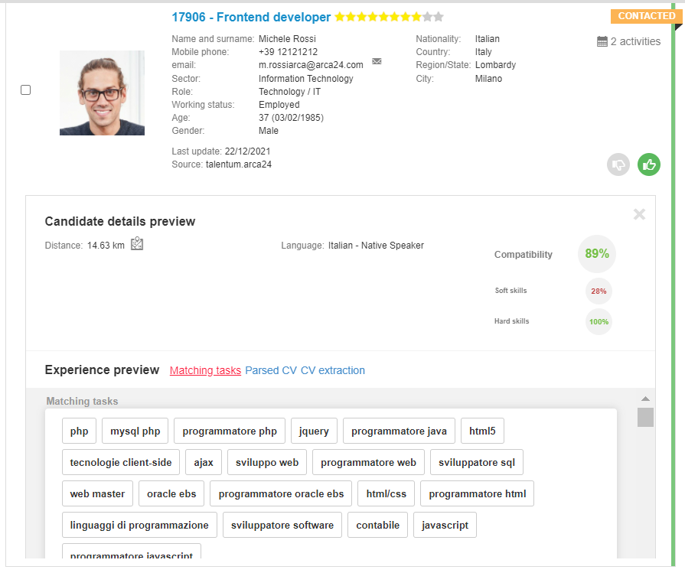

#### Filters

Within the section for matching candidates, there are filters that allow you to reduce or increase the pool of candidates to be considered for the selection process.

After setting the desired filters, just click the button for starting the database search:

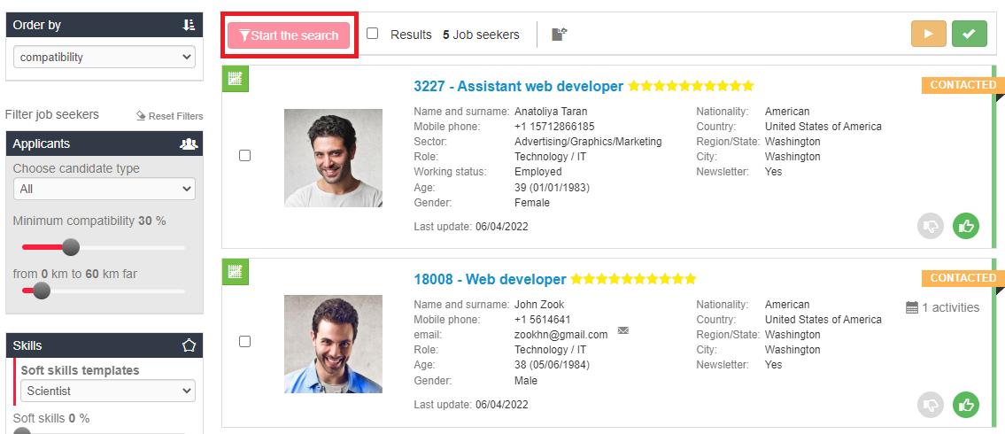

**Ranking:**

* by compatibility (highest to lowest percentage)
* by registration date (from most recent to oldest)
* by last update date (from most recent to oldest)
* by distance (from nearest to farthest)
* by stars (decreasing candidate's rating)
* by thumbs (green thumbs, unmarked and red thumbs)
* by age (from the youngest to the oldest)
* by grade (only for software versions with the field “grade” in the candidate form*): can only be applied if the filter on **education level** has been entered. This is useful for searches where a diploma/graduate degree is a preferred requirement.

**Candidate type**: all matching candidates or just those who applied to the job ad (among the matching ones).

**Minimum compatibility:** 30% by default; it can be lowered to increase the candidate pool or raised to reduce it.

**Km radius:** 60 km from the workplace by default; as in the case of minimum compatibility, it is used to increase/decrease the number of resulting profiles. 

**Skills**: it allows you to select a soft skills template as well as the percentage of compatibility of soft and hard skills. **N.B.:** a candidate can match even if he/she has a different template from the one selected in the job test.

**Filter for exact word in CV**: the search works in relation to CV extraction, candidate’s working experiences, candidate's first and last name and candidate’s job title. It is a Boolean search, based on AND/OR principles.

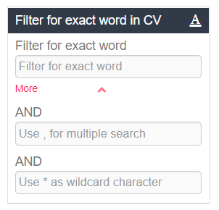

**AND:** it allows you to search for candidates who have **all** the entered exact words in their CV. You can use up to three text fields (the other two are shown by clicking on "More"). Each word must be entered in one field. E.g., first field "programmer", second field "software" -> the system will show only candidates who have entered both words.  
**,** (Corresponding to **OR**). It allows you to search for candidates who have **at least one** of the entered exact words in their CV. E.g., "programmer, musician" -> the system will show candidates who have entered the word "programmer" and those who have entered the word "musician" (or both of them). The comma can be used as an “OR” in each of the three filter fields.

**\*** (Corresponding to a **wildcard character**). Each asterisk replaces a character within a word. E.g., wom*n -> the system will show both candidates who have entered “woman” or “women”.

**Filter for exact word in activities:** search in comments and feedback on manually entered activities and in evaluations. It does not work on the type of automated activity or on feedback entered when sharing a profile. Boolean search is possible as in the case of the keyword in CV.

**Professional details**: These filters correspond to the fields filled in by candidates when registering into the database.

**Language skills**: These filters correspond to the language fields filled in by candidates when registering into the database. You can use the icons to select the corresponding level (“equal to”) or the minimum level required (“equal to” or “more than”).

**Education**: These fields correspond to the education fields filled in by candidates when registering into the database. You can use the icons to select the corresponding level ("equal to") or the minimum level required ("equal to" or "more than").

**Personal details:** Some of these filters can be pre-selected when posting the job ad in the section "Candidate's goal". As an example, the filter by date of birth is useful in cases where it is necessary for the candidate to be of a certain age on the date of contracting (e.g., for apprenticeship contracts). Both filters include the date entered.

**Company structure:** (*additional module*). It allows you to filter by site, division and department associated by recruiters to the candidate profile.

**Candidates’ history:** This filter is used to show candidates who have been moved to step 2 or step 3 in other selection processes. If you set sector and role for the job ad you are interested in, the system will show you the candidates who were moved to step 2 and/or 3 **in the last job ad** with that sector and role. By using the thumb filters, you will be able to see, for each step, the candidates who have received a thumbs down/up or who have not been marked.

**Activities:** These filters allow you to search by type and date of activity as well as by employer who entered the activity or the evaluation (in the proper form within the candidate profile).  
**Status**: This filter allows you to select candidates based on their status (not worked, contacted, interviewed, in presentation, onboarding).

**Hide deleted candidates:** flag selected by default, allows logically deleted candidates not to be displayed in the search result.

**View irrelevant too**: This flag is marked by default to display in the search results candidates who have been set as irrelevant too. If the flag is not marked, irrelevant candidates are not displayed.

**View only highlighted**: If the flag is marked, the system will display only matching candidates who have been highlighted.

**[FOR DATABASE RESEARCHES ONLY]** **Spontaneous applications**: If the flag is marked, the system displays candidates who did not send any direct application for jobs, i.e., who have only spontaneously registered to your database.

**Subscribed to the newsletters**: This flag is linked to the one marked by the candidate when registering into your database ("I consent to receive electronic communications"). This filter can be used when sending a multimailing to candidates.

**See disadvantaged candidates only**: (*Additional module*). This flag can only be used if the proper field has been provided in the application form and allows only disadvantaged candidates to be displayed.

**Source**: This filter allows you to select the source of the candidate's application.

**Login date from/to:** This filter allows you to select candidates based on the login date.

**Update date from/to:** This filter allows you to select candidates based on the update date.

**On board:** This filter allows you to select candidates based on their on-board status (hired, never hired, ex worker).

**Candidates you like:** This filter allows you to select candidates based on the evaluation through thumbs (thumbs up, thumbs down or not marked) in each specific research/selection process.

**Save search**: This filter allows you to save the filters you set.

At the top of the Recruitment page, the "**Back to job ad**" button allows you to return to the list of job offers filtered by the ad in question. This option allows you to return more quickly to the single job posting string, where you can view all the edit, offline and multipost window options. This function is also very useful when you can directly open the link to the job offer to which the candidate applied from the candidate's profile; the "Back to job ad" button takes you back to the menu for modifying the announcement itself.

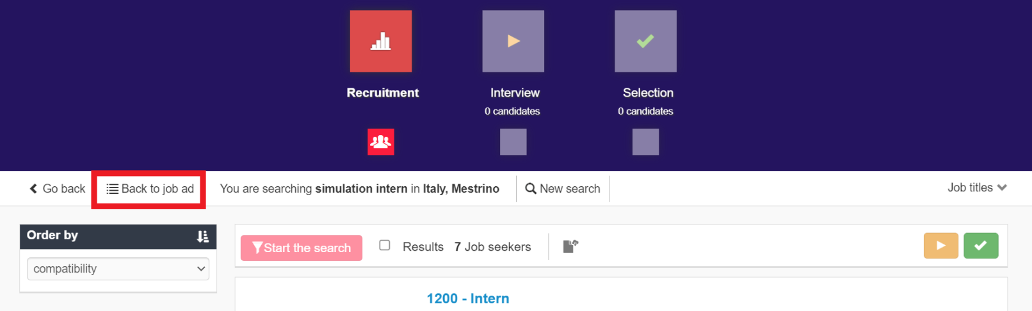

In all searches where the results are divided into several pages, you can display all result pages and select the page to be displayed, so that you do not have to scroll through the pages one by one.

Below are the sections concerned:

- job list (candidate side);

- step 1 jobs/candidate searches.



The page with the darkest colour is the page being displayed at that moment.

#### Mass actions

Within the recruitment steps, it is possible to carry out mass actions by selecting the candidates concerned. Mass actions are tracked, like individual actions, in the activity tab of each candidate's profile.

Mass actions take time to be processed. The employer is notified of the completion of the mass action by a pop-up that appears at the bottom right of the screen.

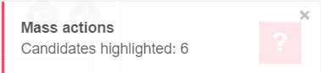

By clicking on the flag "Select all", you can see the filters for mass actions, which allow you to select at once one or more of the resulting candidates in the ranking. You can select only a specific range of candidates (e.g., from 1 to 20). The field "Exclude ID" allows you to select the candidates in the range by excluding some of them. To indicate the candidates you need to exclude from the selection, enter the IDs separated by a comma.

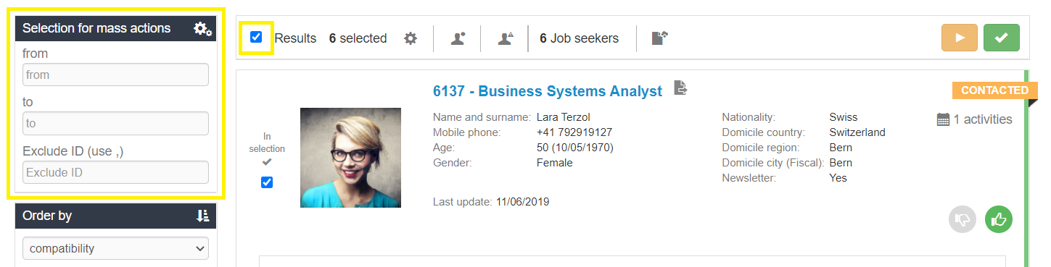

Here are the mass actions:

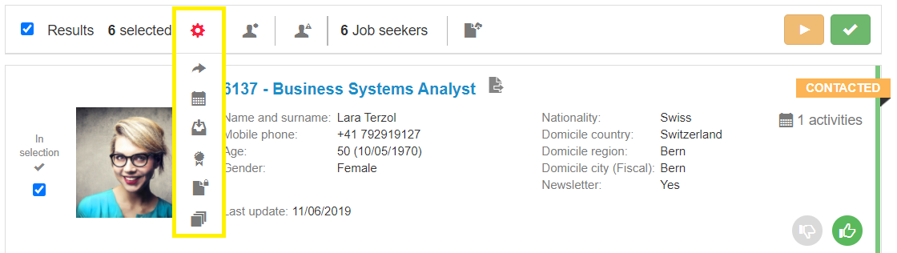

* Share
* Add an activity related to the selected candidates
* Include in a selection process
* Assign to a site/division/department (*optional module)
* Upload public documents for the selected candidates
* Upload private documents for the selected candidates

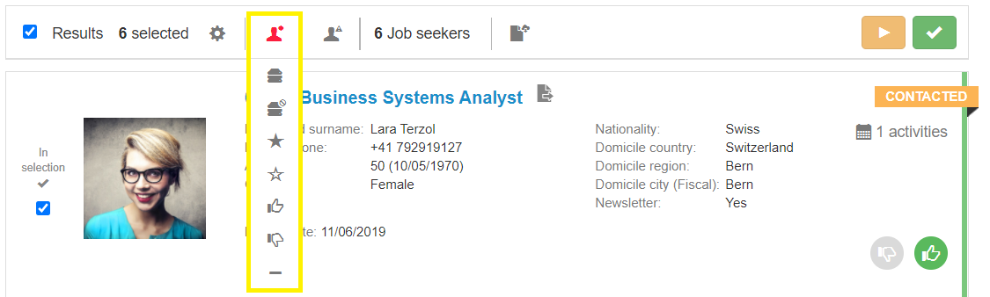

* Mark as relevant in the searches (this option deletes the “Mark as irrelevant”)
* Mark as irrelevant
* Label as highlighted
* Remove highlight label
* Give a thumbs up
* Give a thumbs down
* Remove thumbs

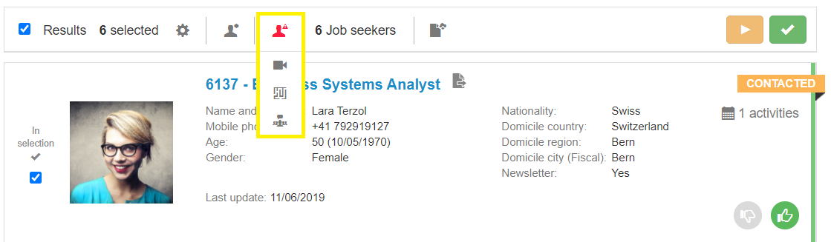

* Request video resume
* Request tests
* Start multimailing (*additional module*)
* Start multi-SMS (*additional module*)

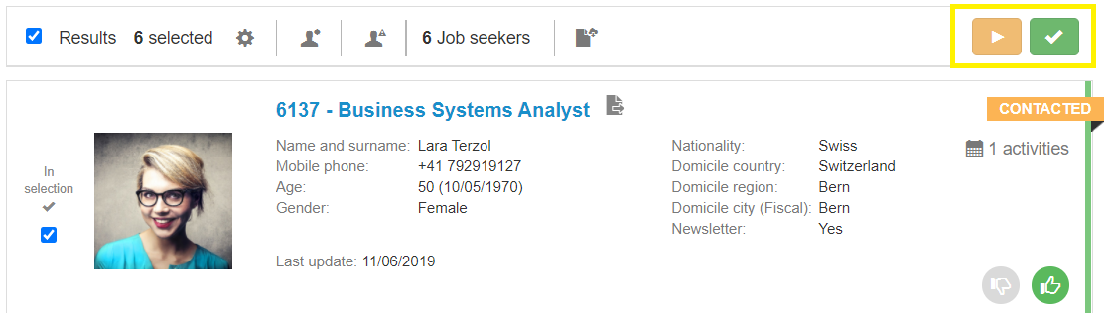

* Move to next steps

**Multimailing**: By clicking on the button "Start multimailing", a pop up will show you an input mask to set the email.

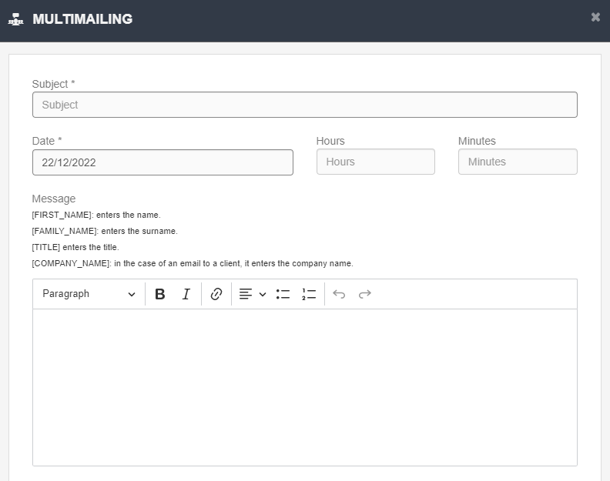

**Date, Hours, Minutes**: You can decide when you would like the mass mailing to be sent (set the date and time).

**N.B:** multimailing messages are sent via a cronjob every half hour (150 mails per half hour); if the number of emails is higher, they will be sent in the next half hour.

**Message**: Field for entering the text of the email; you can also use the text editor tools. Using the parameters in brackets, it is possible to send mass emails in a personalized way: with name, surname, title. Just enter one or more parameters in the email exactly as in the legend> Dear [FIRST_NAME].

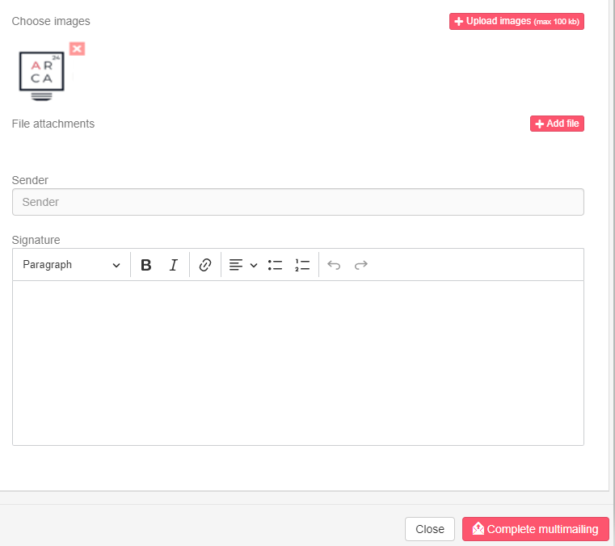

**Choose images:** It allows you to upload images. You just need to click on the image you have chosen and it will be displayed in the body of the e-mail. The maximum size is 100 kb.

**File attachments**: It allows you to enclose files to your e-mail. The maximum size is 2 Mb.

Allowed formats: pdf, doc, docx, txt, odt, rtf, jpg, jpeg, png, xls, xlsx, csv, ppt, pages, pps, pptx

**Sender, Signature**: the system shows the sender and signature set in the section Account Management, however they can be removed or edited. To confirm your choice, you only need to click on the button “Complete multimailing”.

#### Export the candidates to CSV

By clicking on the icon (), it is possible to export a CSV file containing candidates’ data according to the search.

At the end of the export, a pop-up is displayed asking if you want to view the export section immediately. By clicking on "Ok", you will be redirected to the export tab where you can access the extraction history. By clicking on the export, the file will be downloaded.

### Interview step

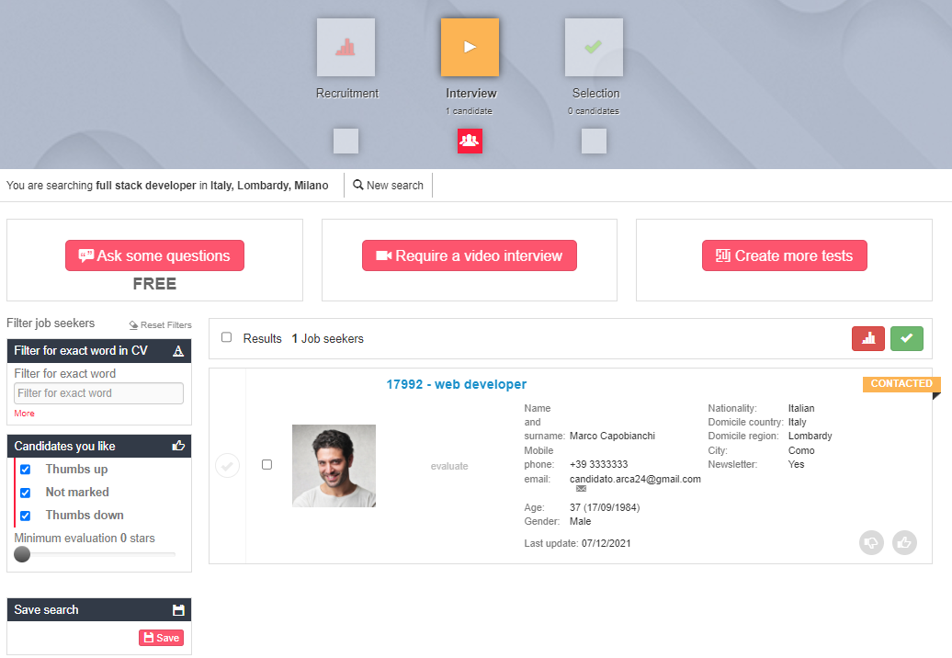

In this step, it is possible to request a written questionnaire (“Ask some questions”) **or** a video interview (“Require a video interview”). If you click on “Create more tests”, you can have access to the test sessions integrated with CVideo, ExaminLab and SoftSkillLab. For more details, please see the handbooks of ExaminLab, CVideo, SoftSkillLab.

In the case of a questionnaire or video interview, **all** the candidates moved to the interview step, from the moment of opening to the moment of closing the session, will be invited to carry out the test by email (sent **only once** per process). In addition, they will be able to access the test either from the email received or from the notifications section in their personal area. Thus, if a candidate has not taken the test before the closure date, and if the session is re-opened, the candidate can access it directly from the "notifications" section of his/her personal area. When accessing the session, candidates can always decide if they want to take the test or refuse it. In both cases, a notification email will be sent to the employer who sent the request.

In the string of each candidate moved to the interview step, a status label is shown:

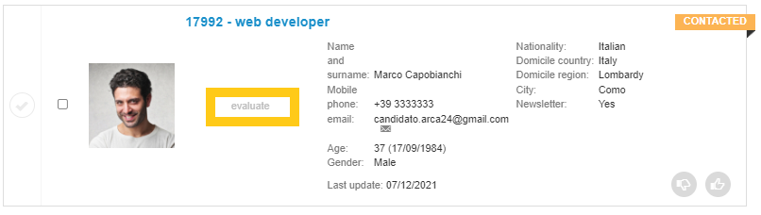

* “Evaluate”, when there is no active session;
* “Waiting for response”, when the request has been sent, the candidate has not replied yet and the session is still open;
* “Declined”, when the candidate refused to take the test;
* “No response”, if the candidate has not replied yet and the session is closed;
* If the candidate answered the test, the results will be displayed based on their score.

**Killer questions:**

By clicking on "Ask some questions", the employer has access to a form to create the questionnaire (i.e., killer questions). The test consists of multiple-choice questions aimed at assessing candidates’ technical knowledge and/or prerequisites necessary for the candidates to reach the next step.

The employer can:

* Set the closing date (by default, it is one week after the session opening);
* Choose a pre-filled template or add the questions related to the given recruitment process;

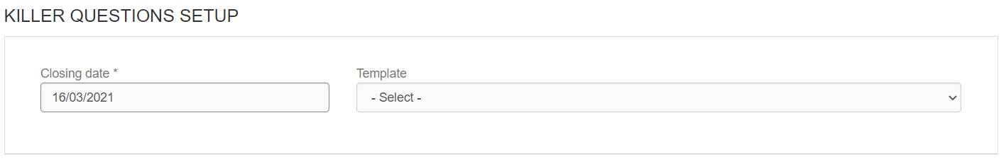

* Add a website or other links (e.g,. for a corporate video presentation);
* Include a text as a description of the test or of your company;

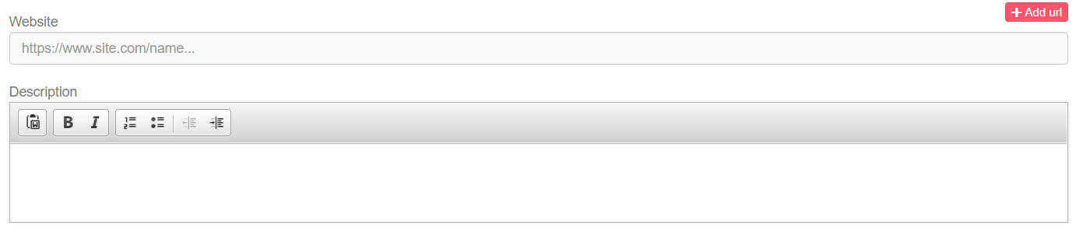

* Write the test questions
* Select the response time for each question
* Write the answers for each question
* Set the score for each answer (scores range from 1 to 10; the option 'disable' gives a score equivalent to -1 and a thumbs down to the candidate who chooses that answer in the interview step).
* Add more questions (the test can take up to 30 minutes).

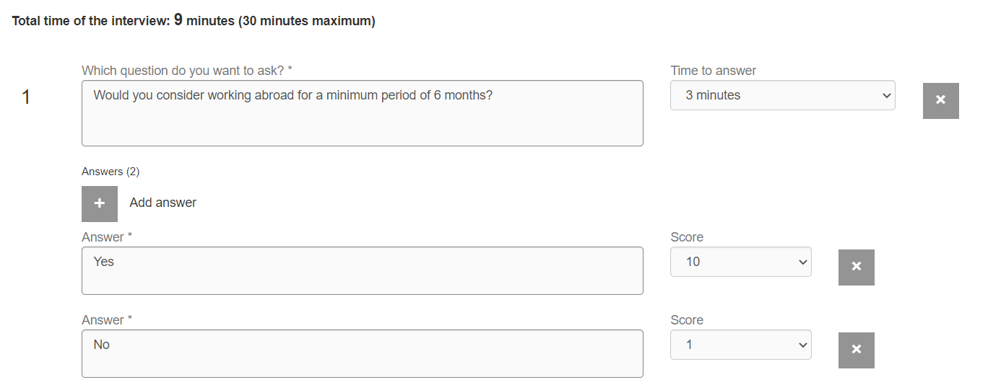

The score of the candidates who completed the test is shown as a percentage within their profile string.

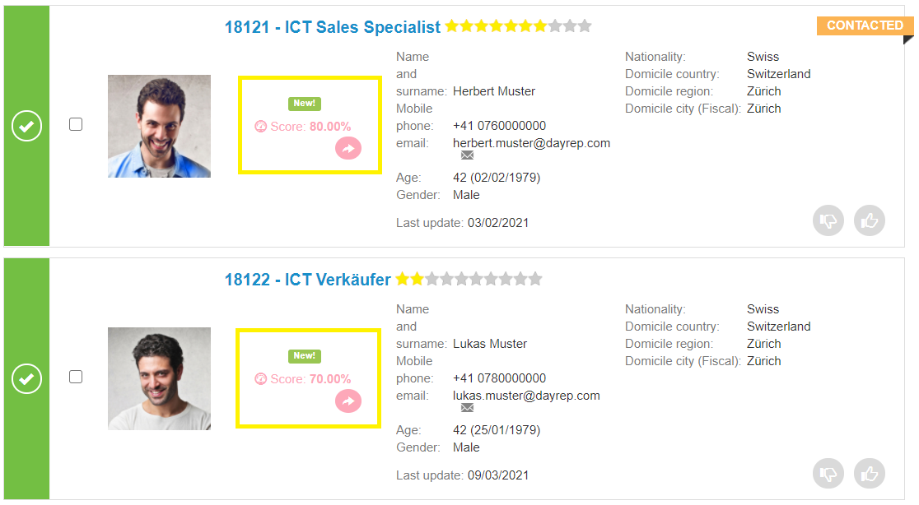

By clicking on the individual candidate's score, it is possible to view the details of his/her answers: the given answer for each question, the response time, the score per question and the final percentage.

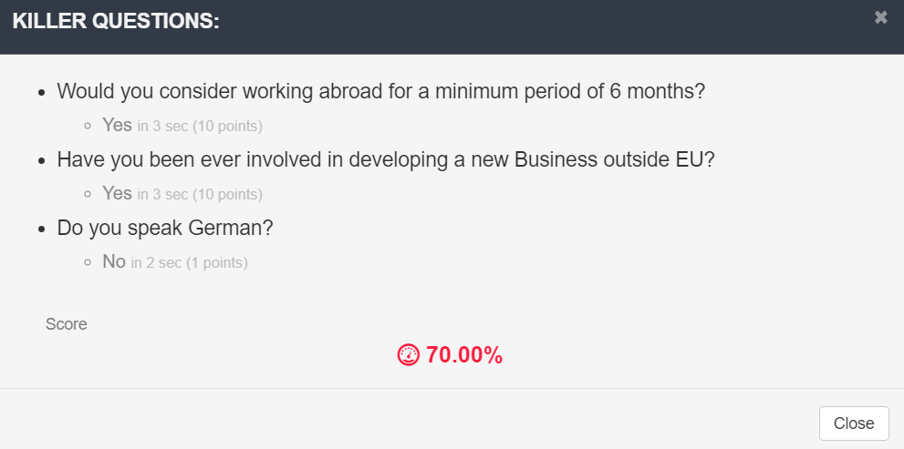

Those details are always visible by all employers within the candidate's profile as well.

By clicking on the icon next to the score (), you can see and copy the link to share the result with third parties (for example, colleagues who do not have access to the platform).

**N.B.:** If a candidate **does not answer** a question in the questionnaire within the set time, the time expires and the answer to the question will not be saved. The test will continue with the next question, if any, otherwise the test will be considered completed. The question for which the response time has expired will not be shown in the candidate's profile (Profile> Test section).

If a candidate **leaves** the page while carrying out a questionnaire, the answer to the question the candidate is on at the time of leaving is not saved. The test will be blocked and can be reactivated by clicking on the "Reset" button, which will appear in the candidate string after about an hour.

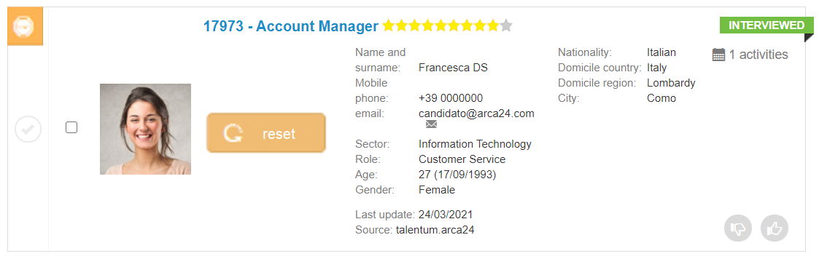

**Video interview**

By clicking on "Require a video interview", the employer will access the form for creating the video session.

The employer can:

* Set the closing date (one week after the session opening by default)
* Choose a pre-filled template or add the questions related to the specific recruitment process
* Add a website or other links (e.g., a corporate video presentation)
* Include a text as a test description or a company presentation
* Write the test questions
* Select the response time for each question
* Add more questions (the test can take up to 30 minutes).

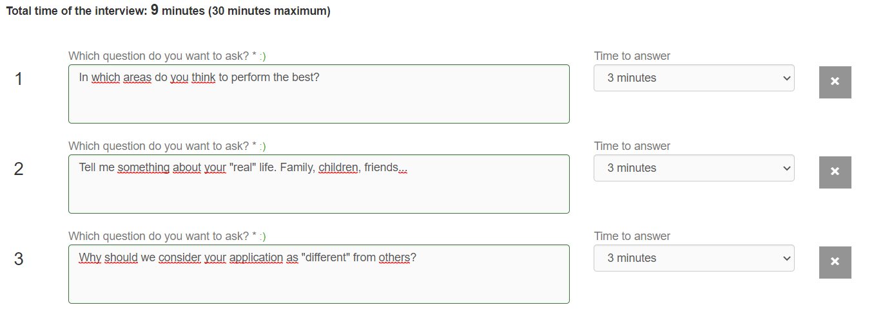

A preview of the video is shown in the string of candidates who answered the test.

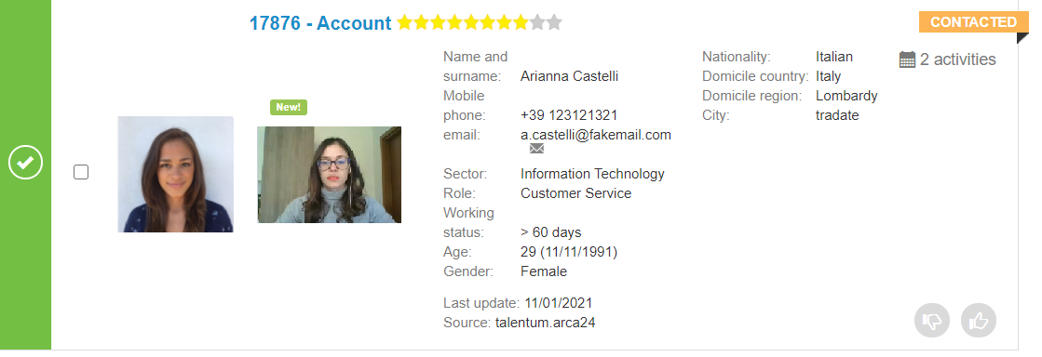

By clicking on it, the video will be opened directly; the same detail can always be viewed by all employers within the candidate's profile (Profile > Videos).

By clicking on the arrow icon, it will be possible to copy the link for sharing.

In case of technical problems during the registration process or if the candidate left the session before completing the interview, the button for resetting the test will be shown in the interview step of the selection process.



By resetting, the candidate can use the email received previously: the link to the interview is going to be available again.

**Closing and reopening sessions (for both questionnaires and video interviews)**

The employer can close the session manually using the specific button.

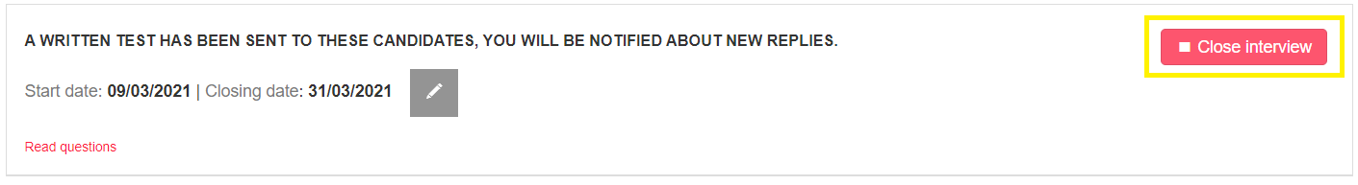

Candidates who try to access the test after the closing date will not be able to take the test.

After closing a session, the employer can reopen it again clicking on the corresponding button.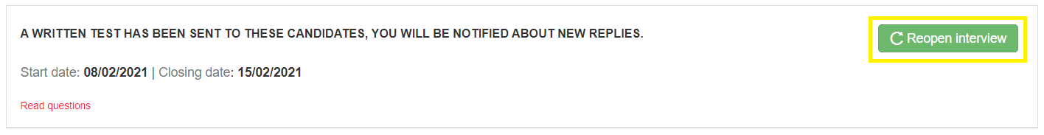

**N.B.:** The email request is sent to candidates **only once per selection process**. If the candidate had not taken the test, he/she can access it after the reopening of the test by clicking on the link from the 'Notifications' section of his/her personal area (from the last notification of interview request).

The sorting in the step is firstly by thumb (green-thumbed, unmarked and red-thumbed candidates), secondly by descending Killer question score, thirdly by date of entry into step2 descending, finally by date of candidate registration descending.

**Filters**

* Filter for exact word in CV (candidate name and surname included)
* Thumbs up
* Thumbs down
* Not marked
* Minimum evaluation (according to the rating): It allows you to view candidates rated with at least a given number of stars.
* Minimum test score (visible only if a questionnaire has been activated). It is a slider that allows you to see candidates according to the results achieved in the test.
* Video interview (shown only if a video interview session is activated). It allows you to only view the candidates who have completed the video interview.

Filters applied in the interview step can be saved using the red button "Save".

The sorting in the step is firstly by thumb (green thumb, unmarked and red thumb candidates), secondly by Killer question score, thirdly by date of entry in step2, finally by date of registration of the candidate.

### Selection step

In the selection step, the employer can move and display the shortlist of candidates who can be interviewed face-to-face or introduced to the division managers.

The filters available are the same as in the step “Interview” and, likewise, their settings can be saved.

* Filter for exact word in CV (candidate name and surname included)
* Thumbs up
* Thumbs down
* Not marked
* Minimum evaluation
* Minimum test score
* Video interview

In this step employers can also hire the candidate(s) by opening each candidate's profile and clicking on the ‘Hire’ button. The candidate will be labelled ‘Hired’:

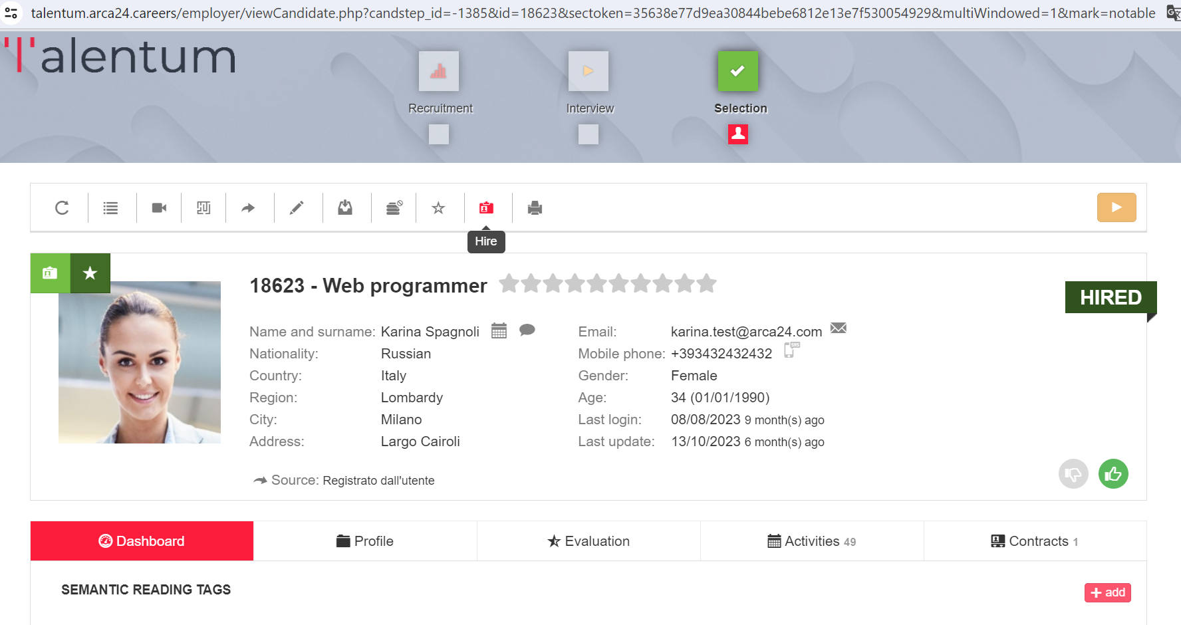

For installations that provide this, the candidate's label will also automatically change to ‘Hired’.

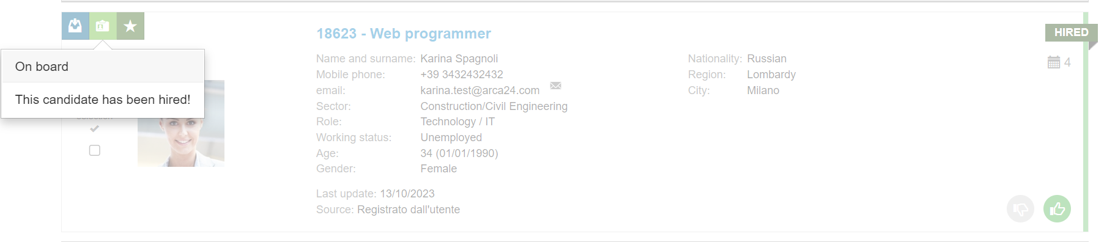

To fire him/her, you must click on the icon within the candidate profile. The status label will revert to "Contacted".

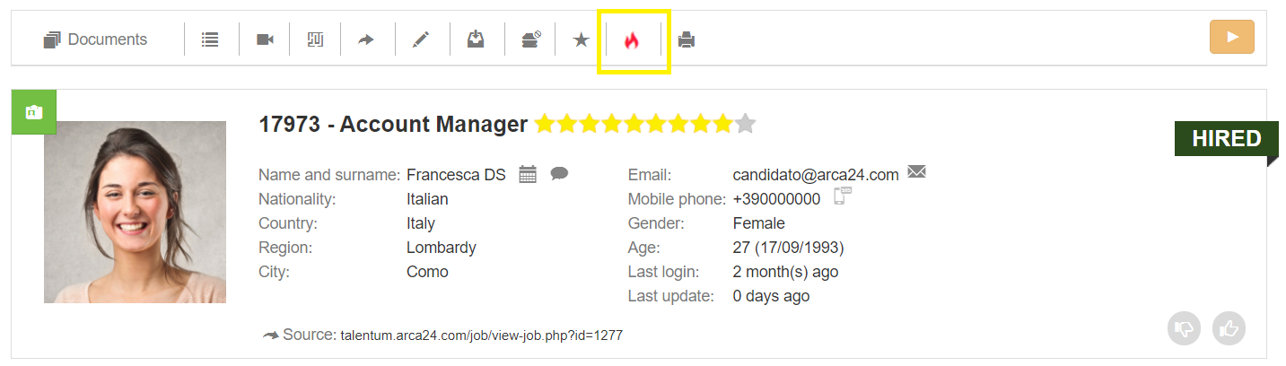

### Candidates (Database searches)

Database searches enable recruiters to search for specific candidates’ profiles and/or carry out database analyses based on pre-set parameters. Database searches are categorized in three steps similarly to the job advert selection process. Based on the search you want to carry out, the following filters are available:

#### Advanced search

In this section it is possible to search for candidate profiles in the database. You can start a search by:

**Candidate name (exact):** search byexact first name, exact surname, exact first name and surname, exact surname and first name.

**Candidate name:** search byexact first name, exact surname, exact first name and surname, exact surname and first name, even if not exact.

**Job title**: The search is based on the semantic engine. As for matching candidates within a selection process, it will be possible to manage the job titles extracted within the recruitment step.

**Candidate ID**: The ID code is the code preceding the job title in each candidate profile. You can search for several candidates at the same time by separating the IDs with a comma (e.g., 123, 12312).

**Candidate email:** Search by complete email address or exact text before @.

**Phone number**: It is necessary to enter the complete number without the international prefix.

**All candidates**: It is possible to search for all candidates in a geographical area. The candidates are sorted by date of registration.

**Activities on candidates**: Search in the text boxes "Comment" and "Feedback" of manual activities search in the text boxes "Comment" and "Feedback" of manual activities and in the evaluation form. The field works as a full-text search. Example: If an activity with the comment "first interview for accounting expert" is entered, the search also works by searching only for "accounting expert interview". If you need to search for one or more words exactly, it is preferable to use the exact word filter in activities.

**Evaluated candidates**: Search for all candidates who have at least one entry in the evaluation tab; this can be the rating, the company structure or the evaluation form.

**Company structure (*Additional module*)**: Search according to the company structure set on the candidates.

#### Last seen candidates

In this section, the last 20 displayed candidates’ profiles are listed.

#### Saved searches

In this section, saved searches are displayed.

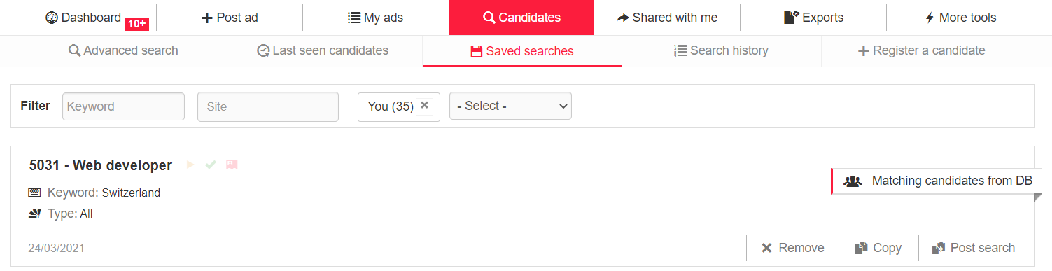

If you want to save a search, you can use the given section within the recruitment step at the bottom of the search filters on the left.

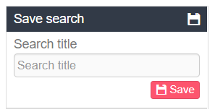

The following options are available for each saved search:

**Remove**: If you want to delete the search.

**Copy**: If you want to copy the parameters set for a new search.

**Post search:** It allows you to post a job ad starting from the saved search. By clicking on the button, you will be redirected to the section "Post ad", where some form fields will be pre-filled based on your search.

**N.B.:** If you delete a saved search, the linked job ad will not be deleted.

#### Search history

In this section, the last 20 searches performed are displayed. Click on each of these to see the detail.

#### Register a candidate

In this section, employers can enter new candidate profiles. The form has fewer mandatory fields than the external registration form, just to allow for faster candidate registration.

**N.B.:** In the field “Email (Candidate)” it is important to enter **correct and existing email addresses**, otherwise the candidate will not be able to access his/her personal area.

### Shared with me

In this section you can view the candidate profiles shared with you by your colleagues and you can filter them by date of profile sharing and by keyword.

These filters are available both in the 'Shared with me' tab and in the candidate sharing page that is sent out by e-mail: the employer and the e-mail recipient can now view the candidates shared in the time frame they are interested in.

The filter can be set by entering dates or by selecting the period of interest (last month, last 3 months, last 6 months, all time).

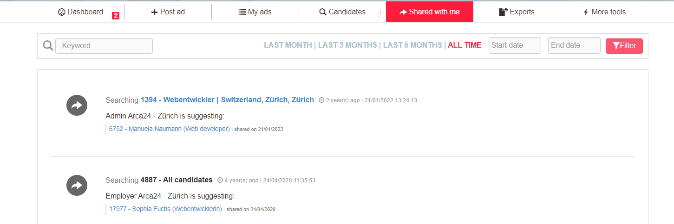

### Exports

In this section, it is possible to see, download and even delete the exports carried out. Click on the string to download the relevant csv. If you want to download an export, you just need to click on the corresponding string.

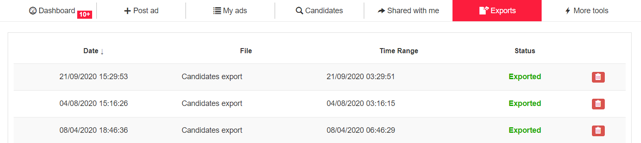

### Candidate profile

By clicking on each candidate string, it is possible to open the full tab, i.e., the profile containing all the candidate details as well as the history of the activities carried out by the employer and by the candidate (test results, videos, etc.).

#### Request buttons



**Update request:** It is visible from 30 days after the date of last modification of the candidate's data. It allows you to send an email to the candidate inviting him/her to login to his/her personal area and update his/her data.

**GDPR log and portability**: In compliance with GDPR, the system makes it possible to view the logs relating to the activities carried out candidates and employers on a candidate’s profile and to extract a file with the candidate’s data, in order to guarantee the right to data portability. Below are the log types available in this section:

CANDIDATE_ADD': registration of the candidate profile.

APPLY_LOGIN': apply to a job advertisement.

CANDIDATE_UPDATE_CV': update cv.

CANDIDATE_UPDATE_CL': update cover letter.

CANDIDATE_JOBTEST: performed job test

CANDIDATE_DELETE_CL': delete cover letter.

CANDIDATE_UPDATE_PHOTO': Update profile picture.

CANDIDATE_DELETE_PHOTO': delete profile picture.

CANDIDATE_LOGIN': Candidate login with username and password or autologin from mail.

CANDIDATE_UPDATE_LOGIN': change of login data.

CANDIDATE_UPDATE': Edit profile data (candidate table).

CANDIDATE_UPDATE_WORKER': Edit profile data (worker table).

CANDIDATE_DELETE': Logical deletion of the profile.

**Request video resume:** It allows you to send a video request by email. If the candidate answers, you will receive a notification via email, which will be visible in the candidate’s dashboard too. The recorded video will be stored in the section "Videos" of the candidate profile.

**Request tests:** Itallows you to send a request for the job test, i.e., the soft skill test, and/or other tests requiring the purchase of credits.

**Share this candidate**: It allows you to share the candidate profile with colleagues registered in the system or with third parties.

**N.B.:** The candidate’s personal data, the tabs “Dashboard” and “Profile” are shared, including job offers to which the candidate has applied; documents are not shown.

The recipient will receive an email with a link to the list of shared profiles. He/she can actually view all the profiles shared with him/her. The list of shared profiles is organized based on the selection processes for which the profiles were shared. Such share actions are sorted chronologically from the most recent to the oldest one.

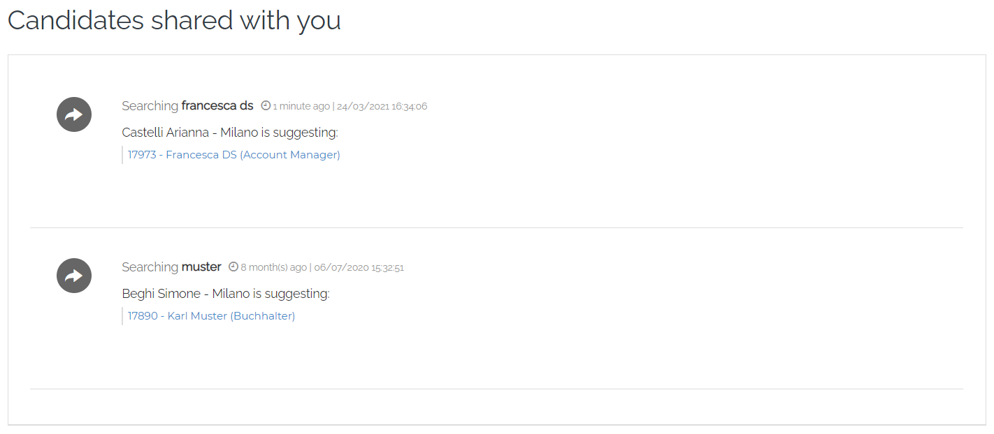

By clicking on each profile, the recipient can make a printout or leave his/her feedback. Such feedback is visible in the candidate profile > Activities > Feedback.

If some feedback is added, the employer to whom the job offer is assigned will receive both an email and a notification in his/her dashboard.

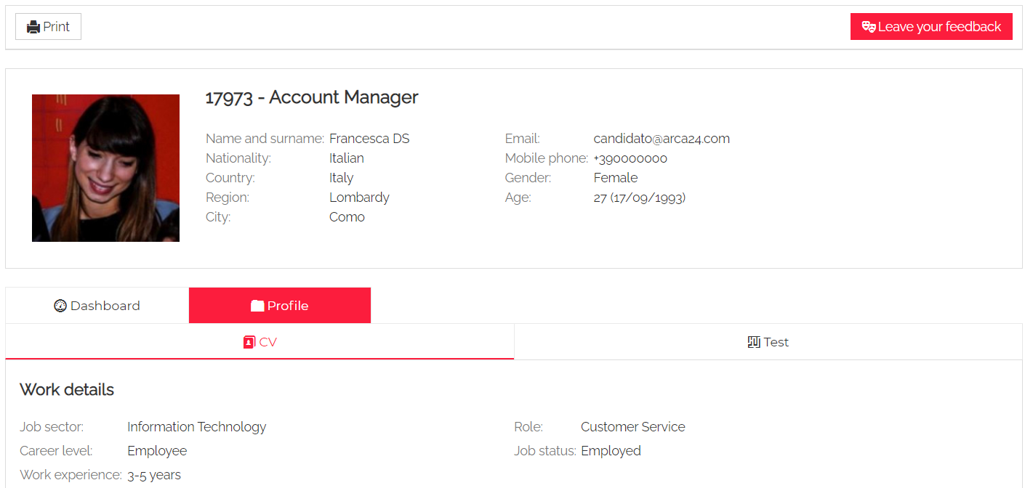

**Edit this candidate**: It allows you to edit the candidate’s data. If you want to edit details such as the candidate’s login credentials, the candidate’s CV as well as the professional tag extracted from the CV, you have to click on “Account management”.

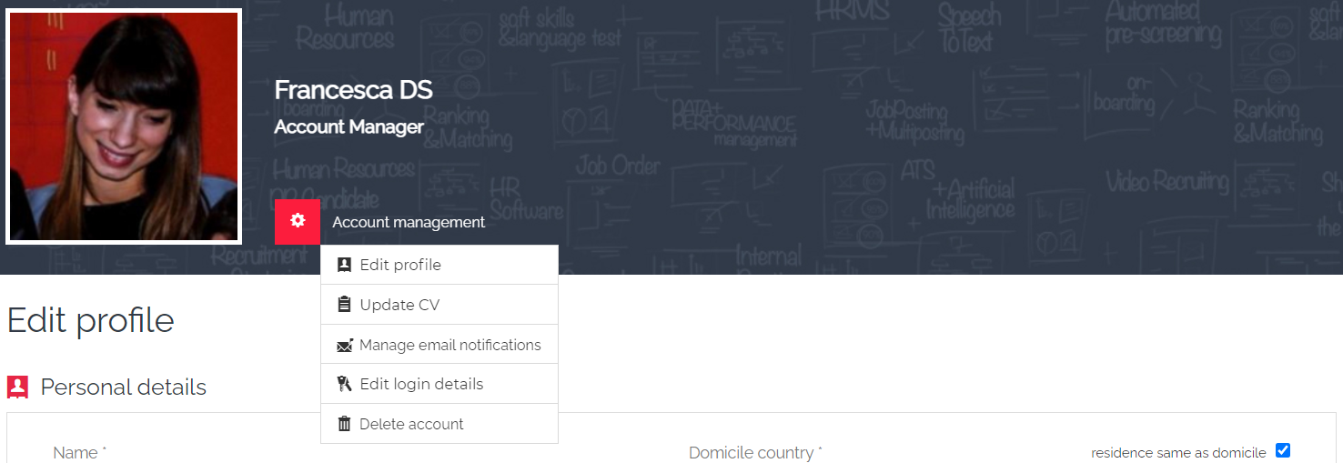

**Delete account:** It allows the deletion of the candidate’s profile by the employer.

In the case of candidates with contracts, we make a **logical deletion**, i.e., the candidate no longer receives emails, the candidate does not access his/her personal area (he/she can re-register to the portal with the same data), the employer can no longer carry out activities on the profile. However, the data are still visible to the employer.

In the case of candidates without contracts, the **deletion is physical**, i.e., the data are completely deleted and can no longer be recovered.

In order to physically delete a profile with contracts, you should delete all the contracts first, and then delete the profile.

If you proceed directly to deletion, without removing the contracts, only logical deletion can be carried out. However, you can physically delete the profile using the following button:

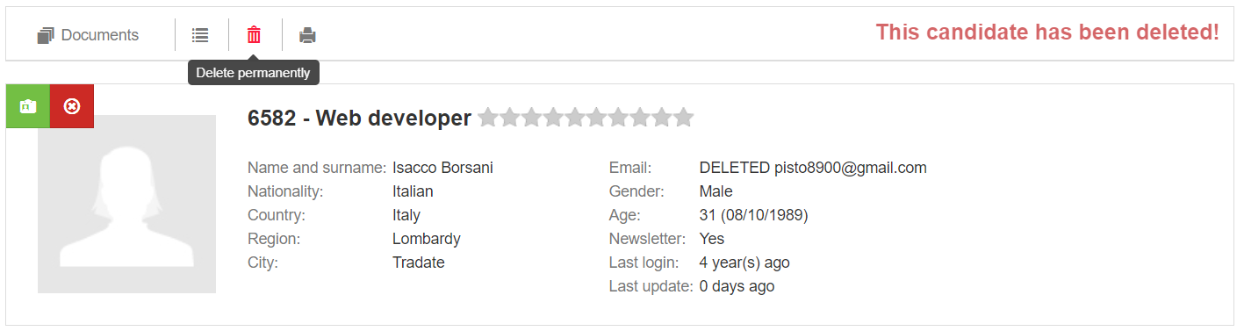

Via the Restore button, it is possible, for Admins only, to restore the logically deleted candidate:

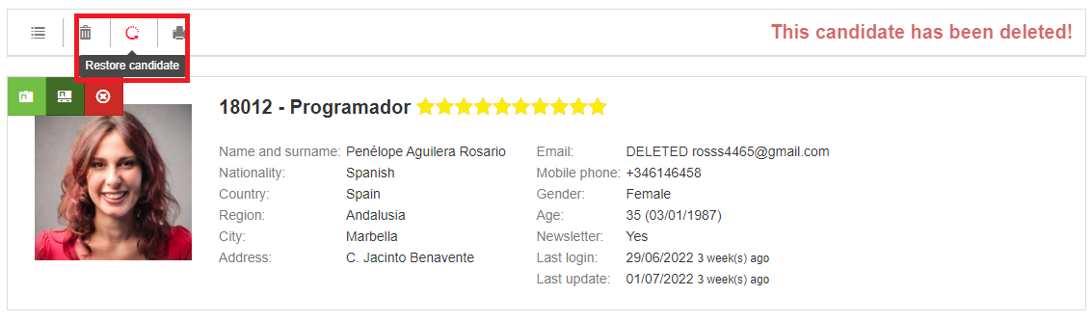

A popup will remind you that once the candidate has been reset, you must **reset an access password** and communicate it to the candidate. The candidate would be then active again and labelled 'Interviewed':

**Include in a selection process:** It allows you to manually move a candidate to another a selection process (including both online and offline job ads or saved searches). This is possible by selecting the colleague to whom the job ad and the related process were assigned. When you manually add a candidate into a job ad, the profile will be inserted in the recruitment step among the registered and possibly compatible candidates. As for saved searches, the candidate will be inserted directly into the interview step. The field to select the target job offer allows both to view a dropdown with the most recent job offers and to search by keyword, so that the search is fast and precise.

**Mark as relevant/irrelevant:** The mark indicates a candidate who should not be taken into consideration for any selection process (when setting up, you can choose whether to set an end date or not). At any time, by clicking the button again, you can reset the candidate as relevant. The irrelevant candidate is marked with an icon and can be hidden among the matching candidates by using the specific filter.

**Label as highlighted:** It allows you to mark a profile as highlighted. The flag indicates a candidate who can be very interesting. The flag can be removed at any time by clicking on the button. That is linked to a filter in the matching candidates that allows you to display only the candidates that are highlighted within a process.

**Hire:** It allows you to mark a candidate as hired.

**Print**: It allows to print the candidate’s profile.

#### Status labels

These are labels that identify the candidate status based on the activities carried out by employers. By default, the labels automatically change according to the activities/contracts entered on the candidate's profile.

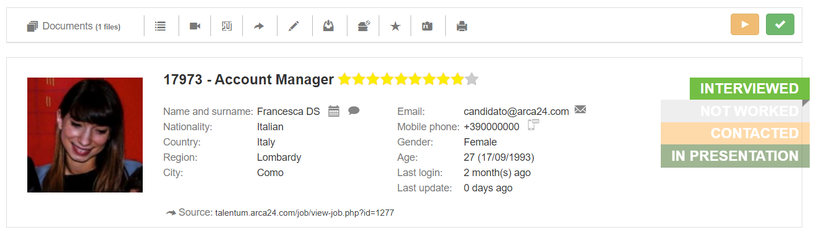

The labels change automatically according to the following rules:

**Not worked**: It is the standard status, where no activity has ever been entered.

**Contacted**: after sending an e-mail from the envelope or entering the activity "Telephone interview".

**Interviewed**: When entering face-to-face interview activities (first/second/third interview) or adding an evaluation in the evaluation tab.

**In presentation:** This label is by default not set automatically. It can be selected manually to mark candidates submitted to the division manager according to the selection process.

**Hired**: When the "Hire" button is used. For software that uses a hiring mod that allows contract dates to be entered, this is activated in particular when the contract has a start date equal to or before today's date. **N.B.:** If the "Fire" button is used, the candidate's label will be changed again into the interviewed status, even if no interview/contact activities were entered.

**Onboarding:** the candidate has a contract associated with him/her whose start date is later than the current one. **N.B.**: only for software versions that use an employment mode allowing contract dates to be entered.

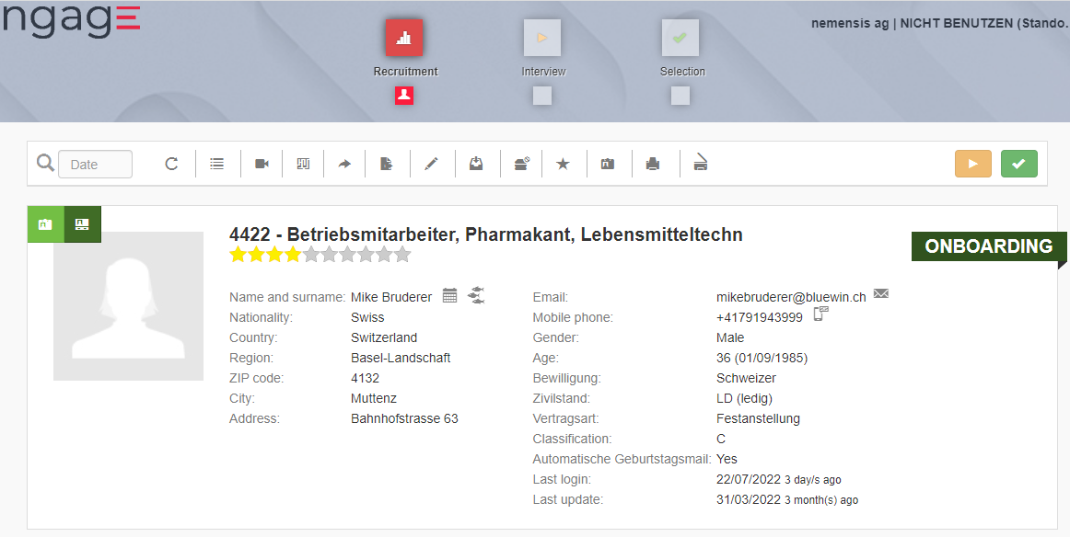

**N.B.:** Labels are temporary, with the exception of the label "Hired", which depends on the expiry and the elimination of the contract/dismissal): one month after entering the activity/data that determined its change, the label reverts to the previous status. The reversion always stops at the label "Contacted"; it never goes back to "Not worked".

#### **Adding activities**

From the calendar icon, it is possible to enter activities related to the candidate (see the section “Agenda” for further details).

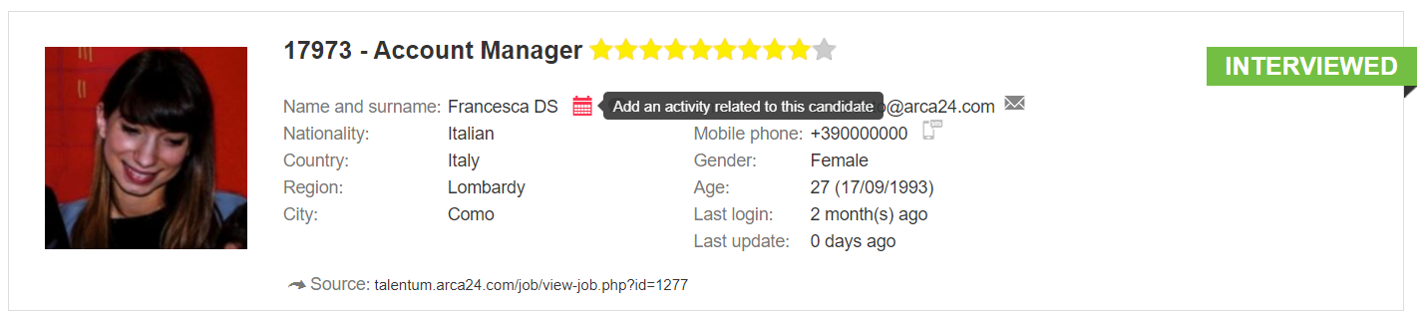

#### **Contacting the candidate from the system**

**Via email**: The employer can send an email directly to the address registered on the candidate. If a candidate replies to this email, the reply is sent directly to the address of the employer who sent the email.

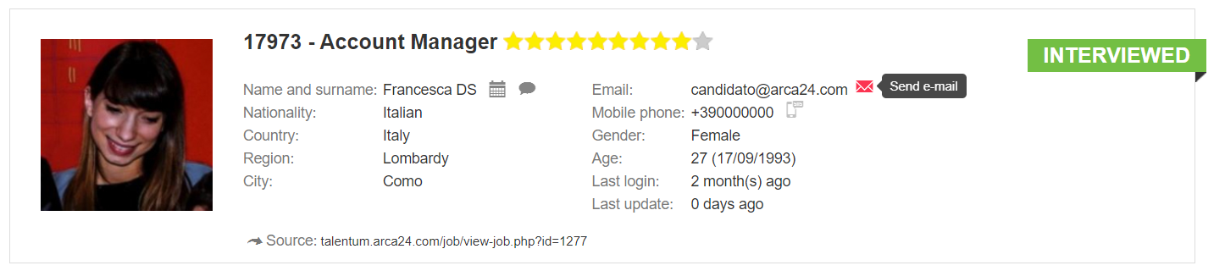

**Via SMS (*ADDITIONAL MODULE*):** The employer can send an SMS to the candidate (the recipient cannot reply to the message).

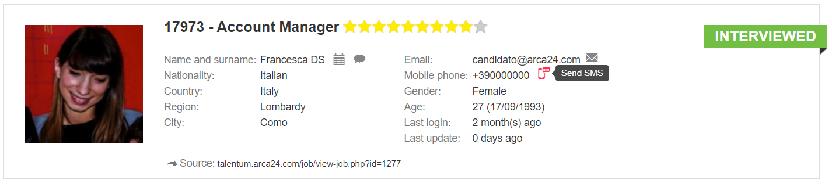

**Real-time communication** **(*ADDITIONAL MODULE*):** The cloud icon allows the employer to contact the candidate when the candidate is logged into his/her personal area and to initiate a chat or (video) call. Such activities will be recorded in the candidate’s activity tab.

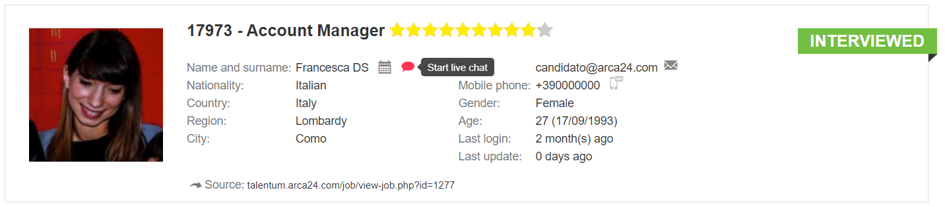

#### TAB Dashboard

This tab shows the following details about the candidate's experience:

* Professional tags automatically extracted from the semantic tool (by clicking on the button “+ Add”, you will be redirected to the page where you can update the candidate’s CV and manage the tags);
* Work experience timeline (work experiences and training path);
* Number of work experiences;
* Working years;
* Number of jobs changed (in the last 5 and 2 years).

**N.B.:** The data is read and calculated based on the candidate's CV extraction as well as candidate’s personal data.

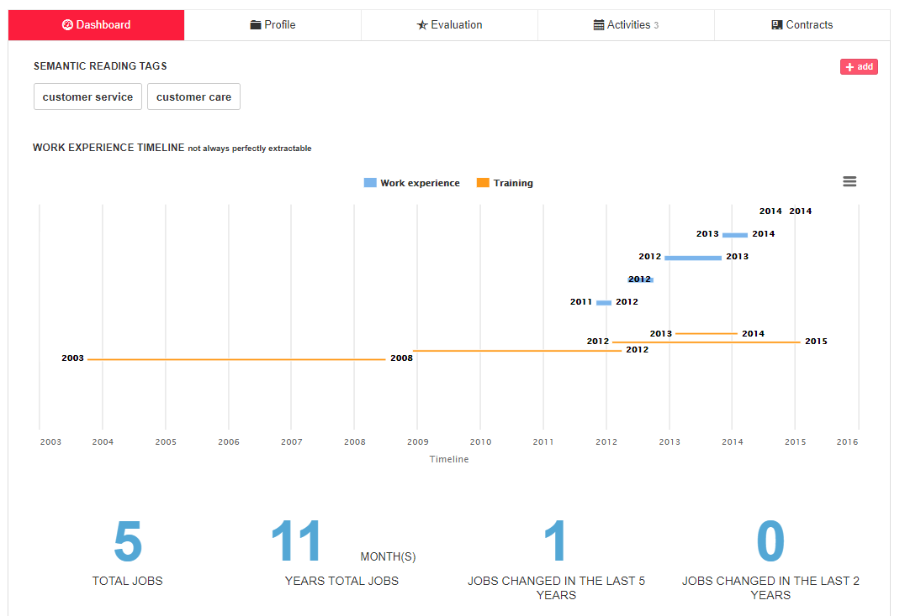

#### TAB Profile

**CV:** In this section, the following data are visible: the list of job advertisements to which the candidate has applied, job details, language and education, the analysed CV, the candidate's original CV.

The section ‘Candidate applied to the following job ads’ shows the offers (distinguishing between online and offline) to which the candidate has applied, and shows the origin of the application. Clicking ‘all candidates’ opens the page of candidates compatible with the ad.

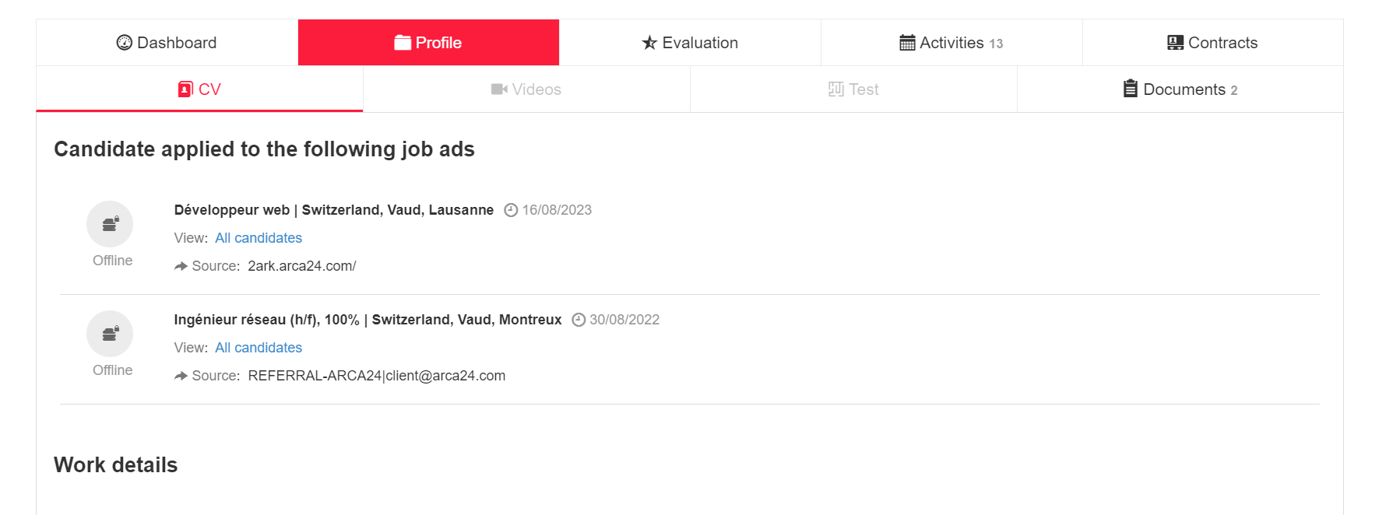

The CV parser analyzes the candidate's CV and divides it into sections:

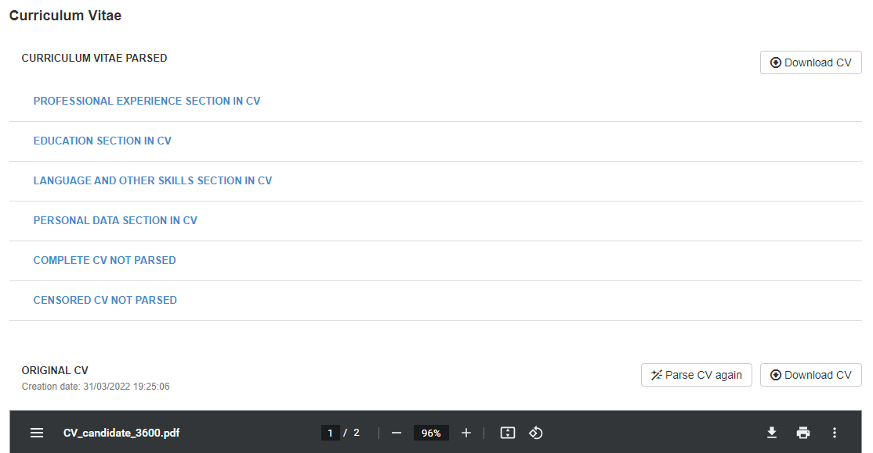

Moreover, it is possible to view the following sections: **Complete cv not parsed** and **Censored cv not parsed.** These are two image versions of the CV that can be edited manually in a similar way to a graphics programme.

The two versions have a button on the right, called “Edit mode”. Once clicked, it displays some functions within the document image.

• The **pen** function allows you to enter some comments directly within the CV document. Once you have clicked on the pen, click on the position where you want to add a note and type the text in the box that opens; save the entered text with the button below:

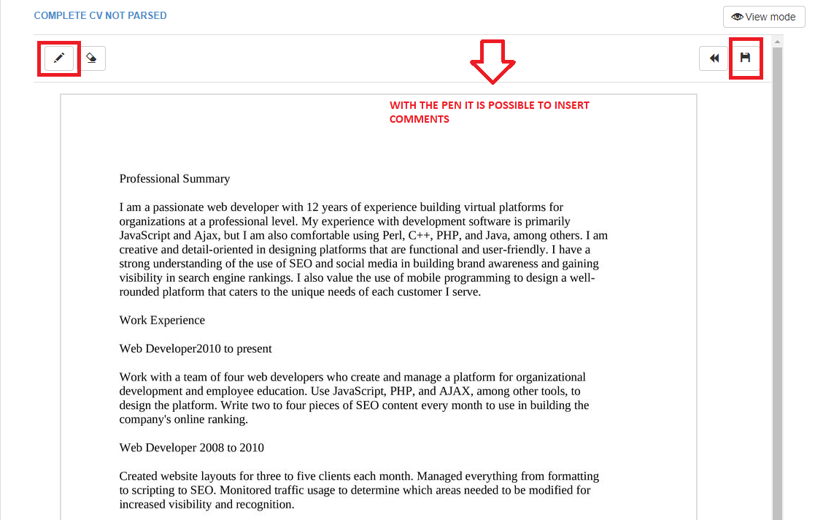

• The “**rubber”** button allows the deletion of parts of the text:

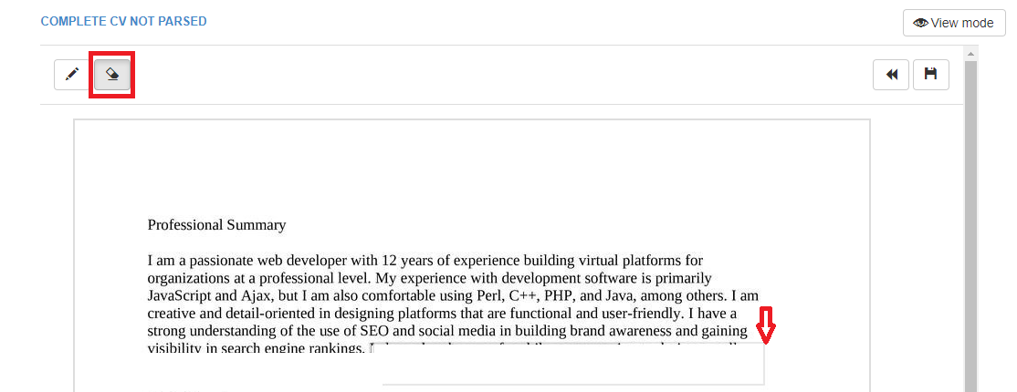

• The two buttons on the right, “**back”** and “**save”**, allow you to undo the changes made and save the final edited version:  
  
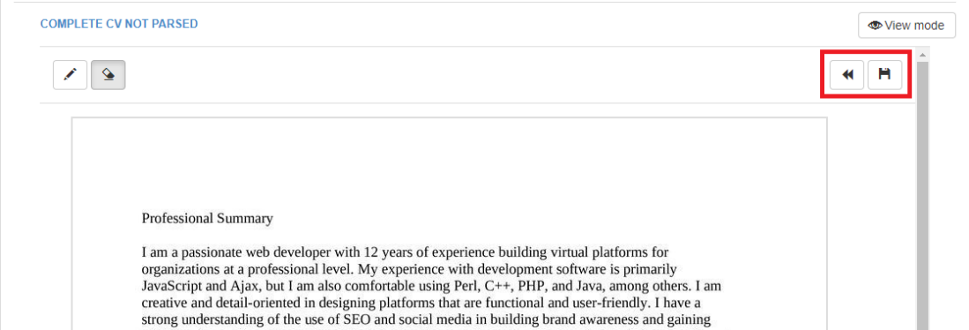

• By clicking on the button on the top right, **View mode**, you go back to the original version of the document.

In the section **CENSORED CV NOT PARSED** certain parts of the CV are automatically censored, but there are two further buttons.

* The **censor** button allows you to blur further sections of text in the image:

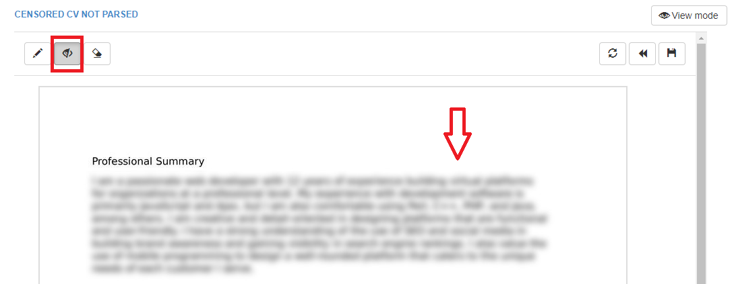

* The following button allows you to undo the automatic censoring of personal data from the CV image and re-start the changes:

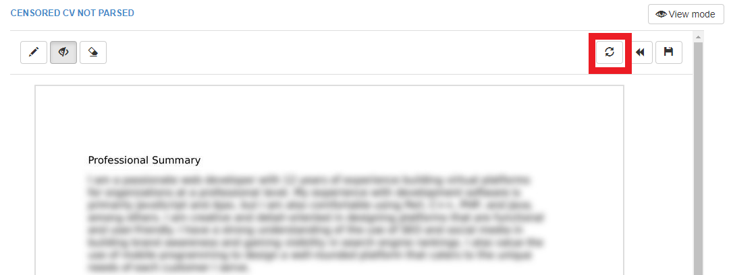

If no CV was entered at the time of candidate’s registration (e.g., applications from some external portals/candidates entered manually) a CV in .txt format is automatically generated with the information available. The CV creation procedure takes place automatically every night.

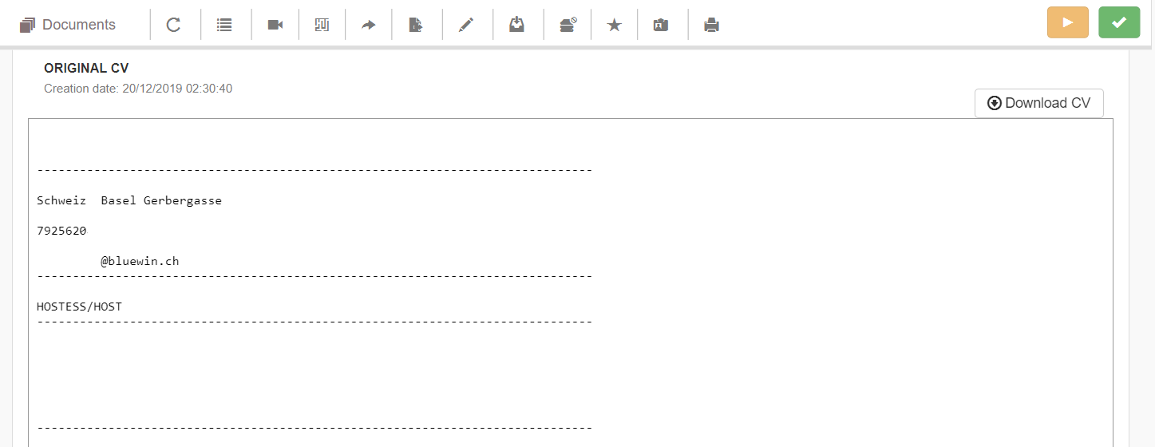

**Videos**: In this section, you can watch all videos, both video resumes and interviews, recorded by the candidate.

**Test**: It shows the results of the tests (e.g., language tests, job tests, questionnaires) carried out by the candidate.

**Documents:** Section for managing documents related to the candidate, which can be uploaded by the candidate in his/her personal area or by an employer.

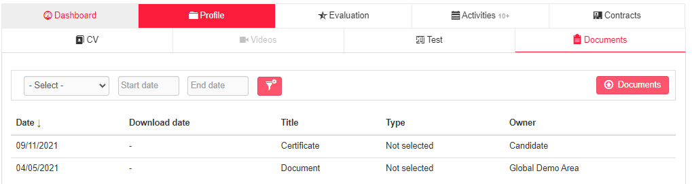

You can upload, download and update the file title and/or description. The maximum size allowed is 2MB. The flag "Visible in the personal area" allows you to decide whether or not to make the document visible to the candidate.

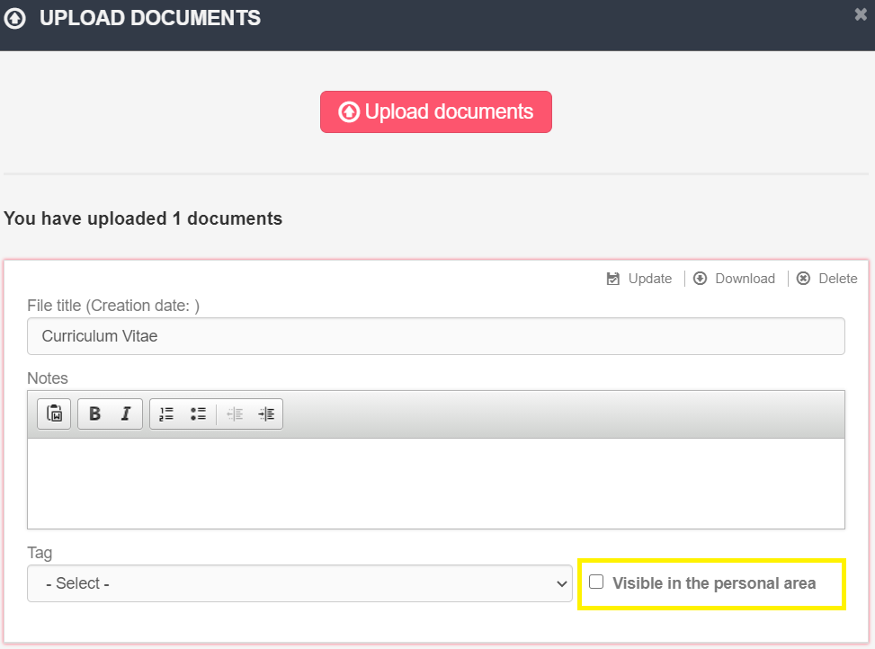

#### TAB Evaluation

Section in which it is possible to add evaluations and assessments of the candidate.

**Rating:** Rating expressed on a scale of 1 to 10. One's own rating is averaged with the ratings entered by colleagues.

**Assign to a site/division/department (*ADDITIONAL MODULE*):** It allows you to determine where you plan to employ the candidate; a maximum of 3 settings can be expressed.

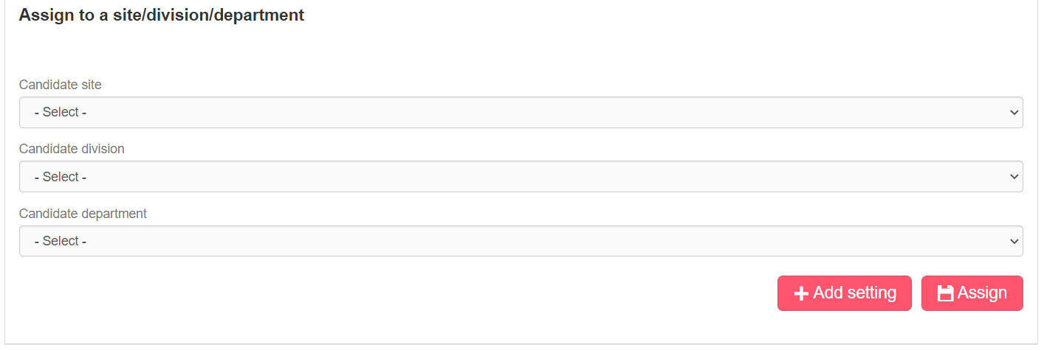

**Candidate evaluation form:** The evaluation form can be set and customized by the system administrator in the account management section. Each time an employer enters an evaluation, it is automatically saved into the evaluation history, a button which is generated when the first evaluation is entered.

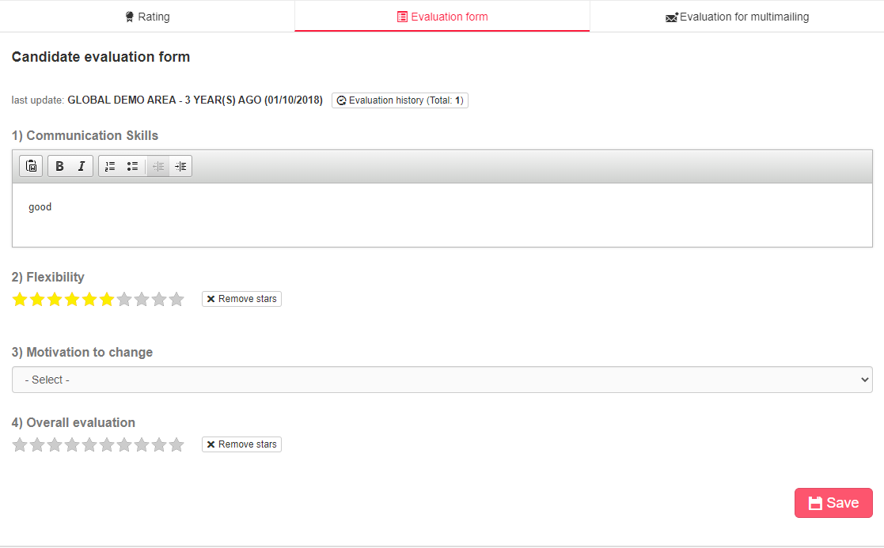

#### TAB Activities

##### *Activities*

Section displaying the history of activities carried out with and on the candidate.   
The sorting of activities takes into account the activity starting date, with reference to manual activities.

**Filters**

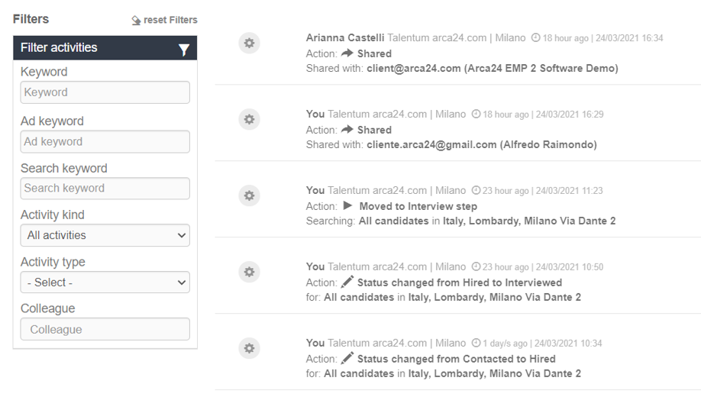

**Keyword:** It allows you to search for a word in the text of both automatic and manual activities; as for the manual ones, it searches in the comment and feedback boxes.

**Ad keyword:** Itallows you to search for all activities related to a given job ad. This filter searches in the field “For selection process” in the manual activities entered from a job ad and in that of “Searching” in the automatic activities. Moreover, it allows you to search in the text of the job advert.

**Search keyword:** It allows you to search for all activities related to a given database search. This filter searches in the field “For selection process” in the manual activities entered from a database search and in that of “Searching” in the automatic activities.

**Activity kind**: it allows you to filter by chat, i.e., activities related to 2chat, real-time messaging, call and video call system (*OPTIONAL MODULE), automatic or manual activities.

**Automatic activities**

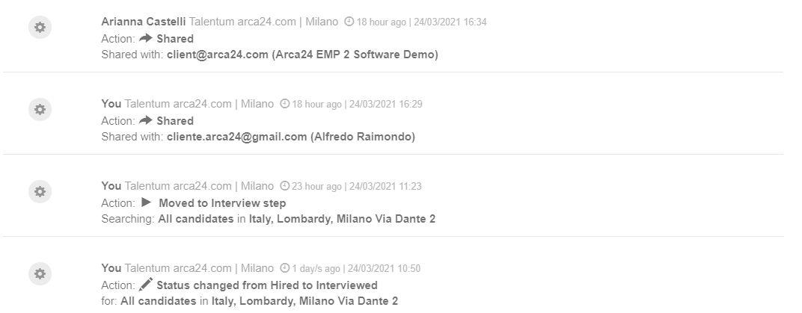

Automatic activities are those identified by a gear icon. These are logs automatically recorded by the system and generated by actions carried out by the employer (e.g., moving through the recruiting steps, requests for tests, videos, etc.).

**Manual activities**

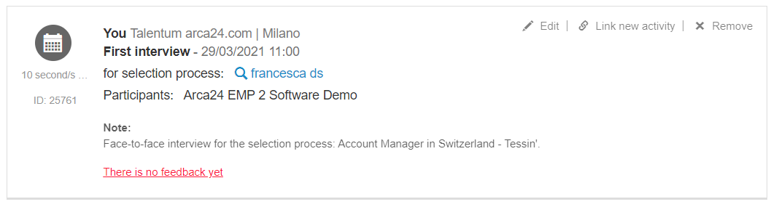

Manual activities are those identified by a folder icon. They are recorded by the employers from their agenda or directly from the candidate’s profile.

**N.B.**: In order to track the selection process in which the manual activity is included, it is necessary to open the candidate's profile **directly from the process** (database search or job ad) **to which the activity relates**.

As for the manual activities, the following options are available:

**Edit.** You can edit **your activities** but not those of other employers.

**Link new activity.** It allows an activity to be linked to a new activity. Several activities can be linked to each activity, but an activity C cannot be linked to an activity B already linked to an activity A: there is only one level of linking.

**Remove.** You can delete **your activities** but not those of other employers.

**Activity type.** It allows you to filter by type of manual activity (e.g., first interview, second interview, etc.).

**Colleague.** It allows you to filter by the colleague who added the activity.

##### *Feedback*

Section displaying feedback from recipients who received shared candidates’ profiles.

It is even possible to enter some feedback manually, by using the button “Add feedback”:

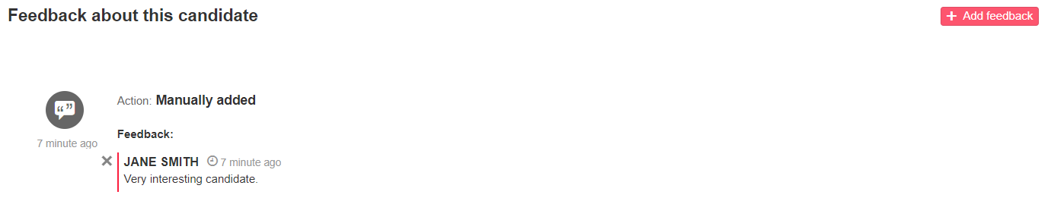

#### Contracts (*ADDITIONAL MODULE*)

In this section, you can view and manage all contracts linked to the candidate’s profile.

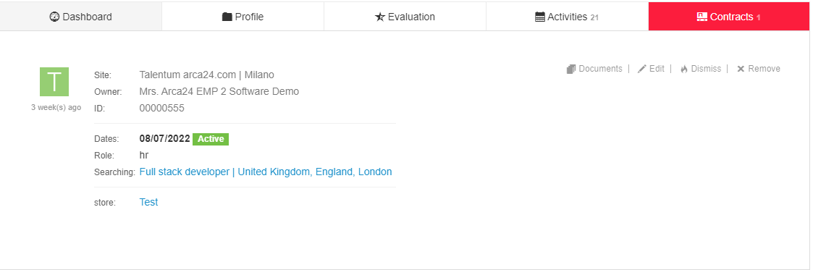

It is possible to attach documents related to the contract, modify the details or delete the contract. Furthermore, it is possible to dismiss the candidate; in this way, the current date is shown on the date of termination of the contract and the profile will result as an ex-worker.

### More tools

**JobArch**

JobArch is a software developed and owned by Arca24 providing an external candidate database, which is useful for searching for further profiles.

It is possible to publish job adverts or carry out searches on JobArch, in the same way as in Talentum, and to import candidates via the button "import".

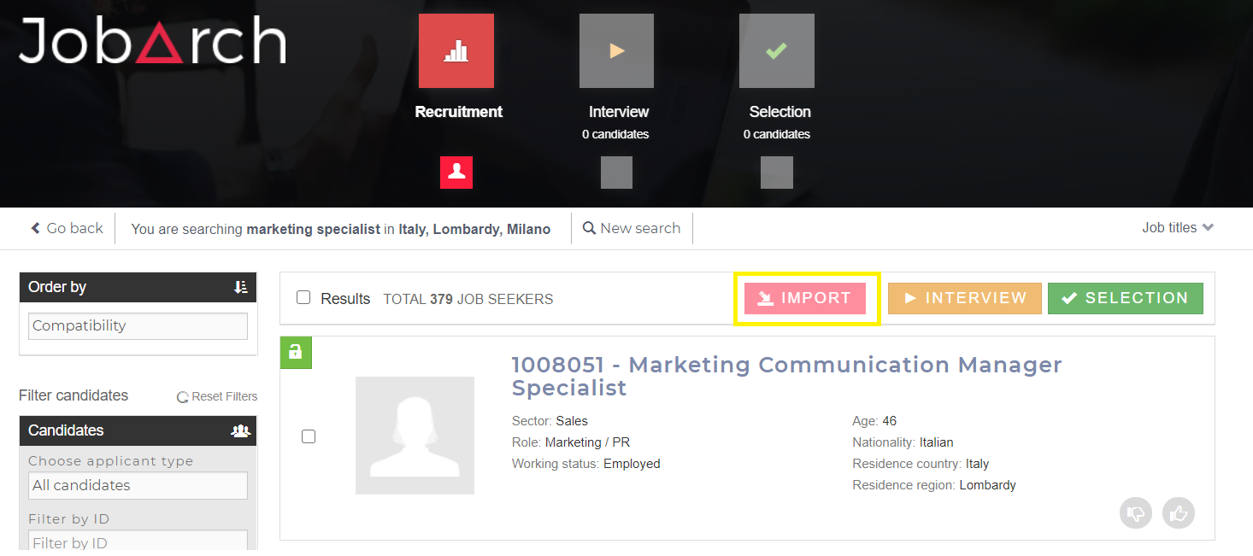

For further details see the handbook TALENTUM - JobArch – en.

**CVideo**

**N.B.:** In order to access CVideo sessions, it is necessary to enable the user's permission in the section “Permissions management”.

For more details on the integration, see the handbook TALENTUM - ExaminLab CVideo SoftSkillLab – en.

**ExaminLab**

**N.B.:** In order to access ExaminLab sessions, it is necessary to enable the user's permission in the section “Permissions management”.

For more details on the integration, see the handbook TALENTUM - ExaminLab CVideo SoftSkillLab – en.

**SoftSkillLab**

**N.B.:** In order to access the SoftSkillLab sessions, it is necessary to enable the user's permission in the section “Permissions management”.

For more details on the integration, see the handbook TALENTUM - ExaminLab CVideo SoftSkillLab – en.

## MODULE REPORTING (*ADDITIONAL MODULE)

The module allows you to monitor the activities related to the Selection’s KPI, to control the Conversions (registration and application of candidates by origin in relation to hires), to possibly view active contracts and Data Logs of sent emails.

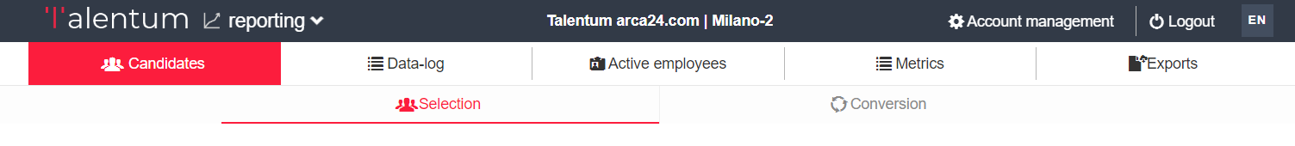

### 4.1. Selection and Conversion

**Reports layout:**

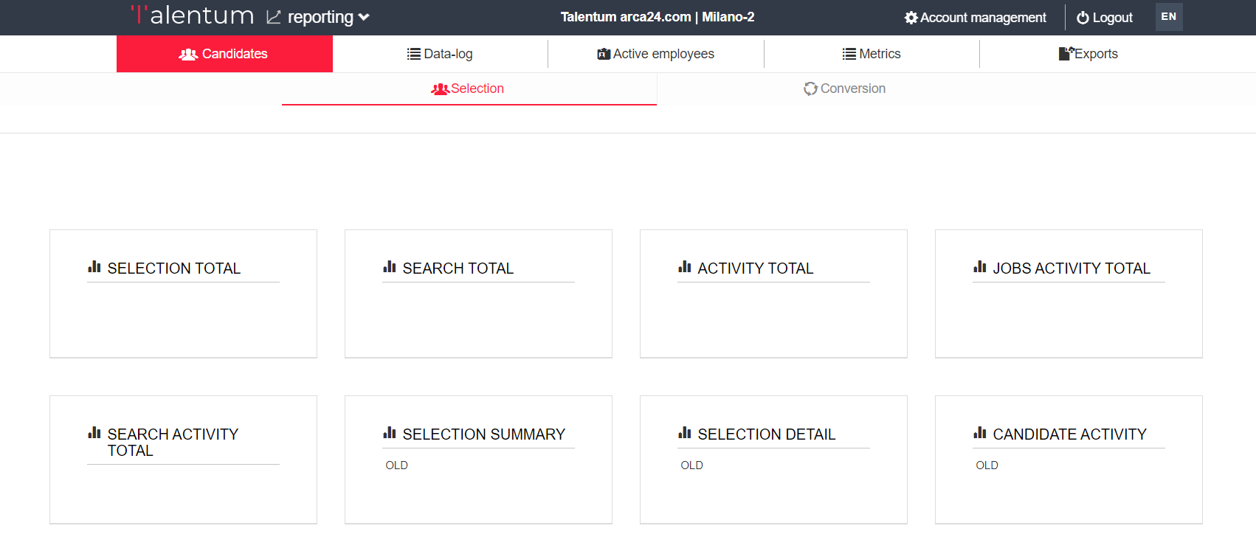

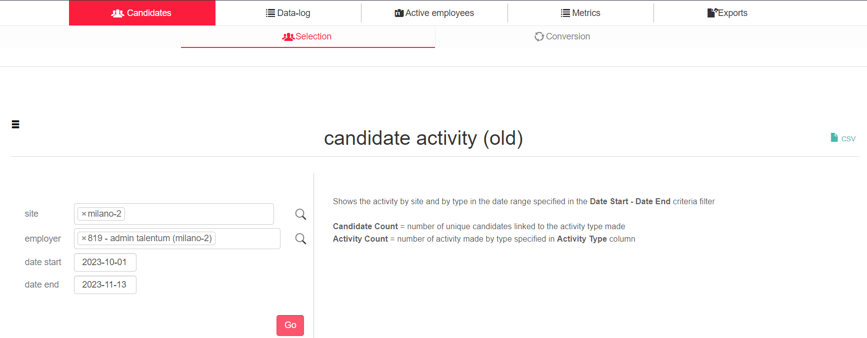

Clicking on the button with the title of the report opens the relevant screen; to return to the main menu, click on the icon 

On the right-hand side is the detailed description of the report content.

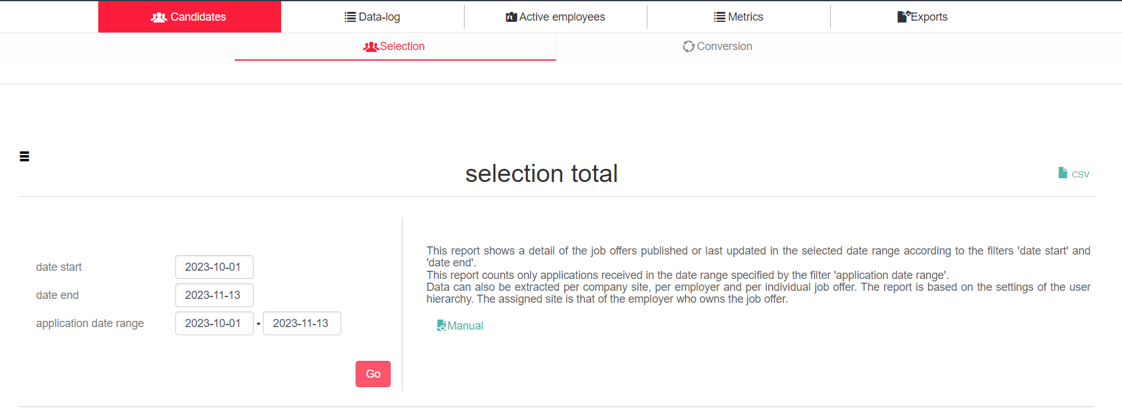

Below the report description, a 'Manual' link is displayed that opens a CSV file containing detailed descriptions of the contents of all fields represented in the RAWDATA, i.e. the report with as much detail as possible.

The Manual of this report contains the following columns:

* Name: The name of the field that is described on the line (e.g. Job post ID)
* Is Link: The link to the applicant or customer that is shown in the report at both
* Format: the format of the content of the column (e.g. Id-title shows the ID number and the title of the advertisement)
* Description: the column contains the exact description of the data shown in that box

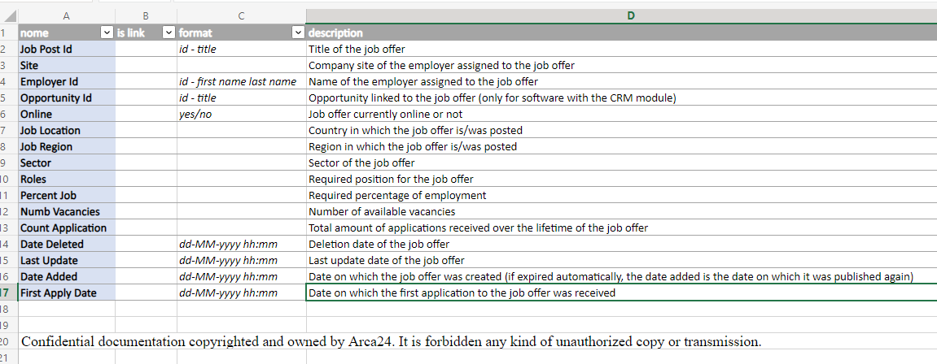  
To start the report extraction, enter a date range (from....to.....) on the left-hand side of the selected report, and click GO.

Only the "Selection total" report has the filter for "application date range", which is used to filter the result according to the date on which the applications took place.

Please note: some reports maintain the following start-up mode:

1. Set search filters.

Please note: The 'Site' and 'Employer' filters are based on site/user groups; they can be pre-filled by default with the name of the person carrying out the search.

Selection modes:

Magnifying glass icon: shows the list of selectable items. Among the listed items, it is possible to:

* highlight one or more choices (by holding down Ctrl)
* select all with "Select All
* cancel selection with "Clear"

You must always confirm the filter setting by clicking 'ok'.

You can cancel your selection by clicking on the x at the selected location or employer.

2. Click on Go

Using the icon in the top right-hand corner, you can extract a CSV. The download is done in real time.

Please note: Data is currently extracted in real-time from the database, so using filters incorrectly or considering wide date ranges may be burdensome to the system and cause slowdowns/time-outs.

Please note: The reports and their interface are in English.

By clicking on a candidate's name within the reports, you can open the candidate's page directly.

#### 4.1.1. Selection

**Selection Total**

This drill down report enables you to firstly start with an overview of the advertisements created or updated in the selected date range, and then go into detail for each of them. The ‘application date range’ filters also includes the possibility of entering in date range the applications we want to display.

More precisely, in this report the total adverts, online adverts, offline adverts, deleted adverts, the number of adverts that received applications and the total number of applications according to the filter date range are shown.

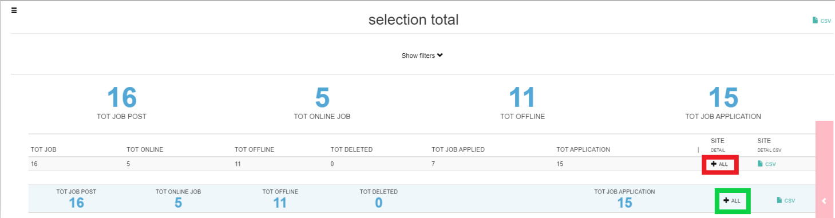

1. Clicking on at "site detail" opens the split with respect to the sites on which the employer has visibility, clicking on CSV at "site detail csv" downloads the csv corresponding to the site detail.
2. Clicking on at the totals row opens the selection rawdata showing the details of each advertisement considered for the calculation of the totals shown in the selection total.

**Site Detail**

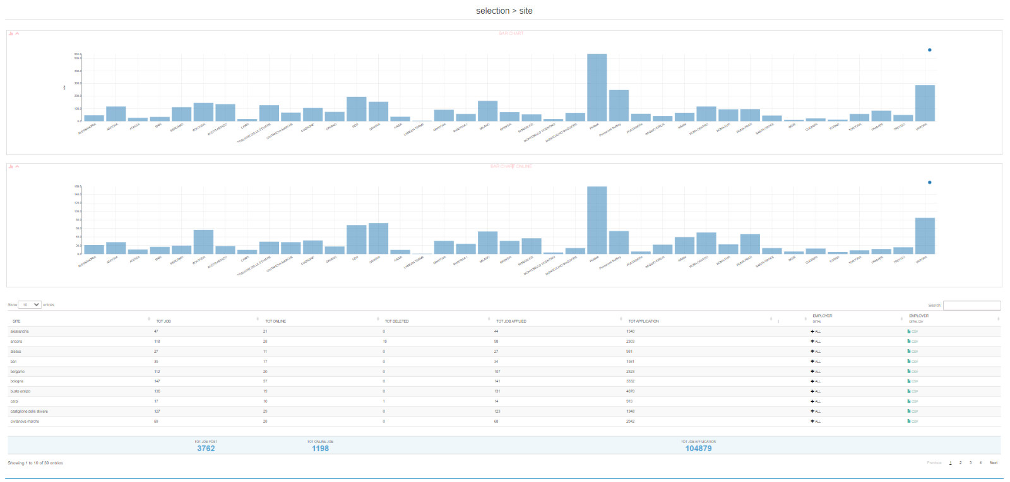  
The charts show for each location: the number of total ads and online ads.

In the table, for each site: the total number of advertisements, online advertisements, deleted advertisements, the advertisements for which applications were received and the total number of applications. By clicking on   
 you can open the employer detail, with the split for each employer in the location. Clicking on CSV under 'employer detail csv' downloads the csv corresponding to the employer detail.

**Employer detail**

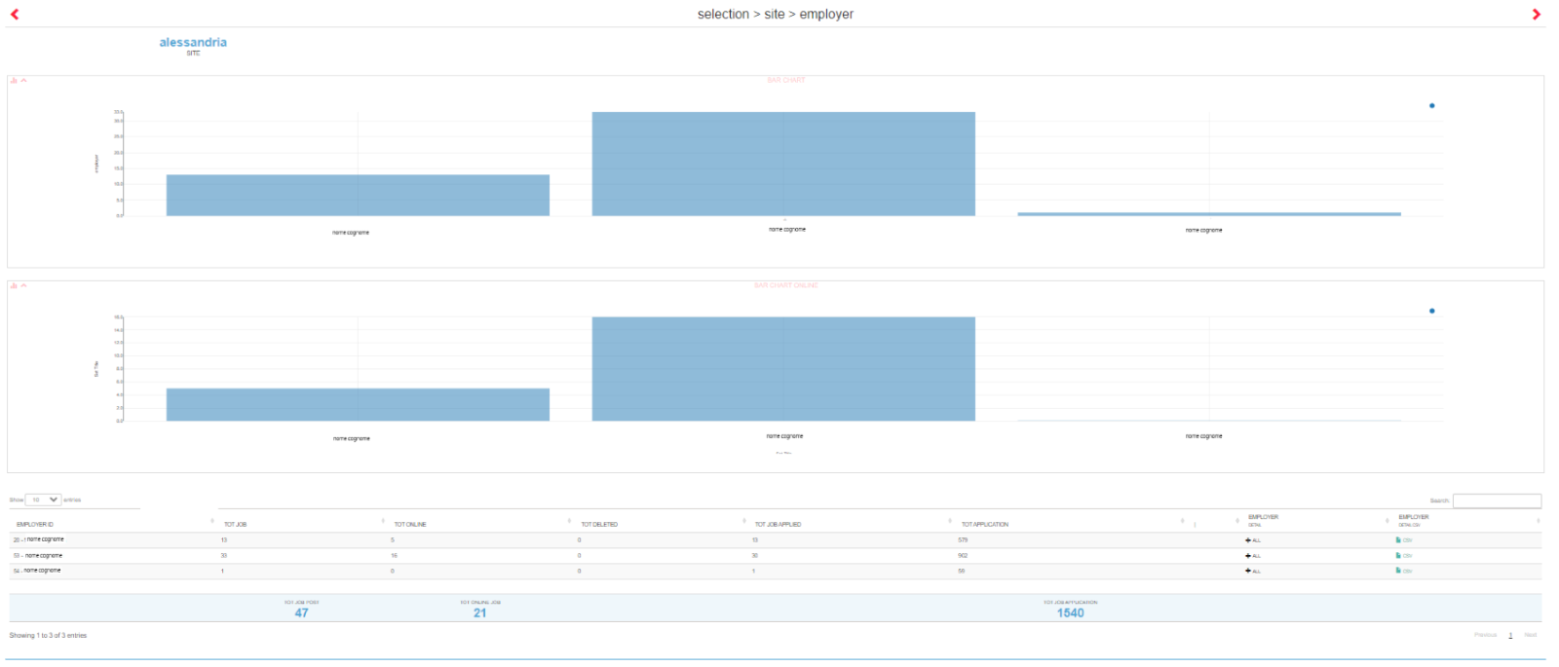The charts show for each employer: the number of total ads and online ads. In the table, for each employer: the total number of advertisements, online advertisements, deleted advertisements, the advertisements for which applications were received and the total number of applications received. By clicking on  you can open the selection rawdata, with the details of each advertisement assigned to the specific user. Clicking on CSV under 'employer detail csv' downloads the csv corresponding to the selection rawdata filtered by employer.

**Selection rawdata**

Please note: If opened via employer detail, it is filtered for the selected employer. If opened directly from selection total, no filtering by employer is applied (so you will see the details of all ads on which the logged-in employer has visibility).

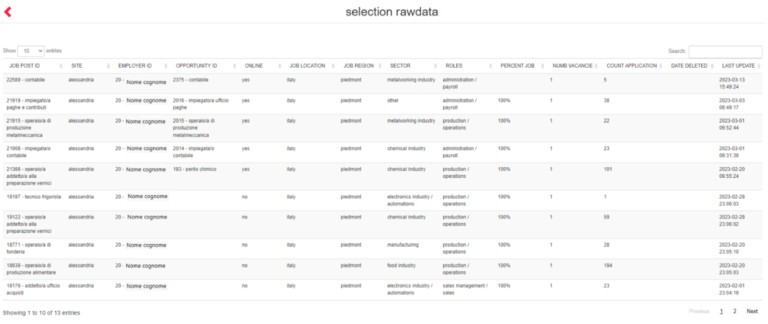  
The following is shown for each advertisement: location ID and title, employer, opportunity (*valued only CRM module active*), online (yes/no), country and region, sector, role, hourly availability, vacancies, application number, deletion date (if deleted), last modification date, date of creation of the advertisement (in the case of an automatically expired offer, the date added is the date on which it was re-published) and date of the first application received.

**SEARCH TOTAL**

Drill-down report showing the details of all searches (saved and unsaved) created or last updated in the selected date range according to the 'start date' and 'end date' filters.

Data can also be extracted per company site, per employer and per individual search performed. Only searches whose last update date does not exceed 24 months are shown. The assigned site is that of the employer who owns the search.

In the Search Total, the total searches, the deleted searches, the number of candidates present in step 2 "Interview" of the searches under examination, the number of candidates moved to step 3 "Selection" for the searches under examination are shown, depending on the date filter and the visibility of the employer that is carrying out the extraction.

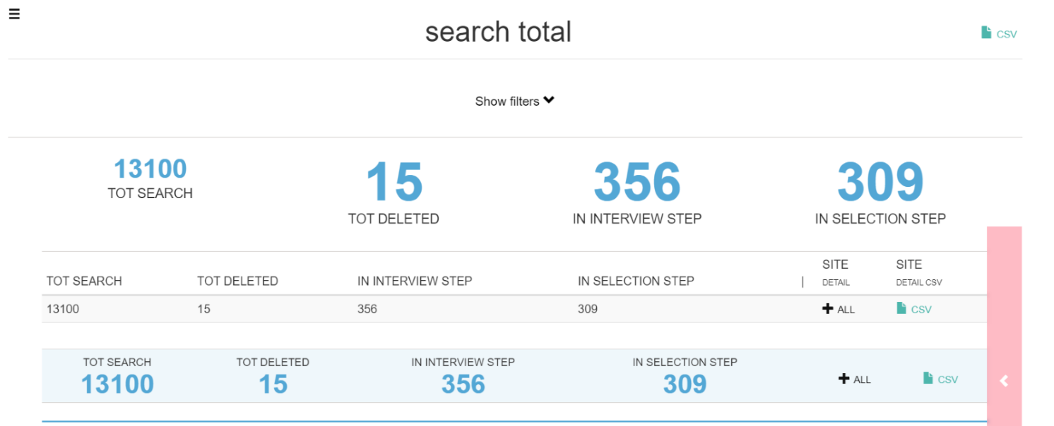

1. Clicking on next to “site detail” opens the split with respect to the sites on which the employer has visibility, clicking on CSV at "site detail csv" downloads the csv corresponding to the site detail
2. Clicking on  next to the totals row, the search rawdata is opened showing the detail of each search based on the totals shown in the search total

**Site Detail**

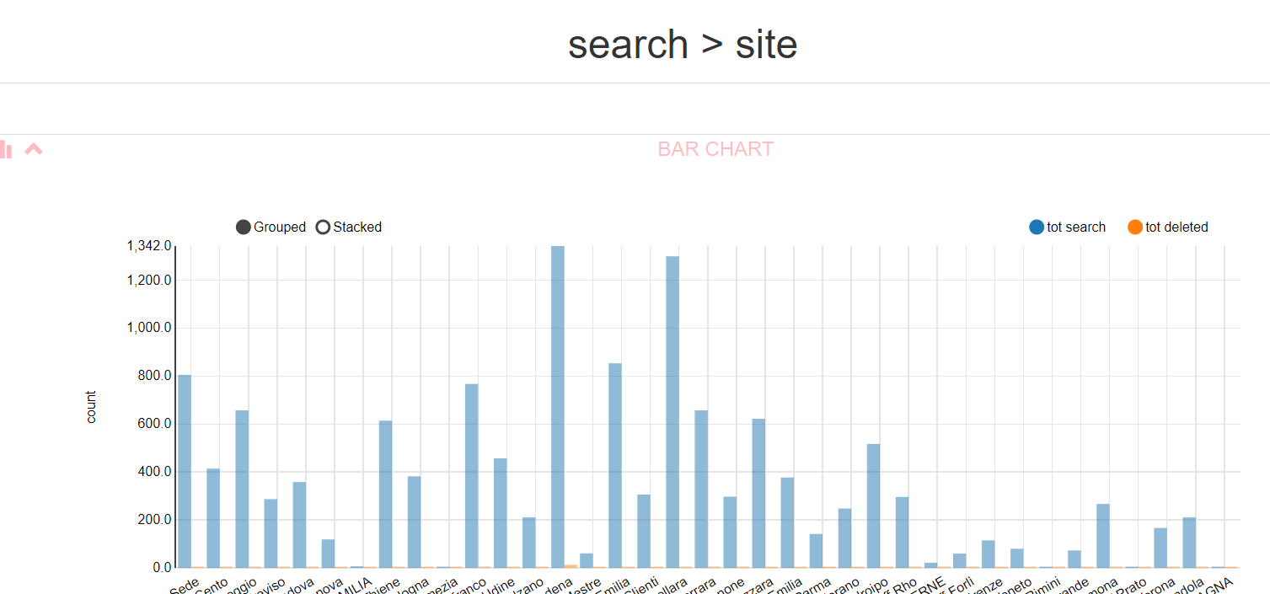

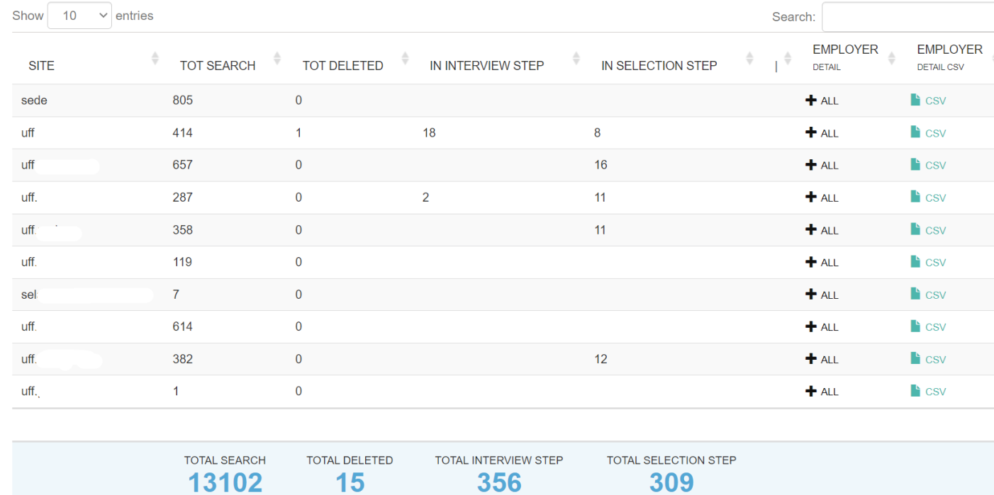  
The graphs show for each venue: the number of searches and the number of deleted searches. The charts show for each location: the total number of searches, the total number of deleted searches, the number of candidates moved to step 2 "Interview", the number of candidates moved to step 3 "Selection".

By clicking on you can open the employer detail, with the split for each employer in the location. Clicking on CSV under "employer detail csv" downloads the csv corresponding to the employer detail.

**Employer Detail**

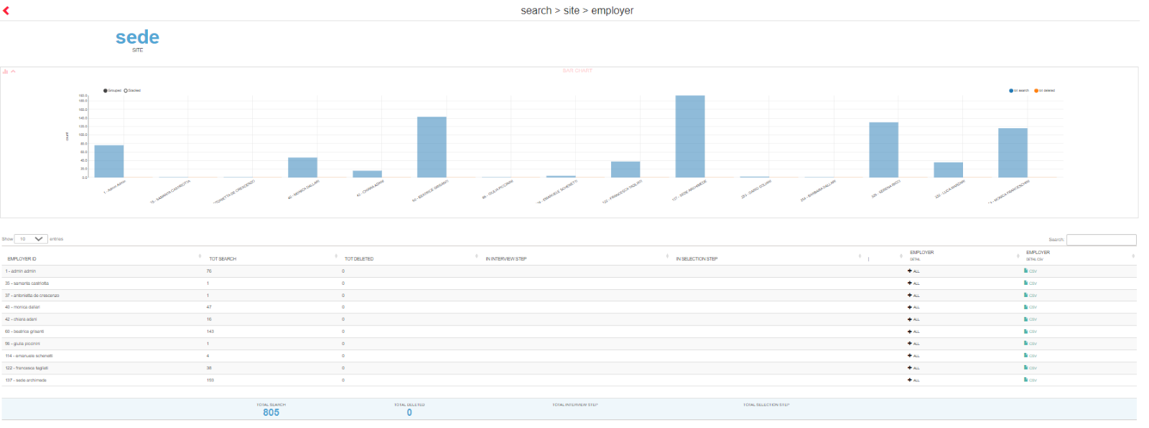The graphs show for each employer: the number of searches and the number of deleted searches. In the table, for each location: the total number of searches, the total number of deleted searches, the number of candidates moved to step 2 "Interview", the number of candidates moved to step 3 "Selection".

By clicking on  you can open the search rawdata, with the details of each search assigned to the specific user. Clicking on CSV under "employer detail csv" downloads the csv corresponding to the search rawdata filtered by employer.

*Search rawdata*

Please note: If opened via employer detail, it is filtered for the selected employer. If opened directly from search total, no filtering by employer is applied (so you will see the details of all searches on which the logged-in employer has visibility).

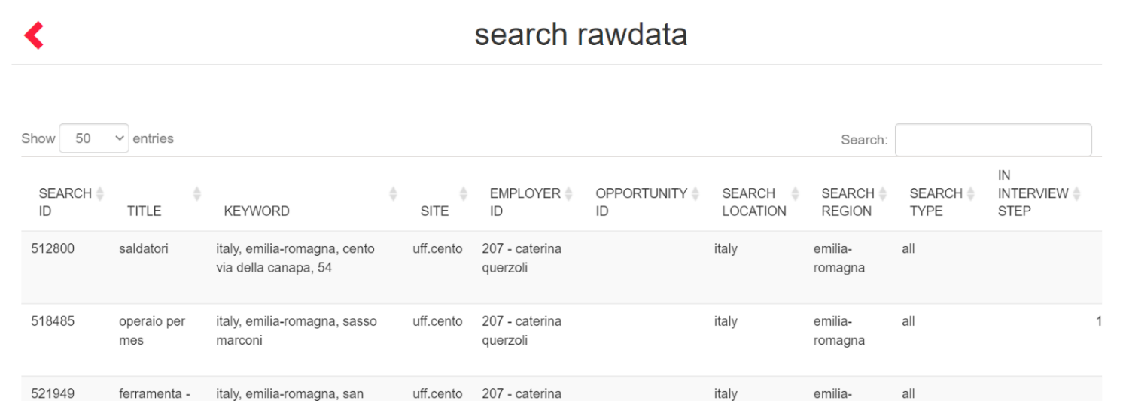

For each search, the following is shown: ID and title, keyword entered in search, location, employer, opportunity (*valued only CRM module active*), country and region, search type, number of candidates in step 2 and 3, date of deletion, date of search update, date of search entry.

**ACTIVITY TOTAL**

This drill down report enables you to start from an overview of the activities manually entered on candidates and get to the detail of each activity. The results take into account the filter date and visibility of the employer who is performing the extraction.

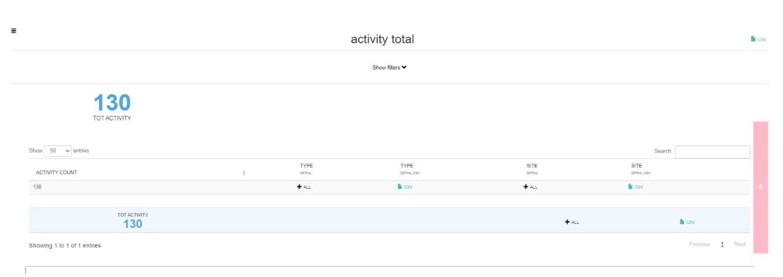

1. Clicking on next to "type detail" opens the split with respect to the types of activities entered on which the logged in employer has visibility, clicking on CSV at "type detail csv" downloads the csv corresponding to the type detail.
2. Clicking on next to "site detail" opens the split with respect to the sites on which the employer has visibility, clicking on CSV at "site detail csv" downloads the csv corresponding to the site detail.
3. Clicking on next to the totals row opens the activity rawdata showing the details of each advertisement considered for the calculation of the totals shown in the activity total.

**Type Detail**

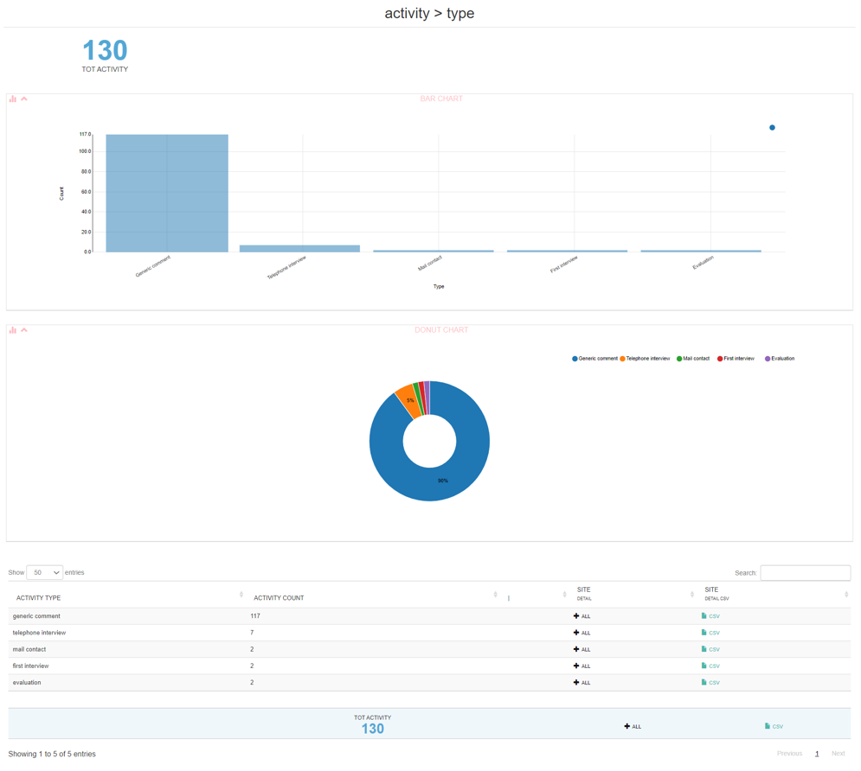  
The charts show the number of activities per type and the percentage of the total. The table for each type of activity shows the number of activities entered.

Clicking on  next to 'site detail' opens the split by site; clicking on CSV at 'site detail csv' downloads the csv corresponding to the site detail.

**Site detail**

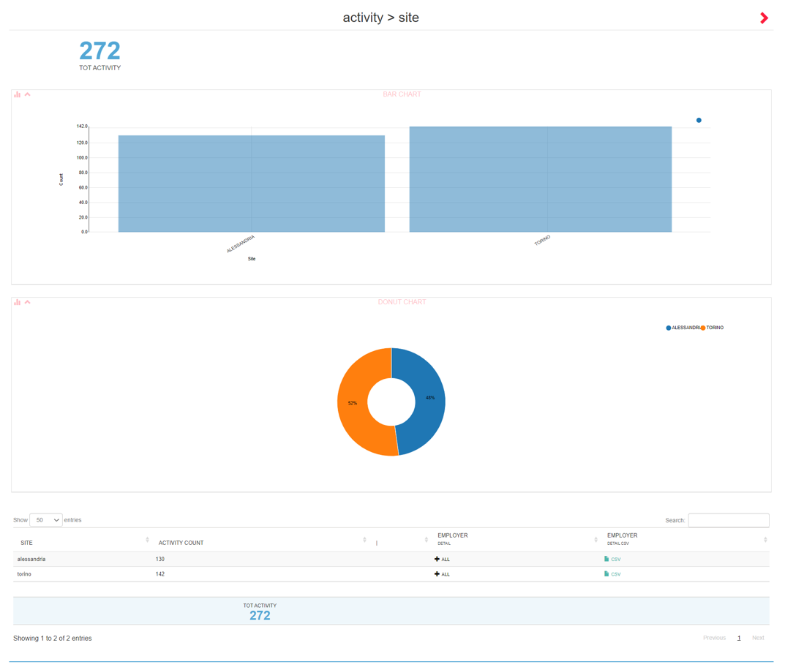The graphs show the number of activities per venue and the percentage of the total. In the table, the total number of activities entered is shown for each location. If the report is opened by activity type it will be prefiltered by activity type. Clicking on  next to "employer detail" opens the split by employer; clicking on CSV at "employer detail csv" downloads the csv corresponding to the employer detail.

**Employer detail**

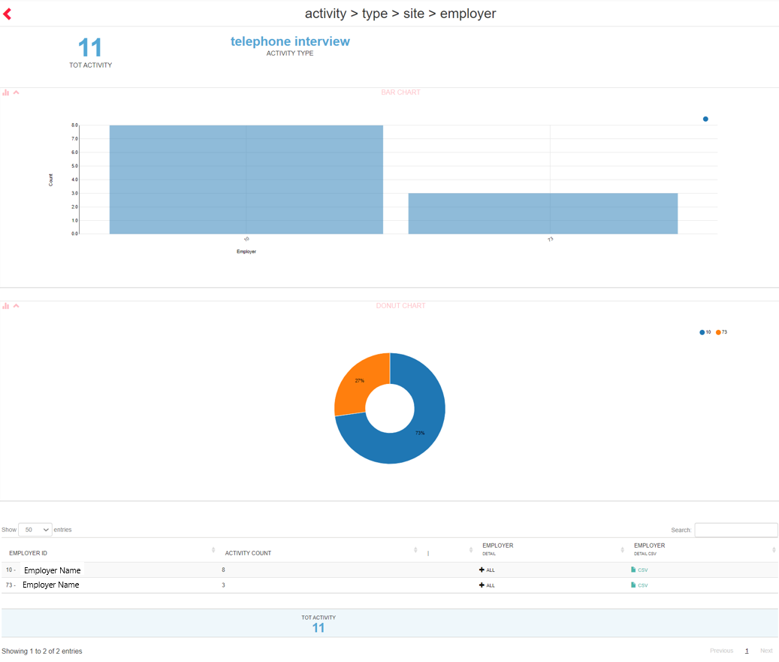

For each employer, the number of activities (possibly prefiltered by type/location) is shown. Clicking on   
next to "employer detail" opens the activity rawdata; clicking on CSV at "employer detail csv" downloads the csv corresponding to the activity rawdata.

**Activity rawdata**

Please note: If opened via employer detail it is filtered for the selected employer. If opened directly from activity total, no filters are applied per employer (so you will see the details of all activities on which the logged-in employer has visibility).

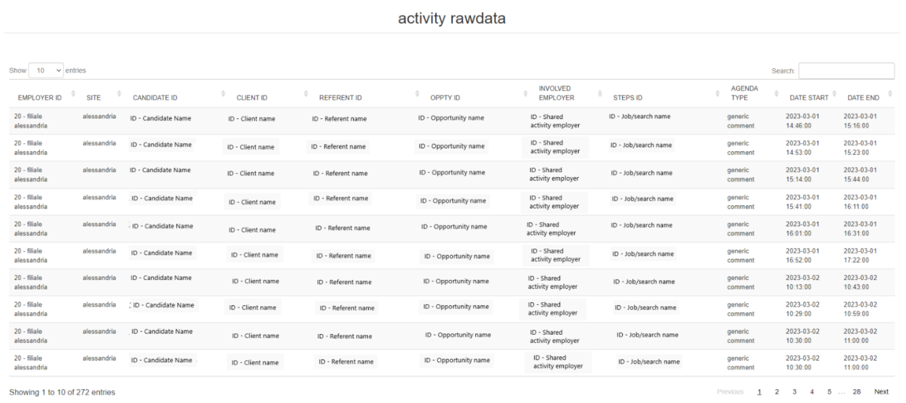  
For each activity is shown employer and assigned location, candidate, employer with whom the activity is shared, advertisement/search to which the activity is linked, activity type, start and end date. For installations with CRM and for activities where provided for, the columns CLIENT ID, REFERENT ID, OPP.TY ID, with customer, referrer and opportunity linked to the activity, are displayed.

**JOBS ACTIVITY TOTAL**

Drilldown report showing the detail of the activities carried out within an advertisement, based on the filter start date and end date. The report is based on the employer's visibility.

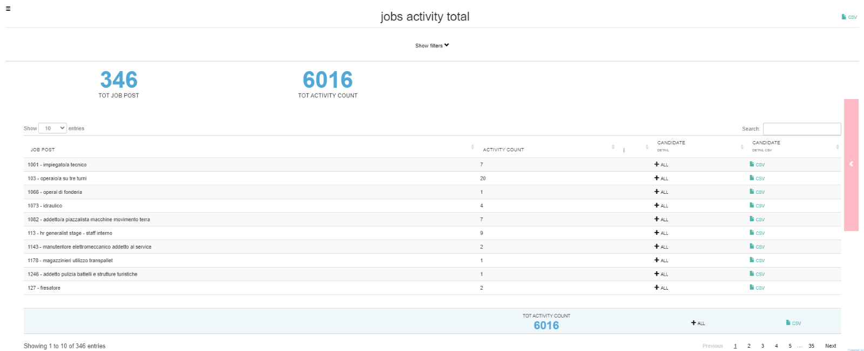  
Clicking on  next to 'candidate detail' opens the split showing the activities performed within the individual vacancy, divided by candidate; clicking on CSV at 'candidate detail csv' downloads the corresponding csv.

*Jobs activity Candidate*

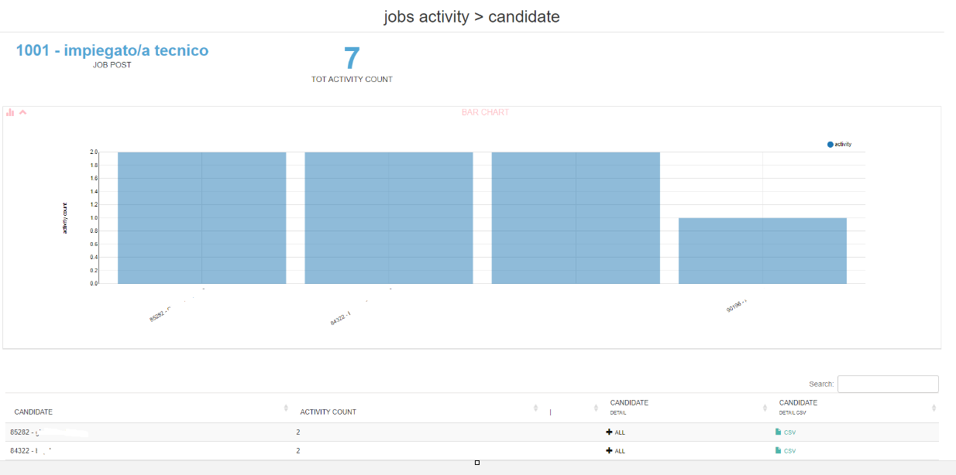  
Clicking on  next to "candidate detail" opens the split against the jobs activity rawdata on the individual candidate, with details for: job number and title, job status (online yes/no), candidate id and name, type of activity, activity notes (if any), start and end date of the activity, creation date of the activity (often different from the start date as activities are programmable)

*Jobs activity rawdata*

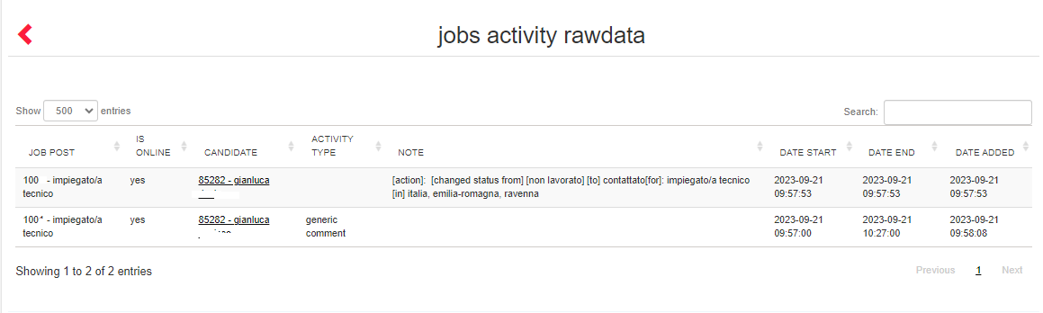  
**SEARCH ACTIVITY TOTAL**

Drilldown report showing the detail of the activities performed within the saved searches, according to the filter start and end date. Data can also be extracted per candidate. The report is based on the employer's visibility.

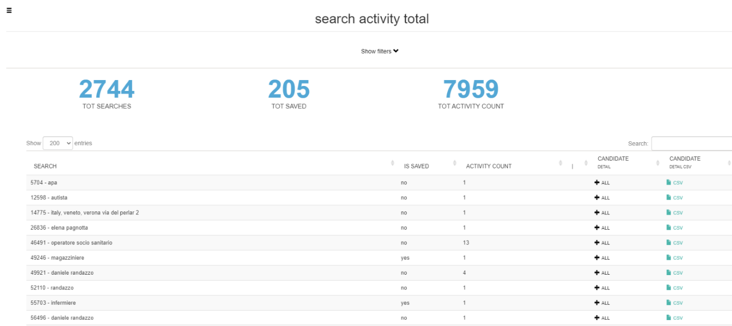  
Clicking on  next to at 'candidate detail' opens the split showing the activities performed within the individual saved search, divided by candidate; clicking on CSV at 'candidate detail csv' downloads the corresponding csv.

*Search activity Candidate*

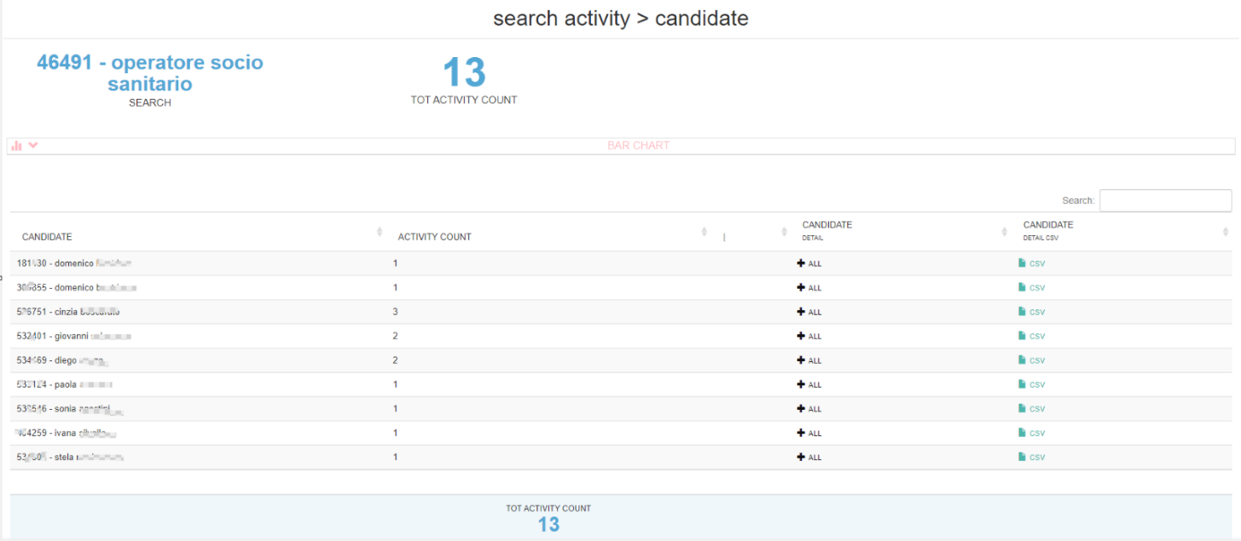

Clicking on  next to'candidate detail' opens the split with respect to the search activity rawdata on the individual candidate, with details for: search number and title, search status (saved or unsaved), candidate id and name, activity type, activity notes (if any), activity start and end date, activity creation date (often different from the start date as activities are programmable).

*Search activity rawdata*

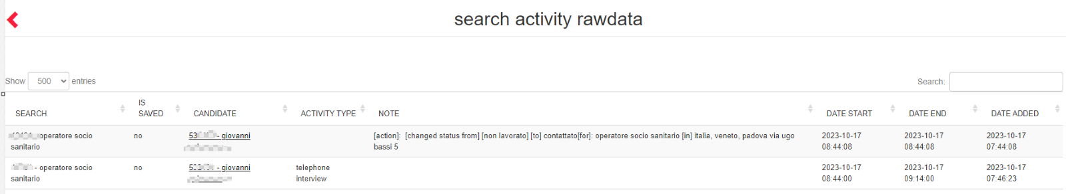

**SELECTION SUMMARY (OLD)**

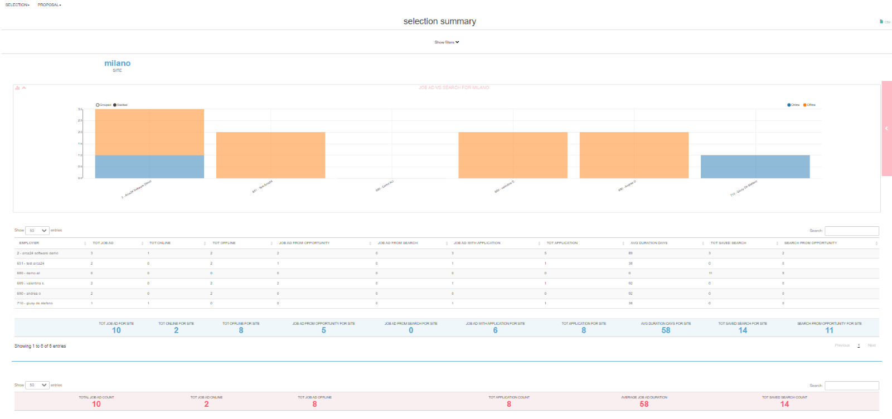The report shows a summary, by location and employer, of the vacancies and searches saved in DB in the date range specified in the criteria filter Start Date - End Date.

For each employer the total number of vacancies is shown, of these the number of online and offline, the number of vacancies linked to a saved search, the number of vacancies that received applications, the total number of applications. The average duration of the advertisements in calendar days (weekends and non-working days included over 24 hours) and the total number of saved searches is then shown.

**SELECTION DETAIL (OLD)**

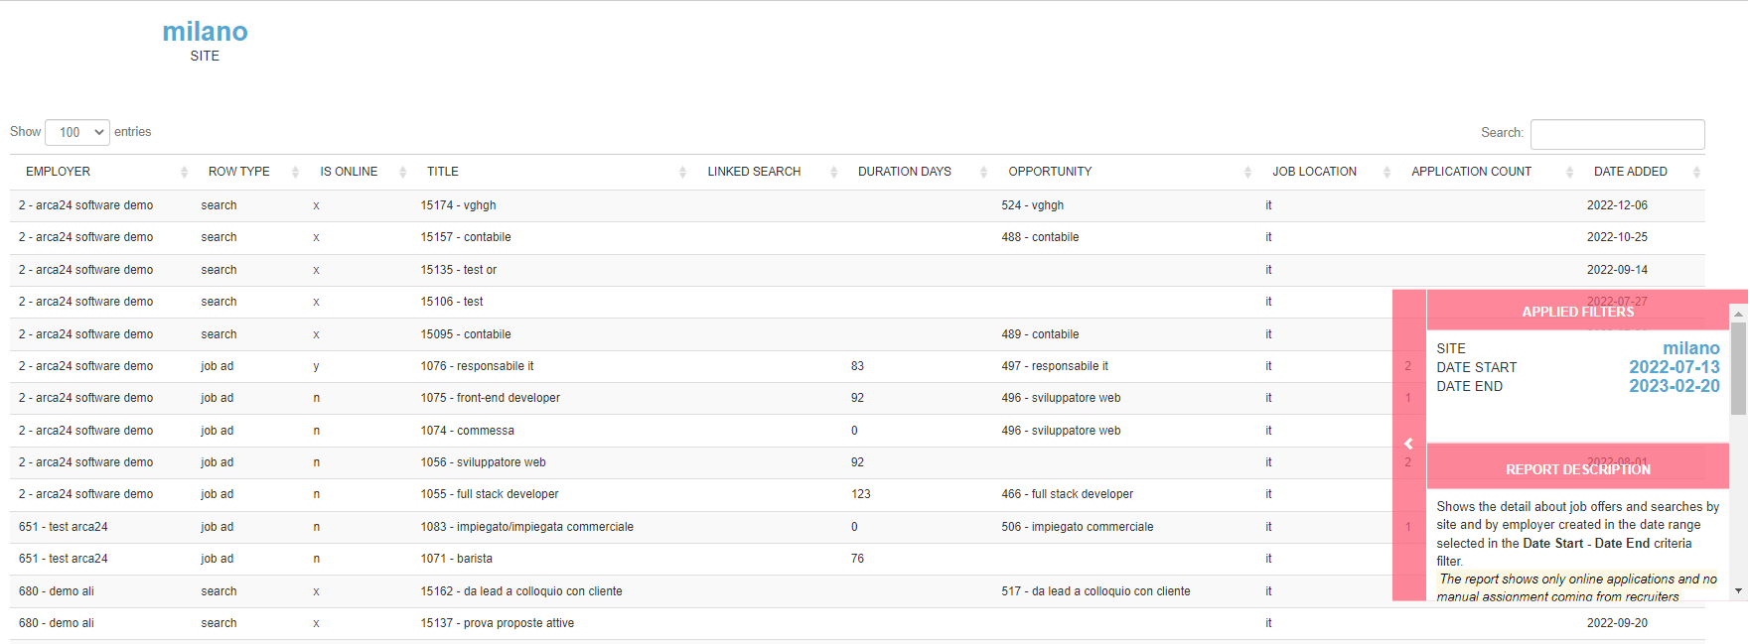

Shows the details of individual job offers and saved searches created in the date range selected in the criteria filter Start Date - End Date.

In particular, the following are taken into account: location and employer, type (offer/saved search), whether it is online (Yes, No and X if it is a search), title, (for advertisements) the id of any saved search from which the offer was published, duration, country, (for advertisements) applications received, creation date.

**CANDIDATE ACTIVITY (OLD)**

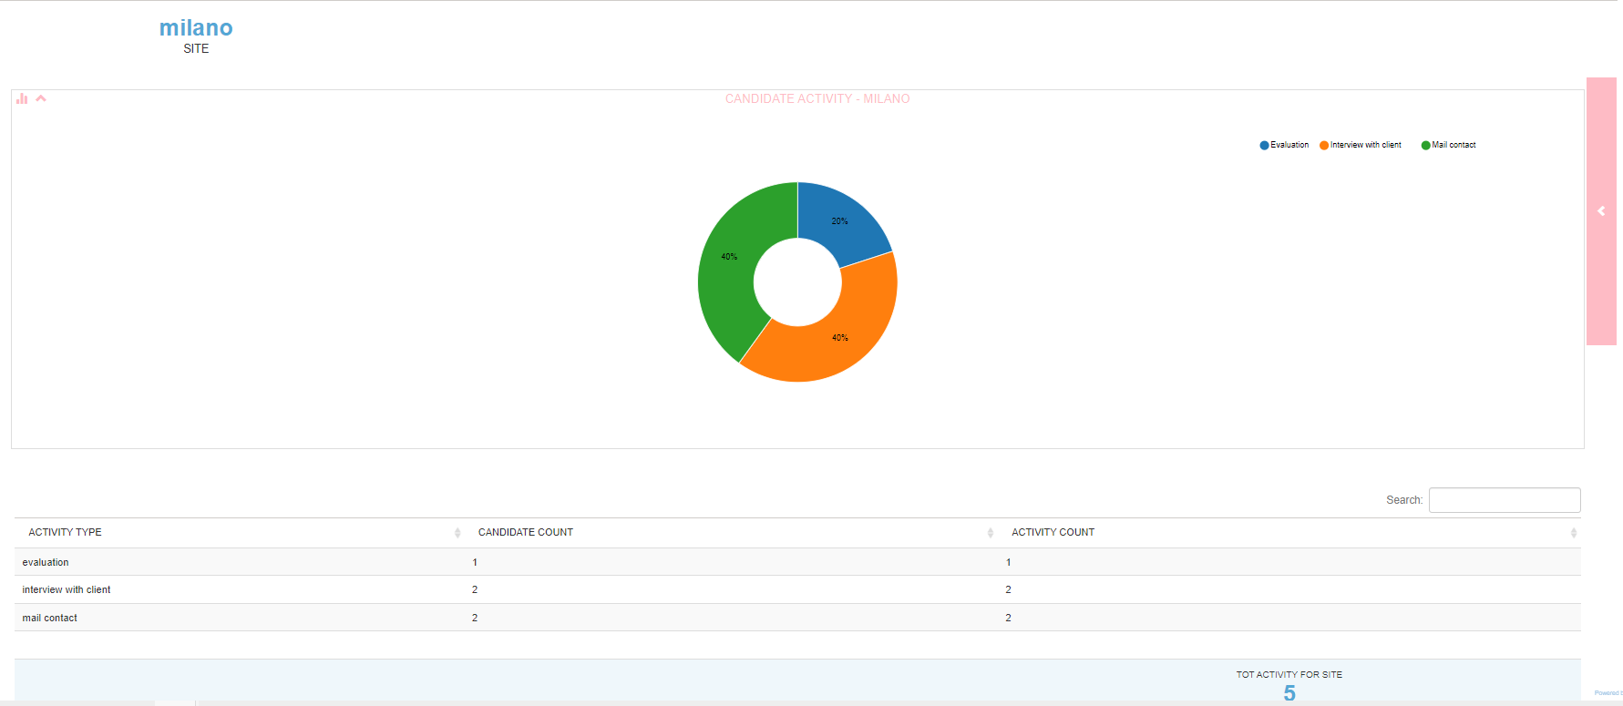

Filtering by site, employer, activity type and dates, shows for each site the number of activities divided by type and number of candidates involved.

N.B.: In all activity type reports, mails sent by the system (envelope icon) are also counted in the activity type "Mail Contact". Mails sent via multimailing are not counted.

**EMPLOYER ACTIVITY (OLD)**

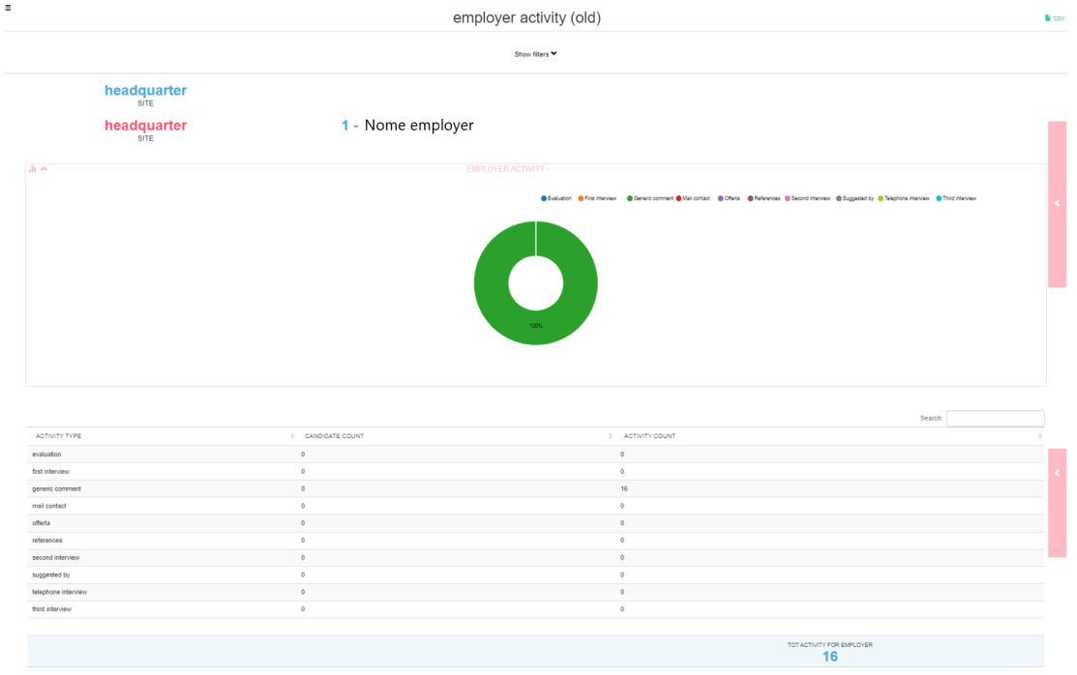The report shows the types of activities, performed on candidates by location and by employer, on the selected dates. This report allows you to select multiple employers before launching the search, returning a result by individual employer and not by total number of activities.

**APPLICATION DETAIL (OLD)**

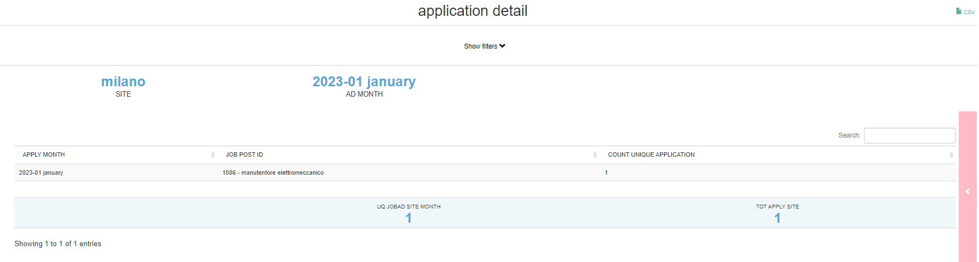  
The filters to be set concern the location(s) and the period when the advertisement was created. Each row shows, for each advertisement published in the selected period, how many candidates applied in that month and possibly in the following months in which the advertisement was online.

4.1.2 CONVERSION

**Candidate Registration Origin**

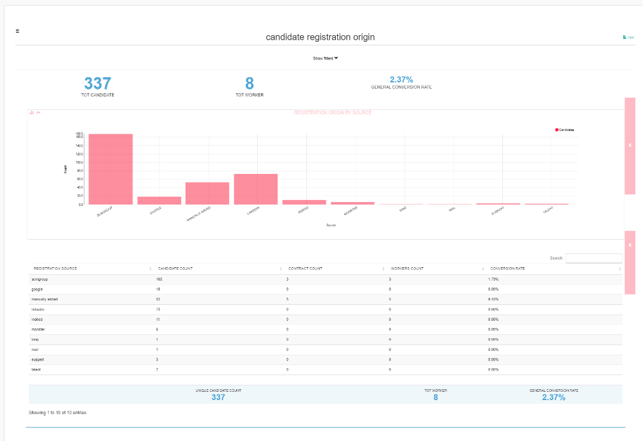  
The report shows the origin of applicants who registered in the system from the 'User From' date to the 'User Date To' date, and of these it counts the number of contracts created (regardless of the contract validity date).

The overall conversion rate shows the employment rate of users who registered in the database for the first time in the selected time period.

In particular, the table shows:

* The registration origin of the candidates
* The number of candidates per origin
* The number of contracts created per origin
* The number of contracted candidates (workers)
* The conversion rate for each registration origin (Number of contracted workers/Total candidates per origin)*100

**[Mod Job Agent]** within all conversion reports, the source //www.job-agent shows the number of candidates who applied to an ad as a result of receiving an email from the JobAgent.

Please Note: Applicants are public platform data and cannot be attributed to any location or employer, so this report does NOT have visibility based on company hierarchy.

**REFERRAL CANDIDATE REGISTRATION ORIGIN/APPLICATION ORIGIN**

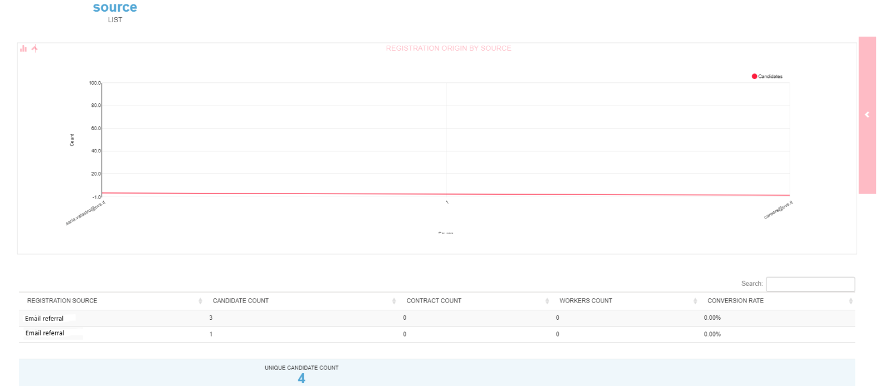The referral module allows you to track, for candidates who register from a link shared by an employee, the company employee who suggested a specific advertisement/spontaneous application to the company. The report shows the e-mail address of the employee who suggested the application, for each, how many candidates have registered, how many contracts and workers there are and the conversion rate.

Please note: Installations without the Referral module will not be able to extract the report.

**CANDIDATE INTERNAL ORIGIN**

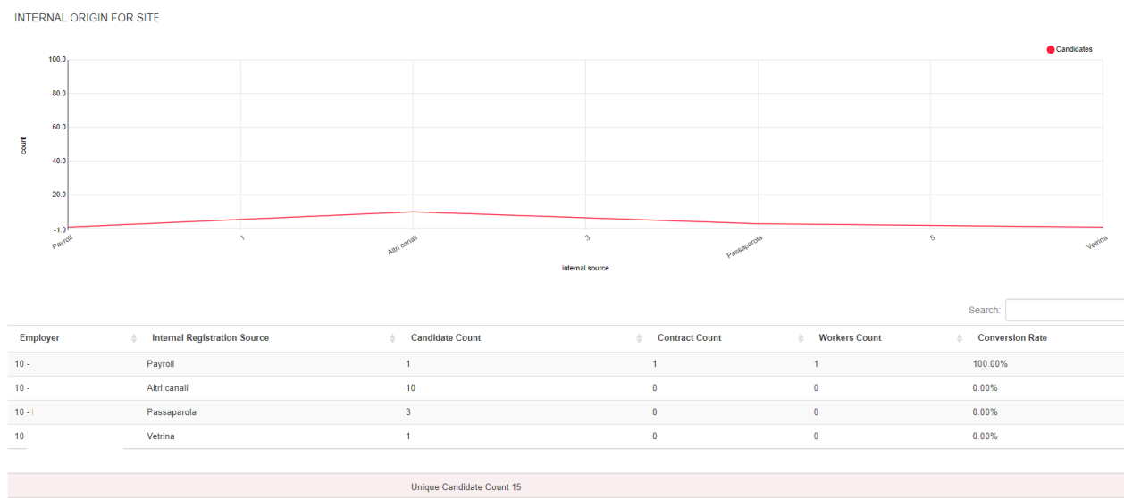  
The internal origin refers to the custom field 'SOURCE' in the employer's candidate registration form. Installations without the custom field will see all origins with " SOURCE NOT COMPILED"/"NO SOURCE".

The report shows the origin of the candidates registered manually by the employer according to the dropdown custom in the candidate registration form.

Please note: The branch data is also available in this section.

**CANDIDATE APPLICATION ORIGIN**

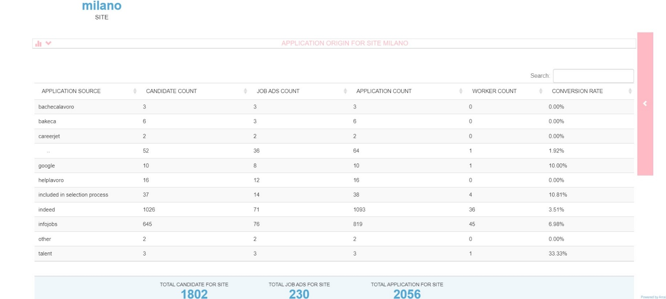

The report shows for each source site and according to the date of the 'Application Data from' and 'Application Data to' filter, the number of candidates who applied, the number of job advertisements for which at least one application was received and the number of applications. It also shows how many candidates have/had contracts (regardless of the date of validity of the contract). At the bottom of the page, you will find the non-unique total count of applicants and the non-unique count of job offers (if an advertisement is published on several portals, it will be counted several times).

Please note: Only the candidate's application is counted, so if I have hired a person on one contract and they have applied from three different portals they are counted three times.

Please note: Data visibility is based on company hierarchy.

**MULTIPOSTING**

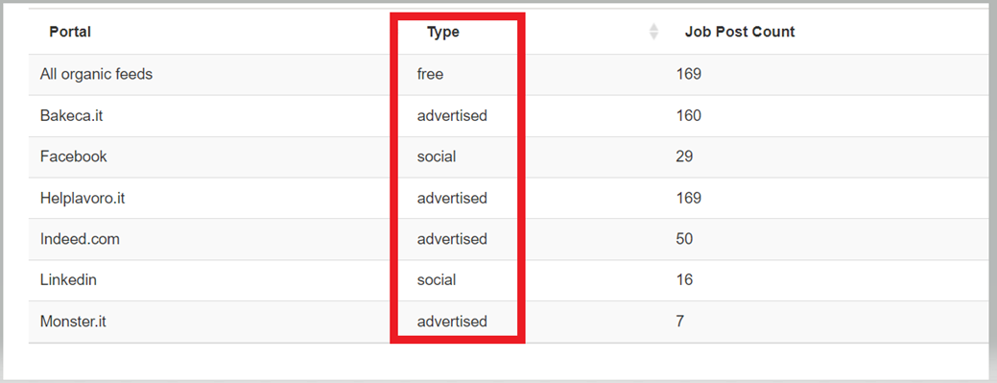  
The report shows according to the filter by location, ad status (all/online) and date, the number of ads published on each feed.

It is also possible to filter by ad by specifying the ad ID of the ad you want to take into account.

Please note: The system considers each ad uniquely: if an ad is taken offline and republished, it is counted only once.

### 4.2 Data-log

#### 4.2.1. Email verification

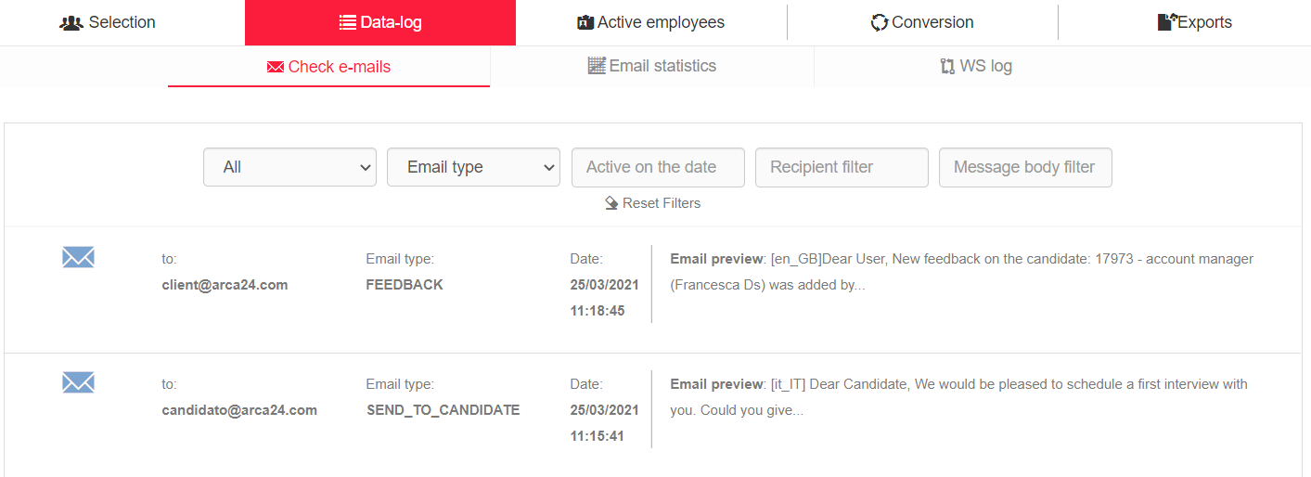

In this section it is possible to check the logs referring to the emails sent. The list below shows the recipient email address, the type of email sent, date and time of sending and the text of the email. The following filter are available: site, email type, sending date, recipient (email address) and keyword in the mail text.

#### 4.2.2. Email statistics

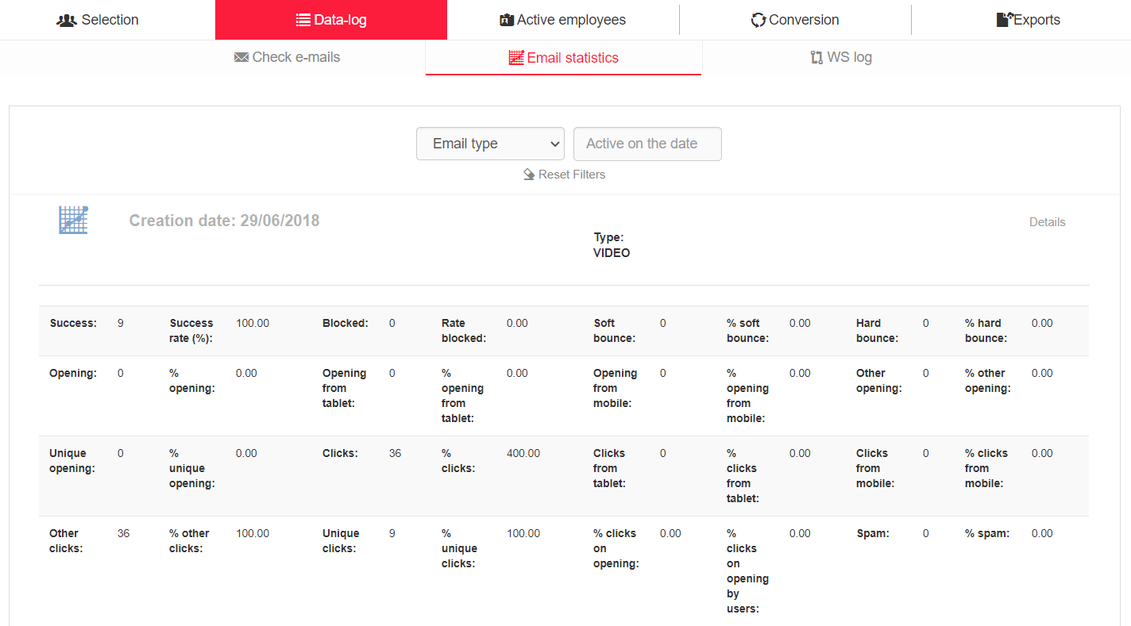

**N.B.** This section is only filled in on software versions connected to Splio, with a dedicated or shared universe.

Details are shown by date and email type. For each case, the number of mails covered and the percentage of total mails is shown.

* **Success**: Emails delivered to recipient
* **Blocked**: Emails blocked upon receipt
* **Soft bounce**: The server refuses emails delivery (temporary problem)
* **Hard bounce**: The server refuses emails delivery (permanent problem)
* **Opening**: It shows the total openings of the email. If the same recipient opens the same message several times, all the openings will be taken into consideration. Hence, the number increases at each opening. Results are divided by the device from which the opening was made (tablet, mobile, other devices).
* **Unique opening**: Total number of recipients who have opened the mail. If the same recipient opens the same message several times, the opening is counted only once.
* **Clicks:** If there are links in the email, the total number of clicks is counted. The count is divided by device (tablet, mobile, other devices).
* **Unique clicks:** The number of recipients who have made at least one click is counted.
* **% clicks on opening**: Comparison between total openings and total clicks.
* **% clicks opening by users**: Comparison between the number of clicks and the openings made by the individual user
* **Spam:** Mail categorized as spam by the recipient's mailbox.

#### 4.2.3. SMS statistics (*ADDITIONAL MODULE*)

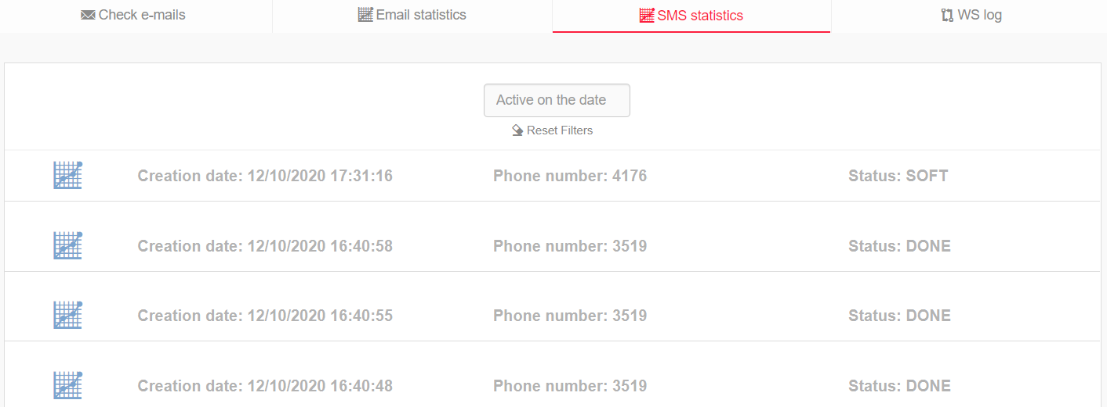

These statistics show the date and time of sent SMS messages, the recipient number and the status. The statuses are “done” (send completed), “waiting for callback” and “soft” (message went into soft bounce). They can be filtered by date.

#### Log WS (*ADDITIONAL MODULE*)

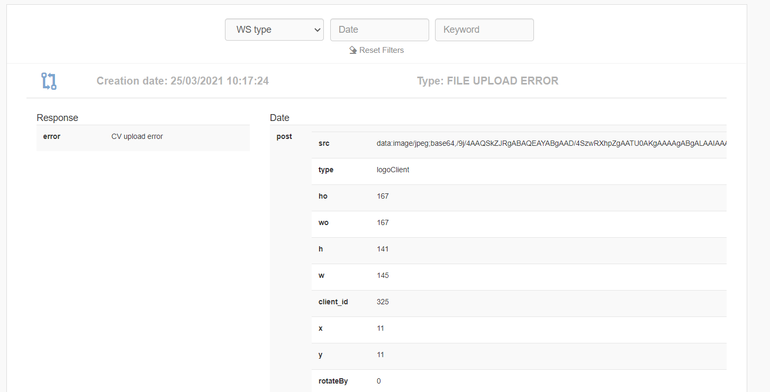

If web services with a third-party software are active, the logs related to calls made/received are visible. This section is therefore used to check what data has been sent from one software to another, to see the answers to the call, and to check for potential errors (these types of logs bear the word ERROR: candidate import error, client export error, etc.). The list can be filtered by WS type, date and/or keyword.

### 4.3. Active employees (*ADDITIONAL MODULE)

In this section you can view the list of all active employees. In the candidate string the contract details are displayed. The ones highlighted in red are the ones expiring the following day to the current date. The ones in pink are the ones expiring from 2 days after the current date to the following week (ex: if today’s number is 06, all profiles whose contract will expire between 08 and 13 inclusive will be highlighted in pink).

With reference to the list, you can:

* Export data to a CSV file, which can be downloaded from the exports panel described at the following paragraph;
* Send mass SMS (*OPTIONAL MODULE);
* Send mass emails to candidates;
* Insert an opportunity linked to an individual contract.

The filters are:

* Order by
  + Active contracts from (contract start date)
  + Active contracts until (contract end date)
  + Last name
* Active contracts from/until: those active on the current date are shown by default
* Start date from/to: contract start date between the dates indicated
* End date from/to: contract end date between the dates indicated
* Branch: branch of the colleague who entered the contract
* Company data (company name and site): filter by the company on which the contract was entered
* Candidate: filter by employee’s contract ID  
  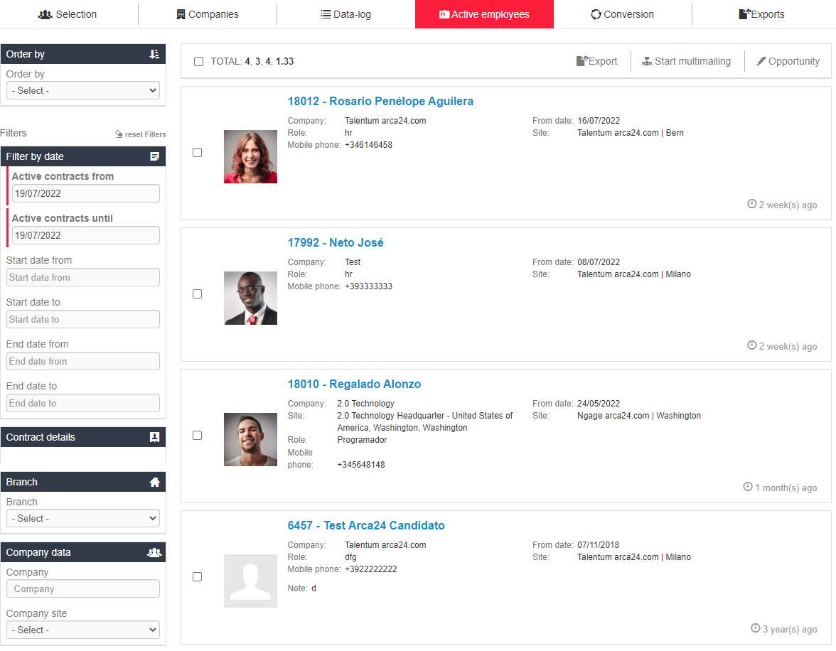

### 4.4. Exports

In this section, CSV files originating from the extractions requested in the other tabs of this module can be downloaded.

Text elements (e.g., note fields) with max. 300 characters will also be printed as CSV file.